Year 3

UNIVERSAL CHURCH – WORLD

Teacher’s page

EXPLORE
For many people, some places in the world are special. For others the whole world is special. We all feel a need to look after what is special to us. Sometimes it is easy to explain why things are special. At other times it might be difficult to put into words why something is special.

- What are your special places and why?
- Can you recall an occasion when you were hurt or angry by the way your special place was treated by others?
Why were you hurt or angry? What did you do?
- Do you know any groups who campaign because of the way people or our world are being treated today?

REVEAL
Christians believe that the diversity of the world and its people is God’s gift. Jesus in his life and gospel, challenges people to appreciate diversity and to create with it a harmony that reflects the unity of Father, Son and Holy Spirit. This is reflected in the work of CAFOD.

Catechism of the Catholic Church
“God created the world to show forth and communicate his glory: that his creatures should share in his truth, goodness and beauty – this is the glory for which God created them.” (CCC319)
“The Church is the people that God gathers in the whole world.” (CCC752)

Word of God
“See, the body is one, even if formed by many members, but not all of them with the same function. The same with us; being many, we are one body in Christ, depending on one another. Let each one of us, therefore, serve according to our different gifts. Do you have prophecy? Let the deacon fulfil his office; let the teacher teach, the one who encourages, convince. You must, likewise, give with an open hand, preside with dedication, and be cheerful in your works of charity. Let love be sincere. Hate what is evil and hold to whatever is good. Regarding brotherly love, have love for one another. Regarding respect, judge others as more worthy. Regarding your duties, do not be lazy.
Be fervent in the Spirit and serve God.” (Romans 12:4-11)

RESPOND
- How can children be encouraged to value and care for creation?
- Why do we, as adults and children, need to work towards justice for all?

Prayer and Reflection

Creator God,
in your hands you hold the depths of the earth
and the heights of the mountains,
for all creation belongs to you.
Grant us grace to cherish your world
and wisdom to nurture its resources.
Save us from the desire to control what is not ours
and the impulse to possess what is not ours
and the impulse to possess what is there to share.
Amen.

(Annabel Shilson-Thomas/CAFOD)

UNIVERSAL CHURCH – WORLD: SPECIAL PLACES – TOPIC OVERVIEW
YEAR 3 - 4 WEEKS | Special places for Jesus and the Christian community
TEACHERS’ NOTES
The Christian community has many special places: places where people gather for prayer and worship; places are holy because of their association with Jesus or holy people; places of pilgrimage.
Scripture: (Ephesians 2: 20-22) You too are built upon the foundation laid by the apostles and prophets, the cornerstones being Christ Jesus himself. He is the one who holds the whole building together and makes it grow into a sacred temple dedicated to the Lord. In union with him, you too are being built together with all the others into a place where God lives through his Spirit.
Catechism of the Catholic Church 2691: Pilgrimages evoke our earthly journey towards heaven and are traditionally very special occasions for renewal in prayer. For pilgrims seeking living water, shrines are special places for living the forms of Christian prayer ‘in Church’.
ABOUT THE TOPIC
Prior learning: the world is God’s treasure given to us
This Topic: learning outcomes
Know and understand:
• Everyone has a special place – Explore
• Special places for Jesus and the Christian community – Reveal
Acquire the skills of assimilation, celebration and application of the above – Respond
SCRIPTURE | TRADITION
Luke 2: 11 Bethlehem Matthew 2: 23 Nazareth  Luke 2: 41, 46 Jerusalem  Mark 1: 9, Baptism in the Jordan Matthew 5: 1-2 Sermon on the mount Psalm 24: 1  Romans 5: 5 | Pilgrimage, pilgrims Temple Jerusalem World as a holy place  Church’s Story 3 pages 28-32 (teachers’ pages 124)
SOME QUESTIONS OF MEANING & PURPOSE | CORE VOCABULARY
Where is special for me?  How do places become special? | special, holy, place, world, pilgrim, pilgrimage, universal, temple, Nazareth
RESOURCES
Church’s Story 3
God’s Story 3
CAFOD website: cafod.org.uk/comeandsee
COME & SEE WEBSITE |  |  | STANDARD INDICATORS
Learning about religion
i beliefs, teaching & sources
ii celebration and ritual
iii social & moral practices & way of life
Learning from religion
i engagement with own & others’ beliefs & values
ii engagement with questions of meaning
RE CURRICULUM DIRECTORY |  |  | LITURGICAL/PRAYERS LINKS | SONGS/  HYMNS TO SING
Area of Study 1: Knowing and loving God, the Scriptures, the Trinity, Jesus Christ, Son of God
Area of Study 2: What is the Church? One and holy, Catholic, Apostolic, Mission
Area of Study 3: Prayer
Area of Study 4: The dignity of the human person, the human community, love of God, love of neighbour

EXPLORE
Everyone has a special place

STANDARD INDICATORS

- Children will be able to ask and respond to questions about their own and others’ experiences of and feelings about special places.
- Children will be able to ask questions about what they and others wonder about special places and realise that some of these questions are difficult to answer.
- Children will be able to make links to show how feelings and beliefs about special places affect their behaviour and that of others.
- Children will be able to compare their own and others’ ideas about questions that are difficult to answer, relating to why some places are special.

KEY WORDS

special, place, cosy, comfortable, safe, warm

RESOURCES

- card circles and strips of paper
- glue
- world templates craft materials

ICT

- CAFOD website, cafod.org.uk/comeandsee for resources and images
- camera

LEARNING INTENTION: Everyone has a special place.

CONTENT

Everyone has a place that is special to them.

Talk about the children’s special places and what makes them special. Perhaps it is somewhere they like to go to think or be alone. Everyone’s will be different.

Show PowerPoint of Yulissa’s story from Colombia – see cafod.org.uk/comeandsee. (Remember, when introducing this topic, the subjective nature of someone’s special place.)

SOME KEY QUESTIONS
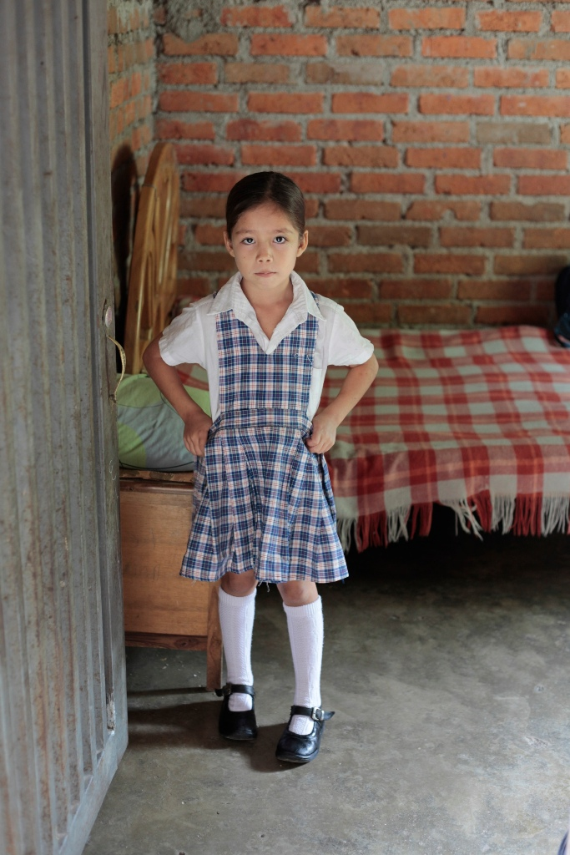
- What is a special place?
- What places are special for Yulissa?
- Where is your special place?
- What makes it special for you?
- Is it a place you go when you feel happy/sad, fed up/angry, just because, or another reason?
- How do you show you appreciate your special place?
- In what ways have any of your special places changed as you have grown up?
- Why do think that everyone needs a special place?

Ask the children to bring in some artefacts that help them talk about their special place.
Encourage the children to think about why these may be special places (e.g. because my friends/family are there; because it is a safe place; because it reminds me of happy things that happened there; because it is beautiful). Help the children see that all these things are true because God is there.

SOME SUGGESTED ACTIVITIES

- On a small circle, encourage the children to draw/write about their special place. Working in a group or as a class, make links by writing words on strips of paper to join these places together.
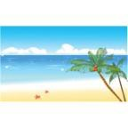
Garden
Home
Beach

safe

relaxing
- Ask the children to create their own imaginary special place. What would it look like?
  - Draw and/or describe this special place.
  - Use a computer art programme to draw this place.
  - Create this place using modelling dough.
You may want to display this work or create a photo gallery to add to the school website or as a link to email parents (if appropriate).
- Invite the children to work in groups to discuss: “What makes a place special?” Ask one child from each group to write down their key ideas from the discussion and another child to present these ideas to the class.
- As a class: ask the children to think about special places at different levels. Begin with special places at home, moving outwards to special places at school, and then into the local community. Finally, encourage them to think globally, by moving further outwards to special places in the wider world, recording as below.
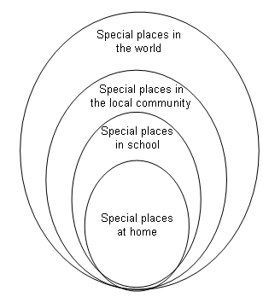

REFLECTION ON SIGNIFICANCE

Play the Special places in our World PowerPoint of images alongside some quiet music (find this at cafod.org.uk/comeandsee). Encourage the children to think about why these may be special places.

As part of the reflection on a template of the world (see cafod.org.uk/comeandsee) ask the children to write a key word that describes how their special place makes them feel (e.g. cosy, warm, safe, happy). One by one, the children may add these to the focus for worship.
At the end of the reflection, invite the children to choose one of the key words to take home as a reminder of how a special place may make you feel. Encourage the children to share
this at home with their families.

REVEAL
Special Places for Jesus and the Christian Community

CONTENT: – scripture – tradition – prayers

STANDARD INDICATORS

- Children will be able to retell the stories about special places for Jesus.
- Children will be able to describe some ways in which religion is lived out by Christians in terms of pilgrimage and worship.
- Children will be able to use a developing religious vocabulary to give reasons why Christians go on pilgrimage.
- Children will be able to give reasons why Christians should care about the world.

KEY WORDS

world, pilgrim, pilgrimage universal, temple, holy Nazareth

RESOURCES

- God’s Story 3
- Church’s Story 3
- Badge-making materials squares of fabric
- card

ICT

- CAFOD website (cafod.org.uk/comeandsee) for resources and images
- internet research camera

LEARNING FOCUS 1: Special places for Jesus.

CONTENT

Engage the children with the PowerPoint of special places for Jesus on the CAFOD website (see cafod.org.uk/ comeandsee). It is possible today to visit many of the places associated with the life of Jesus in what Christians call the Holy Land.

These are the scripture references in the PowerPoint:

Luke 2: 11 Bethlehem Matthew 2: 23 Nazareth Luke 2: 41, 46 Jerusalem
Mark 1: 9 Baptism in the Jordan
Matthew 5: 1−2 Sermon on the mount
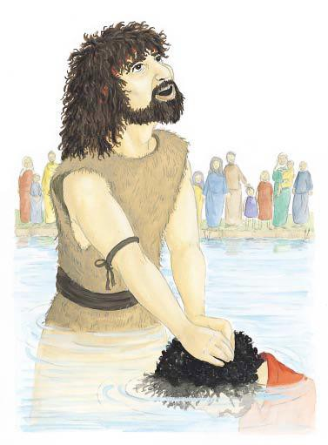

SOME KEY QUESTIONS

- Where were the special places for Jesus?
- Why were they special?
- Why do you think some of these places are still special and holy today?
- Why are these places so special for Christians today?

SOME SUGGESTED ACTIVITIES

- Give the children a map (see cafod.org.uk/comeandsee) with all the places that were special to Jesus clearly marked. Invite the children to write about which event happened there and why it is special to Jesus. They could then relate that to special places for them (e.g. the River Jordan is special to Jesus as he was baptised there. St. Mary’s Church is special to me because this is where I was baptised).
- An alternative activity would be for children to match the events in Jesus’ life with the location where they took place (see Special places for Jesus matching activity at cafod.org.uk/comeandsee).
- Collect photographs of the places that may be special to the children and ask them to name the equivalent special place for Jesus (e.g. local maternity hospital – stable at Bethlehem; their local church – Temple). Ask the children to say what happened at each special place.
- Invite the children to choose and retell their favourite story about Jesus, stating where it happened, why it was special and explaining why it is a special place for people today.

LEARNING FOCUS 2: Special places for the Christian community.

CONTENT | WHOLE CLASS CORE INPUT

Pilgrimage
Explain that many countries around the world have their own places of pilgrimage.

Discuss different places of pilgrimage around the world. See Church’s Story 3, page 29−32 (Rome, Lourdes, The Holy Land – Bethlehem, Nazareth and Jerusalem). Display the pictures, talk about the meaning of pilgrimage and pilgrim. Explain that there are places of pilgrimage in England and Wales, which the children can research further. For example:

- Our Lady’s shrine at Walsingham in Norfolk. This shrine honours the Annunciation and was one of the greatest shrines for Christians in medieval times – when travel to the Holy Land was very difficult.
- Our Lady of the Taper is the national Catholic shrine of Wales. It is in Cardigan. A legend describes how a statue of Mary was found about one thousand years ago by the side of the river Teifi. The statue was of Mary with Jesus on her lap and a candle (taper) burning in her hand.
- St Winefride’s Well in Holywell, North Wales, centres round a holy woman called Winefride who lived in the 7th century. She became a saint and her well at Holywell has been a place of pilgrimage and healing since that time.

Explain to the children that part of a pilgrimage to a special place is that it reminds people how important it is to pray and take time to think about what is important in their lives. Have a quiet moment with the children to reflect on God being with us always.

Lord, thank you for giving us so many special places
In our homes, In our school,
in our churches, in our world,
in our hearts.
Help us to take time to be still.

SOME KEY QUESTIONS

- Have you or anyone you know been on a pilgrimage? Share your experiences.
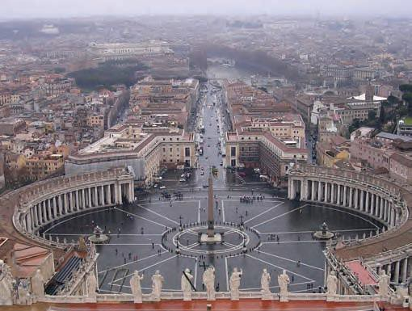
- Why do you think people go on pilgrimages?
- What might be the joys of a pilgrimage and how would it help the person in their Christian life?
- What do you think the challenges of making a pilgrimage might be?
- Why do you think a pilgrimage is a special time to pray?

SOME SUGGESTED ACTIVITIES

- On the internet, the children may research one site of Christian pilgrimage – they could choose a ‘local’ site of pilgrimage or a site from somewhere else in the world. Feedback the findings to the class, encouraging children to show how people’s beliefs affects their behaviour.
- In the past, pilgrims often returned from their pilgrimage with a badge to show where they had been. Pilgrims to the shrine of St James at Compostella in Spain wore a shell badge. Ask the children to design a badge for one of the special places of pilgrimage they have learnt about today. They could describe these to the class, giving reasons for their choice of design.
- Plan and go on pilgrimage to your local church. Invite the children to suggest suitable prayers or activities for their outing. Take photographs of your pilgrimage.
- Ask the children to research the practices of Christian pilgrimage-journey, individual prayer, group prayer etc. Look at the websites of pilgrimage tour operators to see the daily events of a pilgrimage. List some of the activities which take place during a pilgrimage. Discuss in groups what these are and why they happen and give reason why this is important for Christians.
- Invite someone in who has recently been on a pilgrimage. Individually, in groups or as a class, prepare questions for the pilgrim. Find out why that place was special for them and their reasons for going on pilgrimage.

LEARNING FOCUS 3: Holy places of worship.

CONTENT

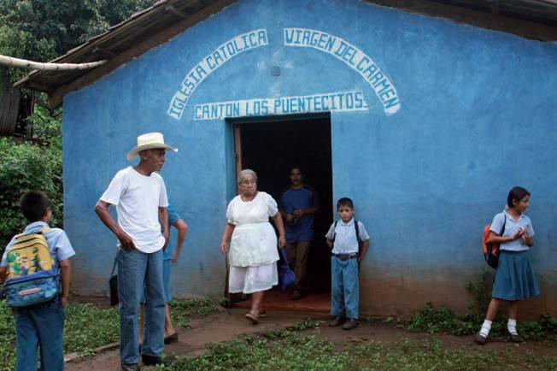
Look at places of worship around the world (see PowerPoint presentation on CAFOD website cafod.org.uk/comeandsee). You may wish to add a photograph of where the school community worships.

Ask the children to compare these places of worship with their own church buildings. Emphasise that that these buildings are for worshipping the same God.

SOME KEY QUESTIONS

- What do you notice about these places of worship?
- What is the same or different about them?
- Why do you think people like to go to special places to worship?
- What do you think makes somewhere holy?
- Have you ever been to Mass or church in a different country? What was it like?
- Have you ever been to a Mass not held in a church? What was it like?

SOME SUGGESTED ACTIVITIES

- Set up a special place of pilgrimage around the school hall or school grounds (similar to a treasure hunt). Children find cards (use images from previous PowerPoint presentations) with pictures of holy places of worship on them. Then, on an answer sheet, fill in what the place is, why it is special and for whom.
- Children to write about a place of worship that is special to them, giving reasons why they go to this place. Compare this place to another place of worship somewhere else in the world. Include what is different and similar about these places of worship.
- Create a special place of prayer in the classroom. Include global pictures/artefacts/symbols from around the world to remind us to pray for our global neighbours.
- With the children, create a special place of prayer outside, using various materials. In groups, children could create a design for a special place of prayer. The prayer area could include a prayer focus, prayer cards, candles and areas of quiet reflection for the children to spend some time being still and quiet with God.

LEARNING FOCUS 4: The world as a special place for the Christian community.

CONTENT

The World as a Special Place
Explain to the children that our world has been given to us by God, to enjoy, to share and to take care of.

Share the PowerPoint resource – The World as a Special Place (see cafod.org.uk/comeandsee) with the children. It contains the following scripture passage:

The earth is the Lord’s and everything in it,
the world, and all who live in it. Psalm 24

TEACHING POINT
Grace is the free gift of God’s love

SOME KEY QUESTIONS

- Why is God’s world so special?
- How can you help to keep it special?
- Why is it important for Christians to keep the world a special place?
- How are some people stopping certain places from being special?
- What can you do to change this?
- What ideas do you have for making your school, classroom, home and God’s world a place that is enjoyed, shared and cared for?

SOME SUGGESTED ACTIVITIES

- Look up the word ecology: it is about everything working in harmony, as God planned it. In groups produce some ideas for bringing more harmony into your school environment e.g. grow something to enjoy and share, tidy a messy area etc. Work out a plan and present it to the class for action and say why this is important for Christians.
- Hold a class debate, encouraging the children to think about and discuss a statement, such as “The World is ours – act now before it’s too late!” Debate for/against the statement. Draw out of the discussions why, as Christians, we act in certain ways.

LEARNING FOCUS 5: Respecting our world as a special place.

CONTENT

Take Action
Explore CAFOD’s Taking Action PowerPoint (see cafod.org.uk/comeandsee)

SOME KEY QUESTIONS

- Why are these people taking action?
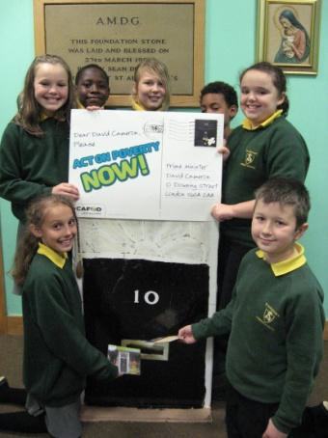
- Name some of the different ways these children are showing respect for God’s world.
- Why is it important to think about our brothers and sisters around the world?
- In what ways do people in some other parts of the world contribute to the way you live?
- In what ways can we and our families contribute to the way of life of people in other parts of the world?
- What action can you take to preserve God’s world as a special place?

SOME SUGGESTED ACTIVITIES

- Individually invite the children to complete the Taking Action worksheet based on the PowerPoint about different ways of taking action to respect God’s world (see cafod.org.uk/comeandsee). Children to describe the action being taken and why.
- Invite the children to work in groups to think of an issue that is spoiling our world (e.g. climate change, pollution). Together, encourage the children to agree what action they will take to improve the situation, because our world has been given to us by God, to enjoy, to share and to take care of. An example of an action might be to find out about recycling in the local area.
- Invite the children to write an acrostic poem using the letters of the words RESPECT at the start of each new line, linking this to how we look after God’s world. Write the poems on cut-out leaves (using recycled paper where possible) and attach all the leaves to the branches of a tree for a class display.
- For more activities relating to respecting our world, see CAFOD’s livesimply poster set (Go Green with CAFOD).

LEARNING FOCUS 6: We have a special place in our hearts where God dwells.

CONTENT

Share and discuss this line of scripture:

...the love of God has been poured into our hearts by the Holy Spirit. Romans 5:5

Explain to the children that God dwells in a special place in our hearts, and it is a special kind of prayer when we take time to think about God in our hearts. Wherever we pray, God has a special place in our hearts.

Show the PowerPoint of Rosena’s experience of God having a special place in her heart. (Available at cafod.org.uk/ comeandsee.) Explain that when things were difficult for Rosena, she could still feel God in her heart, and the Word of God kept her safe. Emphasise that God has a special place in our hearts in good times and difficult times.

SOME KEY QUESTIONS

- What was difficult for Rosena?
- Who helped her in the difficult times?
- What kind of things did Rosena do when she felt God close to her in her heart?
- What kind of things do you do that help you feel God close in your heart?
- What would you like to tell Rosena about the good times and difficult times in your life?

SOME SUGGESTED ACTIVITIES

- Pope Benedict spoke about ‘hearts speaking to hearts’.
Ask children what they think it means to be able to speak to God through their hearts and ask children to write a message to God on a heart template and take it home to keep.
- God is always in our hearts. Gather the children together for a quiet moment to recognise the times that they have been aware of God in their hearts, in good times and in difficult times.
- Invite children to think about what they would like to tell Rosena about the good times and difficult times in their lives. Record in an appropriate way e.g. interview one another with video, digital cameras and microphones.
- Invite the children to prepare a short prayer or to complete a paper heart template with an intention on it to place in the prayer focus area.
- After the activities pray this prayer together
God, thank you for having a special place in our hearts.
Help us to take time to be still,
To know that you are always there in good times
and difficult times.
Fill our hearts with your Holy Spirit.
Amen

RESPOND
Remembering, celebrating and responding to: everyone has a special
place and special places for Jesus and for the Christian community

Remember
Start the session with a moment of quiet reflection. Provide each child with the opportunity to engage with questions of meaning and purpose related to the experience of World.
Using the display, children may be able to recognise the following by use of discussion, role-play, drama, art, cue cards etc.

Ask the children if there is anything they wonder and ask questions about:
- How do places become special?
- What makes a place special?

Provide the opportunity, possibly by one of the means above, for the children to remember
- Where are special places for you?
- Where are the special places for your family?
- Where were the special places for Jesus?
- What does it mean to go on a pilgrimage and what effect does it have on a pilgrim?
- Why are Lourdes, Rome, Walsingham, St Winefride’s Well etc. special places for the Christian community?
- Why do Christians want to keep the world a special pace?
- How can you help to keep our world a special place?
- Why is our heart a special place?
- Where can we always find God?
- What did you learn from Rosena?

Rejoice

Remember to plan. (Download the Rejoice and Gather Form on the Come and See website.)

Renew
The teacher helps each child to make an individual response to what they have understood of their own experience and the experience of the Church community.

Apply their learning
How can you help to make the world a special place?

Some suggested ideas
After a time of quiet reflection and prayer, invite the children to think quietly about what they can do in the coming weeks to show how they and others are able to enjoy, to share and to take care of God’s world.

Teacher evaluation
This is ongoing and will inform future teaching and learning, which will include assessment for learning.

SUMMARY

Children will be able to ask and respond to questions about their own and others’ experiences of and feelings about special places and ask questions about what they and others wonder about special places and realise that some of these questions are difficult to answer.

They will be able to retell the stories about special places for Jesus and describe some ways in which religion is lived out by Christians in terms of pilgrimage and worship

Children will be able to make links to show how feelings and beliefs about special places affect their behaviour and that of others and compare their own and others’ ideas about questions relating to why some places are special that are difficult to answer.

Children will be able to use a developing religious vocabulary to give reasons why Christians go on pilgrimage and be able to give reasons why Christians should care about the world.

CHURCH TEACHING

This is an outline of the teaching of the Church covered in SPECIAL PLACES:
- The importance of places associated with the earthly life of Jesus.
- The place of pilgrimage in the Christian life.
- Conservation of Creation.
- The interdependence within Creation.
- Places set aside for worship; churches.
- Beginnings of an understanding of contemplative prayer.
- The social teaching of the Church: justice and solidarity.

