Fratelli Tutti animation script
KS1

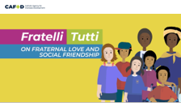 | Fratelli Tutti by Pope Francis.
 | Fratelli Tutti is a letter from Pope Francis about love and friendship. Fratelli Tutti means we are all brothers and sisters.
 | In the letter Pope Francis says that for many years we were all working together to build a happy and peaceful world.
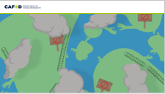 | But things are starting to go backwards.
 | We are not as close to others as we used to be.
 | It seems like we are putting walls between ourselves.
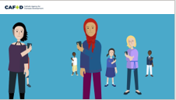 | And even though our world is more connected, we have stopped listening to one another.
 | Now it is time to dream a new dream.
 | A dream where we see everyone as part of our worldwide global family.
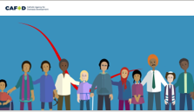 | Where we treat everyone like a sister or brother.
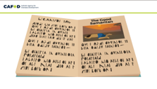 | Where we care for every man, woman, young and old the same way as the Good Samaritan did in the story Jesus told us.
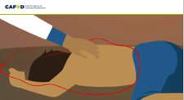 | There was a man on the road who was hurt. People walked past him and didn't help him. But the Good Samaritan did help the person, even though he didn't know him.  This kind of love is called Fraternal love.
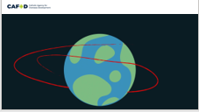 | Love reaches out and helps others in need, no matter where they are from.
 | We need to all act like the Good Samaritan and become good neighbours to everyone.
 | Fraternal love is loving others as if they were a brother or sister. This love brings us together.
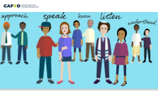 | Let us ask God to help us learn about other people. Let’s speak, listen and try to understand one another.  We cannot build this new dream alone; we need to dream together.
 | We need to work to help everyone.
 | And speak up for people who need our help.
 | We need to think of ourselves as a single family living in a common home.
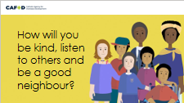 | How will you be kind, listen to others and be a good nieghbour?

