Feast of the Epiphany
liturgy
This short presentation is designed for a teacher or class to produce a liturgy or assembly to help young people reflect on the Feast of the Epiphany.

Themes: Epiphany
Countries of focus: Cambodia, Zimbabwe and Brazil
Materials Required: The accompanying PowerPoint, copies of the readings and prayers for the readers, the words of the hymns “The light of Christ” and “One bread, one body” (optional).
Time allocation: Assembly format, 10-20 minutes

Slide 1: Welcome
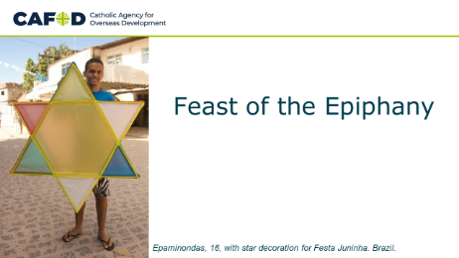
Leader: We gather as a community to continue our celebration of the birth of Jesus, the Light of the world, God’s gift of love to all. The name Jesus means ‘Saviour’.

Slide 2: The light has come
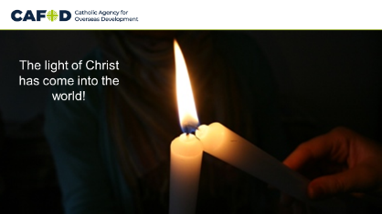
EITHER Reader 1 OR a group of young people announcing: The light has come to shine on all people throughout the world, to guide them to the new life offered by Jesus.

All: sing the chorus (x2)…
“The light of Christ has come into the world,
The light of Christ has come into the world.”

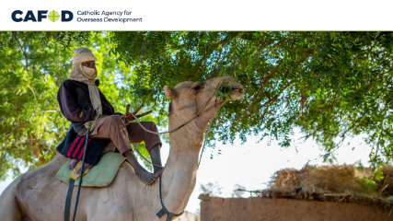
Slide 3: The visit of the wise men
Reader 2: In the gospel of Matthew, we hear the story of how some wise men from another part of the world were led by a star and travelled the long journey to Bethlehem, looking for Jesus. They found him in a stable.
Reader 3: “After Jesus had been born at Bethlehem in Judaea during the reign of King Herod, some wise men came to Jerusalem from the east... And suddenly the star they had seen rising went forward and halted over the place where the child was. The sight of the star filled them with delight, and going into the house they saw the child with his mother Mary, and falling to their knees they did him homage. Then, opening their treasures, they offered him gifts of gold, frankincense and myrrh.” (Matthew 2:1, 9-12)

Slide 4: This is a day of real celebration
Reader 4:
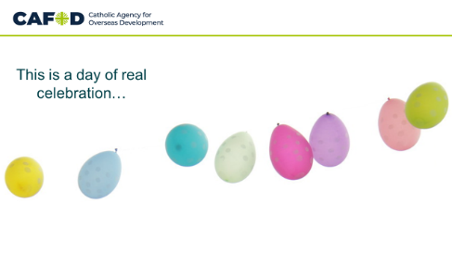
This day is a significant and important one
for people of every race and nationality,
because the wise men represent God’s people throughout the world.
The Son of God, the Word made flesh,
came into the world as a Jew, to give life and salvation to every member of the human race.
No matter what our race, nationality, colour or religion, each of us is made in the image and likeness of God.
For all of us, this is a day of real celebration – we, too, are chosen.

All: sing ‘One bread, one body…’ (Laudate 832)

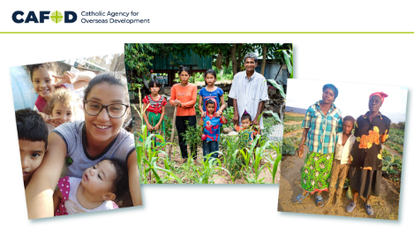
Slide 5: Children of God
Reader 5: CAFOD works alongside people of all faiths and none, recognising all people as our sisters and brothers, equal members of our global community. We are going to meet families in three countries of the world. Like all of us here, every one of these people is a child of God; and the Light of the World has shone for them too.
Let’s listen to their stories…

Slide 6: Story
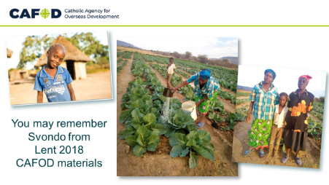
Reader 6: Svondo’s older brother had been undernourished. His mum, Marian, did not want the same to happen to Svondo. CAFOD worked with church organisation, Caritas Gokwe, to help them set up a gardening club to grow vegetables.
Last year, CAFOD revisited Svondo and Marian in Zimbabwe to find out how they were coping in the Covid-19 crisis.
They were doing well - their vegetable plot was thriving and they were able to live on the vegetables.
They were using a handwashing station and soap provided by Caritas, and taking turns to water the plants with other members of the gardening club.

Slide 7: Story
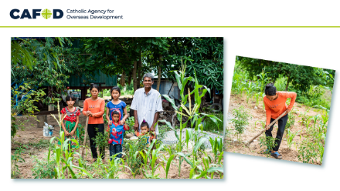
Reader 7: In Cambodia, Mr Sat Rot and his family were struggling financially due to the pandemic.
He said: “Since the global virus existed we started to have financial problems. It’s really affected us selling things. Nobody buys, even if we have goods to sell.‘
So, local experts, KBO, supported by CAFOD, gave the family emergency food and hygiene supplies, followed by five chickens and training in farming.
Now the family uses their training to grow vegetables that reduce their food expenses, as well as rearing chickens.
Mr Sat Rot says: 'Profound thanks …for the food and hygiene emergency supply.'

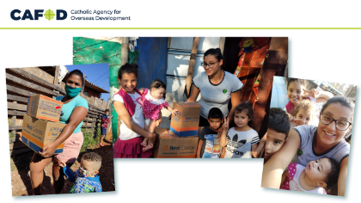
Slide 8: Story
Reader 8: These families in São Paulo, Brazil, were receiving food packages to help them through the coronavirus pandemic.
CAFOD worked with MDF (Movement in Defence of the Favelas), training local volunteers to safely give out food and hygiene kits in the favelas, the poorest parts of the city. The packages shown here were donated to MDF by the local council.
MDF ensured that help reached the families who needed it most - especially families with young children.

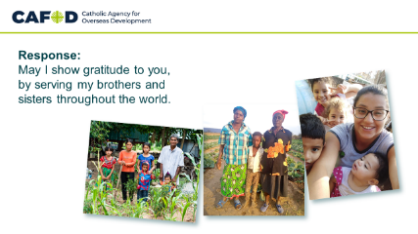
Slide 9: Let us pray
Reader 9: Let us pray. (Pause.)
Light of the world, let me see with your eyes, so that I may recognise your presence in every person of every race, nationality and colour.
We pray together:
All: May I show gratitude to you, by serving my brothers and sisters throughout the world.

Reader 10: Guide on our journey, help me to understand that, when I act justly and love tenderly, I am walking humbly with you. We pray together:
All: May I show gratitude to you, by serving my brothers and sisters throughout the world.

Reader 11: Light in our darkness, help me to realise that I have gifts to offer to you through your people every day, and these gifts are precious to you. We pray together:
All: May I show gratitude to you, by serving my brothers and sisters throughout the world.

Reader 12: Bringer of comfort, may I be a light for those whose lives I share; may my kindness and care bring courage and hope to those who are sad. We pray together:
All: May I show gratitude to you, by serving my brothers and sisters throughout the world.
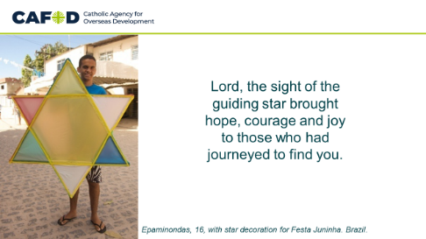
Slide 10: Final prayer
Leader:
Lord, the sight of the guiding star
brought hope, courage and joy
to those who had journeyed to find you.
When our journey seems long,
when hope seems far away,
when our courage is failing,
fill us with faith and trust;
shine your light on our fears,
lift our hearts with your joy.
Help us to recognise you
in our brothers and sisters throughout the world;
show us how we can work together,
so that we may all come to share in the life
promised to us by Jesus,
the Saviour of us all.
Amen.
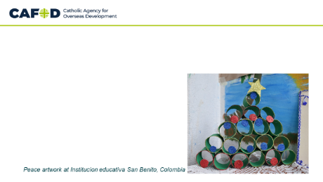
Slide 11: Closing screen

