World Gifts newsletter notice for Advent 2026

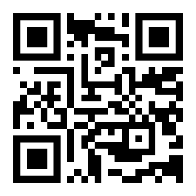
CAFOD World Gifts: Love your neighbour this Christmas
This Christmas, share the joy of Christmas with a CAFOD World Gift – from safe water to school supplies! A meaningful way to bless loved ones while putting your faith into action in solidarity with families around the world.
Collect a catalogue from church, call 0300 777 0030 or visit worldgifts.cafod.org.uk.

