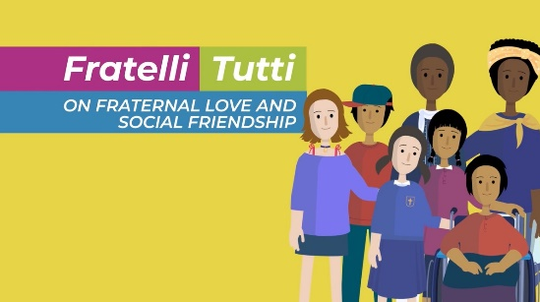
Fratelli Tutti animation script

Fratelli Tutti. Brothers and Sisters all - is a letter from Pope Francis urging us all to build a better world based on fraternal love.
In the letter he writes:
For years it seemed that we had learned a lesson from our many wars and disasters, and we were working together towards a shared dream for the future of our global family.
Overcoming divisions and working towards peace.
But we have allowed dark clouds to form over our shared dream, and things are now beginning to go backwards.
We are growing distant from one another, seeing others as competitors or enemies.
We are building a culture of walls; walls of the heart and walls on the land, that stop us from meeting with other people and other cultures.
And even though our world is becoming more connected, we have stopped listening to one another.
We interrupt and disagree with what others have to say, before they've even finished saying it; denying people the right to have a different opinion.
We have stopped seeing each other as sisters and brothers.
This is why a new way is needed.
It is time to dream a new dream.
A dream where we no longer see each other as competitors or enemies, but as part of a single global family.
Where we treat everyone as a sister or brother.
Fraternal love means caring for every man and woman, young and old, with the same care as the Good Samaritan, who refused to walk by and ignore the injured man as other people had done.
He saw the injured man not as an outsider, but instead as a brother.
Fraternal love goes beyond all boundaries, calling us to reach out, and to help others in need, no matter how far away they are, or which group of people they belong to.
We cannot ignore suffering; we cannot allow anyone to go through life as an outcast.
In the face of suffering, our only way forward is to act like the Good Samaritan. No longer asking ’who is my neighbour?’ but instead, becoming neighbours to all,
Bending down to touch and heal the wounds of others.
In the depths of every heart, love creates bonds and draws us out of ourselves, and towards others.
Fraternal love shatters the walls that keep us separate. In their place it builds bridges
and treats everyone as a neighbour.
Let us ask God to prepare our hearts to encounter our brothers and sisters. Let’s create a ‘culture of encounter’.
This means that we approach, speak, listen and come to know and understand one another, in all our diversity.
If we are to build a better world we cannot build this dream alone, we need to dream together.
To work for the good of everyone, respecting the human dignity of every person,
and changing the conditions that cause so much suffering.
We need to think of ourselves more and more as a single family living in a common home.
Each of us bringing the richness of our faiths and beliefs, each of us with our own voice, brothers and sisters all.
Signed, Pope Francis.

How will you put Fratelli Tutti into action by being a global neighbour?

