CAFOD’s Big Lent Walk!

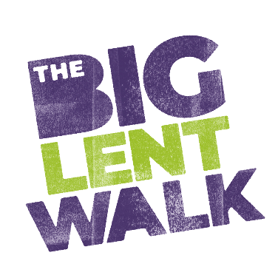
Dear parent

This Lent our schools is supporting CAFOD and joining other schools around the country to help fight poverty around the world.

To raise money, we’re going to [add in details of your Big Lent Walk event and link to your JustGiving page] on [date]

How our fundraising will help

CAFOD is the Catholic Agency for Overseas Development, working together with communities all over the world for an to end to extreme poverty and global injustice.

Our fundraising will help hardworking people like James the fisherman in Liberia to feed his family for good. James now has the tools and training he asked for to fish safely and sustainably. Compasses and GPS fish-tracking systems means he can find the best fishing spots and make his way home with an even bigger catch for his family.

We have chosen to support CAFOD as a way for our pupils to put their faith into action. By raising money together, we will be supporting our brothers and sisters around the world and living out our school mission.

Join as a family!

You can join the Big Lent Walk too! Why not visit JustGiving to sign up and take on the challenge as a family?

We really appreciate your support and hope that everyone has fun helping us raise money for CAFOD.

For more information about CAFOD please visit cafod.org.uk/families

Yours faithfully,

[Name]

