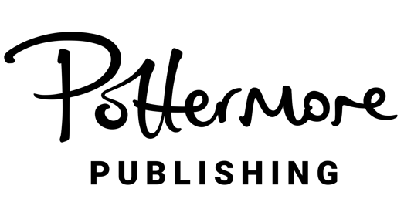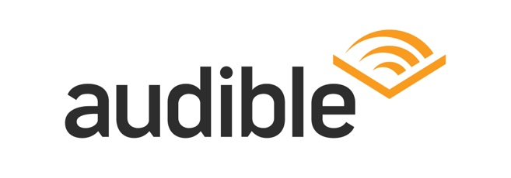
CONFIDENTIAL & EMBARGOED UNTIL WEDNESDAY, SEPTEMBER 10
6am PST / 9am EST / 2pm BST

POTTERMORE PUBLISHING AND AUDIBLE REVEAL ADDITIONAL
STAR-STUDDED CASTING FOR THE HIGHLY ANTICIPATED
HARRY POTTER: THE FULL-CAST AUDIO EDITIONS

The Powerhouse Ensemble of 200+ Performers to Include:

Kit Harington as Professor Lockhart,
Keira Knightley as Professor Umbridge,
Iwan Rheon as Professor Lupin,
Ruth Wilson as Bellatrix Lestrange,
Ambika Mod as Nymphadora Tonks,
Leo Woodall as Bill Weasley,
Simon Pegg as Arthur Weasley,
James McAvoy as Mad-Eye Moody,
Gemma Whelan as Professor Sprout,
and Matt Berry as Sir Cadogan

Harry Potter and the Sorcerer’s Stone to Debut
November 4, 2025 on Audible, Followed by Monthly Releases of Each Audiobook

Headshots Available HERE

LONDON / NEWARK – September 10, 2025 – Pottermore Publishing, the global digital Harry PotterTM publisher, and Audible, Inc., a leading creator and provider of premium audio storytelling, today announced additional casting in the powerhouse ensemble of more than 200 actors in Harry Potter: The Full Cast Audio Editions.

The newly announced casting of iconic roles includes Kit Harington as Professor Lockhart; Keira Knightley as Professor Umbridge; Iwan Rheon as Professor Lupin; Ruth Wilson as Bellatrix Lestrange; Ambika Mod as Nymphadora Tonks; Leo Woodall as Bill Weasley; Simon Pegg as Arthur Weasley; James McAvoy as Mad-Eye Moody; Gemma Whelan as Professor Sprout; and Matt Berry as Sir Cadogan.

James McAvoy said: “I am absolutely thrilled to bring the fiercely determined Mad-Eye Moody to life in these dynamic audio editions from Pottermore and Audible. He's a layered character, constantly shifting between battle-hardened intensity and unexpected moments of wisdom. Capturing his commanding presence was incredibly fun.”

Leo Woodall said: “In creating Bill Weasley's adventures through voice, it is genuinely special to be part of bringing this world to life in a new way for listeners. From the stellar cast to the immersive sound world that Pottermore and Audible have put together, listeners everywhere will be given a new way to be transported directly into these celebrated stories.”

This news builds upon previous casting announcements for Harry Potter: The Full-Cast Audio Editions, which included Cush Jumbo OBE as the narrator, Hugh Laurie as Albus Dumbledore, Matthew Macfadyen as Lord Voldemort, Riz Ahmed as Professor Snape, Michelle Gomez as Professor McGonagall, Mark Addy as Hagrid, Alex Hassell as Lucius Malfoy, Daniel Mays as Dobby, and Sara and Avni Deshmukh as The Patil Twins. Rising stars Frankie Treadaway, Max Lester, and Arabella Stanton will portray Harry Potter, Ron Weasley, and Hermione Granger respectively in audiobooks one, two and three. Jaxon Knopf, Rhys Mulligan, and Nina Barker-Francis will assume the roles of the beloved trio (Harry, Ron, and Hermione respectively) beginning in audiobook four and carrying through to the epic conclusion.

Additional cast members will be announced this fall. These brand-new productions of the original seven stories by J.K. Rowling will showcase the listening experiences as never heard before—offering immersive audio entertainment through high-quality sound design in Dolby Atmos, stunning scoring, captivating performances from A-list actors, original music, and real-world sound capture.

Following Harry Potter and the Sorcerer’s Stone releasing on November 4, 2025; Harry Potter and the Chamber of Secrets releases December 16, 2025; Harry Potter and the Prisoner of Azkaban releases January 13, 2026; Harry Potter and the Goblet of Fire releases February 10, 2026; Harry Potter and the Order of the Phoenix releases March 10, 2026; Harry Potter and the Half-Blood Prince releases April 14, 2026; culminating with the release of Harry Potter and the Deathly Hallows on May 12, 2026.

Harry Potter: The Full-Cast Audio Editions are available to pre-order now on Audible here.
ABOUT AUDIBLE, INC.
Audible, Inc., an Amazon.com, Inc. subsidiary (NASDAQ:AMZN), is the leading creator and provider of premium audio storytelling, offering global audiences a powerful way to enhance and enrich their lives through extraordinary content. Audible’s catalog includes more than 1,000,000 audio titles, including Audible Originals as well as audiobooks and podcasts from leading studios, print, audio and magazine publishers and world-renowned entertainers.
ABOUT POTTERMORE PUBLISHING
Pottermore Publishing is the global digital audiobook and eBook publisher of J.K. Rowling’s multi-million bestselling Harry Potter series and associated titles from the world of Harry Potter. Working with a global network of retail and library partners, Pottermore Publishing prioritises accessibility, creativity, and innovation as it brings these beloved stories to life for each generation of readers and listeners to discover.

MEDIA CONTACTS:

Jessica Shoffel
shoffel@audible.com

Camilla Mosley
cammosc@audible.co.uk

Keri Dizney
dizneykd@audible.com

Michael San Gabino
msangabi@audible.com

NOTES TO EDITORS:
These brand-new productions complement the iconic single-voice English language recordings by Jim Dale and Stephen Fry, which have delighted audiences since they were first released in 1999. They have been unprecedented in their popularity since launching on Audible in 2015, with 1.8 billion global listening hours now reached. They will still be available for listeners as classic editions.

The complete Harry Potter audiobook collection on Audible also includes The Tales of Beedle the Bard performed by Jason Isaacs, Warwick Davis, Jude Law, and a full cast, Quidditch Through the Ages performed by Andrew Lincoln, From the Wizarding Archive, featuring Evanna Lynch, Harry Potter: A History of Magic performed by Natalie Dormer, and Fantastic Beasts and Where to Find Them performed by Eddie Redmayne.

