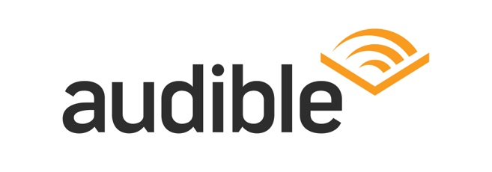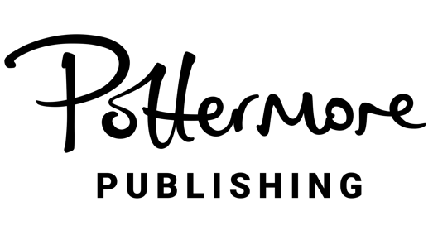

STRICTLY EMBARGOED UNTIL: 9am EST / 2pm GMT / 6am PST

FOR THE FIRST TIME EVER, ORIGINAL HARRY POTTER STORIES TO BE RELEASED AS FULL-CAST AUDIO PRODUCTIONS, EXCLUSIVELY ON AUDIBLE

All Seven Harry Potter Audiobooks Will Feature New Voice Casting with 100+ Performers, Original Scoring, and Immersive Sound Design in Dolby Atmos

To Date, Worldwide Audiences Have Consumed 1.4 Billion Hours of Harry Potter on Audible

Watch the Announcement Video HERE

LONDON / NEWARK – April 25, 2024 – Pottermore Publishing, the global digital Wizarding WorldTM publisher, and Audible Inc., the leading creator and provider of premium audio storytelling, today announced a brand-new co-production of the original Harry Potter stories, revisiting the beloved listening experience for the first time ever. Scheduled for late 2025, these full-cast audio productions will bring these iconic stories to life as never heard before, offering immersive audio entertainment through high-quality sound design in Dolby Atmos, stunning scoring, a full range of character voices, and real-world sound capture.

Each of the seven English language audiobooks will be released sequentially for a global audience, and will sit alongside and complement the iconic single-voice English language recordings by Jim Dale and Stephen Fry. The Harry Potter audiobooks were first published in 1999 and have been unprecedented in their popularity since they launched on Audible in 2015, with 1.4 billion global listening hours now reached.

Bob Carrigan, CEO of Audible, said: “Beloved the world over, Harry Potter stories have captivated and enchanted fans of all ages for nearly three decades. With millions upon millions of Audible listeners devouring Harry Potter at an astonishing rate, we are thrilled about the opportunity to be part of this next chapter – delighting new and old fans alike with a reinvigorated listening experience that Audible is expertly positioned to create.” Carrigan continued, “Together with Pottermore Publishing, best-in-class producers, and over one hundred actors, we will introduce a groundbreaking new soundscape for the Wizarding World, as well as performances that will inspire our listeners’ imaginations and redefine these quintessential characters for a new generation.”

Neil Blair, Chairman of Pottermore Publishing said: “We are delighted to be collaborating with Audible on what will be a ground-breaking audio edition of the beloved Harry Potter stories. J.K. Rowling’s storytelling lends itself perfectly to the application of new audiobook technologies, and we’re certain this sophisticated, immersive audio experience will not only add a new listening dimension for existing fans but will introduce a whole new generation of listeners to the wizarding world.”

The complete Harry Potter audiobook collection on Audible also includes The Tales of Beedle the Bard performed by Jude Law, Harry Potter: A History of Magic performed by Natalie Dormer, Fantastic Beasts and Where to Find Them performed by Eddie Redmayne, and Quidditch Through the Ages performed by Andrew Lincoln. Audible’s continued collaboration with Pottermore Publishing joins Audible’s production and development deals with top industry creatives such as President Barack Obama and Michelle Obama’s Higher Ground, Kerry Washington’s Simpson Street, Daniel Dae Kim’s 3AD Productions, Lorne Michaels’ Broadway Video Enterprises, and James Patterson Entertainment.

ABOUT AUDIBLE, INC.
Audible, Inc., an Amazon.com, Inc. subsidiary (NASDAQ:AMZN), is the leading creator and provider of premium audio storytelling, offering global audiences a powerful way to enhance and enrich their lives through extraordinary content. Audible’s catalog includes more than 900,000 audio titles, including Audible Originals as well as audiobooks and podcasts from leading studios, print, audio and magazine publishers and world-renowned entertainers.
ABOUT POTTERMORE PUBLISHING
Pottermore Publishing is the global digital audiobook and eBook publisher of J.K. Rowling’s multi-million bestselling Harry Potter series and associated titles from the Wizarding World. Working with a global network of retail and library partners, Pottermore Publishing prioritises accessibility, creativity, and innovation as it brings these beloved stories to life for each generation of readers and listeners to discover.

MEDIA CONTACTS:

Audible:
Jessica Shoffel
shoffel@audible.com

NOTES TO EDITORS:

- Announcement video: https://youtu.be/5UU6h3T3naY

- Further details about content and production, global release dates, voice casting, and how to access the audiobooks will be released later.

- The original, iconic Stephen Fry and Jim Dale English language audio recordings will continue to be available.

