**21 November 2024**

**Expanding our Purpose into Botswana – Singita Elela Lodge to Open in 2026**

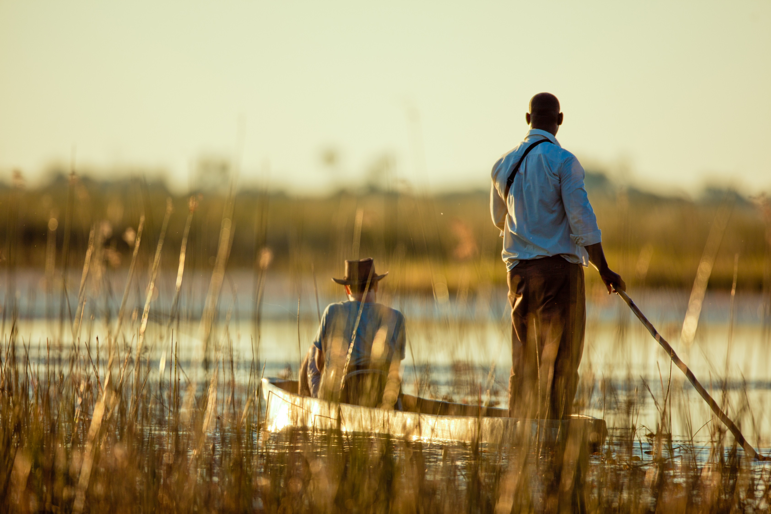

As our presence in Africa gradually and naturally grows, we are privileged to be expanding into Botswana’s Okavango Delta. Rich in life of every shape and form, this remarkable region was an intuitive extension of our 100-year purpose.

Our new lodge, Singita Elela, opening in 2026, will embody the Delta’s fluidity in all ways. Adapting as nature itself does, we are moving our design and guest experience forward in honour of this new region and its ever-evolving landscape.

**Elela** – meaning ‘to flow’ in Setswana – will celebrate the Delta’s essence of eternal cycles and continuity. A new lodge concept will echo this with an ease embedded into the design and experience it offers, which will place the spirit of this wonder-filled oasis at its centre.

Made up of ancient meandering waterways that fill when the rains arrive and recede as the seasons change, islands bursting with a myriad of species, and an ever-shifting patchwork of lagoons, grasslands and swamps, the Delta mirrors nature’s own ebb and flow. Its complexity and biodiversity are matched only by its beauty**.**

Unique to the Elela experience is a sense of unending vastness – while the Delta possesses an inherent sense of space, Singita guests will also have exclusive access to one of the largest concessions in the region – 170 000 hectares of pristine wilderness.

A year-round lodge, Elela will personify immersion. And while new to our family, it will be a natural continuation of all that Singita holds true.

[Contact Lisa Carey](https://url.za.m.mimecastprotect.com/s/eOaaC2RJ0JUk0MEQs8TAH5ihz3?domain=singita.cmail20.com), our PR Manager, for media enquiries or to stay updated as we approach our opening in 2026.

**Ends**

Note to Editors:

**Singita**

Singita is a conservation and ecotourism brand that has been helping to preserve Africa’s wildlife and wilderness for the past 30 years, offering guests exceptional safari experiences at 19 luxury, award-winning lodges, and camps across four countries. In partnership with non-profit Funds & Trusts which implement strategic conservation projects in each region, Singita’s 100-year purpose is to preserve and protect large parts of African wilderness for future generations. [www.singita.com](http://www.singita.com)

For reservations: +27 21 683 3424, [enquiries@singita.com](mailto:enquiries@singita.com)  
Press release issued by: Singita Public Relations  
Email: Lisa Carey lisa.c@singita.com