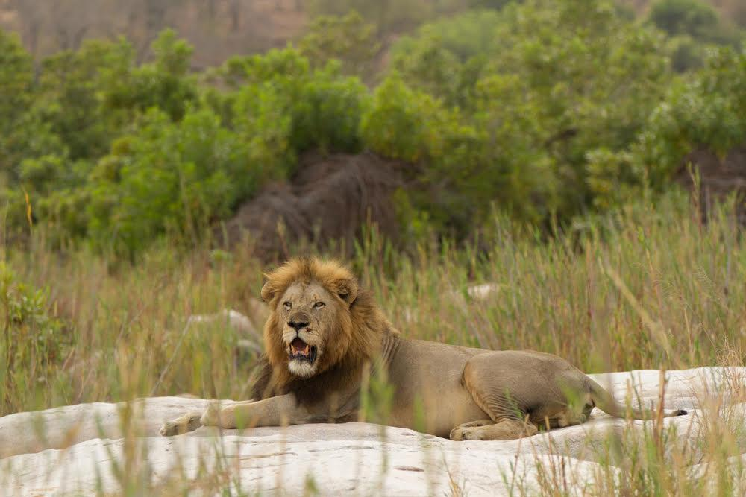

**WILDLIFE JOURNAL**

**SINGITA SABI SAND, SOUTH AFRICA**

**For the month of October, Two Thousand and Twenty-Four**

**Temperature Rainfall Recorded Sunrise & Sunset**

Average minimum: 17.3˚C (63.1˚F) For the month: 11.5mm Sunrise: 05:20

Minimum recorded: 12.0˚C (53.6˚F) Season to date: 11.5mm Sunset: 18:00

Average maximum: 30.1˚C (86.1˚F) (*Season = Oct to Sep)

Maximum recorded: 37.0˚C (98.6˚F)

October has been particularly dry, in comparison to the same time last year when we had already welcomed 51mm of rain. Everything then had significant greenery - a stark difference this year. Two dramatic thunder storms occurred, strong winds raced through the property, uprooting some trees. For the first time in a long time, we were not pointing any fingers at the elephants for the debris-packed roadblocks! Another storm had guides returning back to the lodges, ominous clouds grew and a lightning display of note was followed by some golf ball-size hail! The weather was almost as dramatic as the wildlife, and it certainly was rejuvenating. The Sand River continues to flow, albeit a trickle, and has a lot of the larger mammals coming to seek not only a drink, but also refuge from the heat. We look forward to what November has in store for us.

**Here is a recap of our wildlife viewing for October:**

**Cheetahs**

* We continue to pinch ourselves on almost a daily basis with the occurrence of the female cheetah and her three cubs! This Makatini female continues to raise her three cubs in the southern parts of the reserve. She’s a phenomenal mother, hunting successfully most days and even twice a day on some occasions. On two occasions a male has been seen with her and the cubs. He is the same male cheetah we see every so often in a similar area in the south of the reserve.

**Leopards**

* The Nkuwa female leopard has again been seen with the Thamba male leopard in the near proximity of the lodges. This would be the second time in almost a month that we’ve seen the two of them together mating. Fingers crossed in a couple of months we’ll have some new spotty faces on the reserve!
* Thamba male leopard, shortly after having been seen with Nkuwa, was found having a territorial dispute with the Ravenscourt male leopard. Thamba was being pushed further east by Ravenscourt, perhaps a shift in dominance between the two?
* We have been seeing Nkuwa’s 2:2 young male fairly regularly all over, his slightly bigger brother was last seen in the very far eastern parts of the Sabi Sands, perhaps a little braver venturing further afield into unchartered territory.
* The Hlambela male leopard is seen more often by the staff at the lodges from the comfort of the overlooking decks as he patrols the northern bank of the Sand River.

**Lions**

* The Tsalala lioness has been through a rough period. There have been occasions where she has been seen with her cubs retreating to safety from the Nkuhuma sub-adults. At one sighting there was a carcass that distracted the sub-adults and she managed to get the cubs to safety. Unfortunately, she was recently seen on her own contact calling, with no cubs. We don’t want to assume the worst but we hope all the little ones are alright.
* The Ximungwe Pride have been seen again in the western parts as well as the far north-western reaches of the reserve. They, together with the Plains Camp male lions were in the Sand River feeding on a buffalo towards the end of the month.
* The Mhangeni Pride have been scarce of late. They’ve been frequenting the western sector of the Sabi Sand and have had altercations with the Ximungwe Pride, resulting in them only having six youngsters between the three adult females.

**African wild dogs**

* The Othawa Pack have been seen a lot of late, every so often encouraging a resident leopard into the nearest tree for safety! Their Beta female left the pack and has now joined a pack with two males who were previously denning in Dudley (several articles were written about them because their puppies were commandeered by the Toulon Pack earlier this year). There was a recent sighting of them interacting with a crash of seven white rhinos at one of the waterholes.

**Elephants**

* The elephant herds have been cashing in on the debris that has fallen from the thunderstorms! We have been fortunate to observe particularly large of herds of elephants throughout the property over the month of October. The larger pachyderms provide us with endless entertainment on the warmer afternoons down at the river.

**Buffalos**

* The large herd of buffalos continue to pass through the property, north and south of the river. Always quite the show when the 1 000+ buffalo come down to drink at one of the waterholes during morning game drive!

**Birds**

* Two new birds for the month include the marsh owl and the yellow-bellied eremomela taking our tally to 290 birds for the year. The violet-backed starling, red-chested cuckoo and the Jacobin cuckoo have all once again been seen and heard back in the Sabi Sand.

**Unusual sightings**

* We again had one pangolin sighting which the majority of the guests with us were fortunate to witness.
* On drive in the south of the reserve, the Othawa Pack of wild dogs caught an impala, only to be chased off by elephants. The dogs, in turn, ran off flushing the Makatini female cheetah and her cubs off their kill not far from their position! When the dust settled, the large herd of over 1 000 buffalo chased the dogs off their stolen kill!

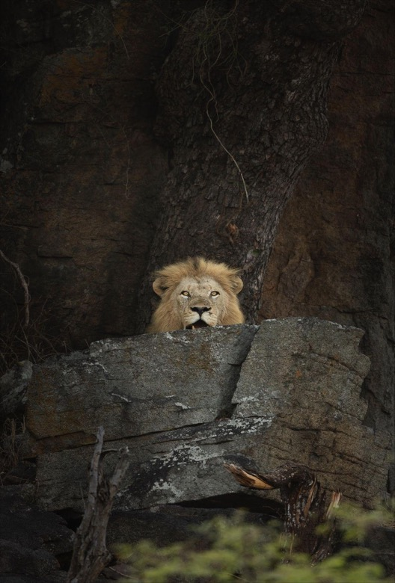

A Plains Camp male lion up in the koppies! Image by Andrew Taylor.

**Some bush stories follow, as well as the October Gallery of images.**

**The giant plated lizard *(Gerrhosaurus validus)*  Article by Luke Abbot**

Imagine walking through the bush and bumping into a creature that looks like it’s wearing an iron vest straight out of a medieval cosplay convention? Enter: The giant plated lizard! This lizard is basically the Knight of the Reptilian Round Table, if the knights were more into sunbathing and snacking than jousting.

These lizards aren’t called “plated” for nothing. Their scales look like someone glued armour plates all over them - practical for a lizard trying to survive in a neighbourhood full of larger, toothier carnivores. When in danger, this lizard doesn’t panic and sprint away like a clumsy track star; it dramatically wedges itself into cracks or burrows and dares its enemies to do their worst. You want to eat me? Come peel this living tank out of its hiding place! Spoiler alert: predators usually give up.

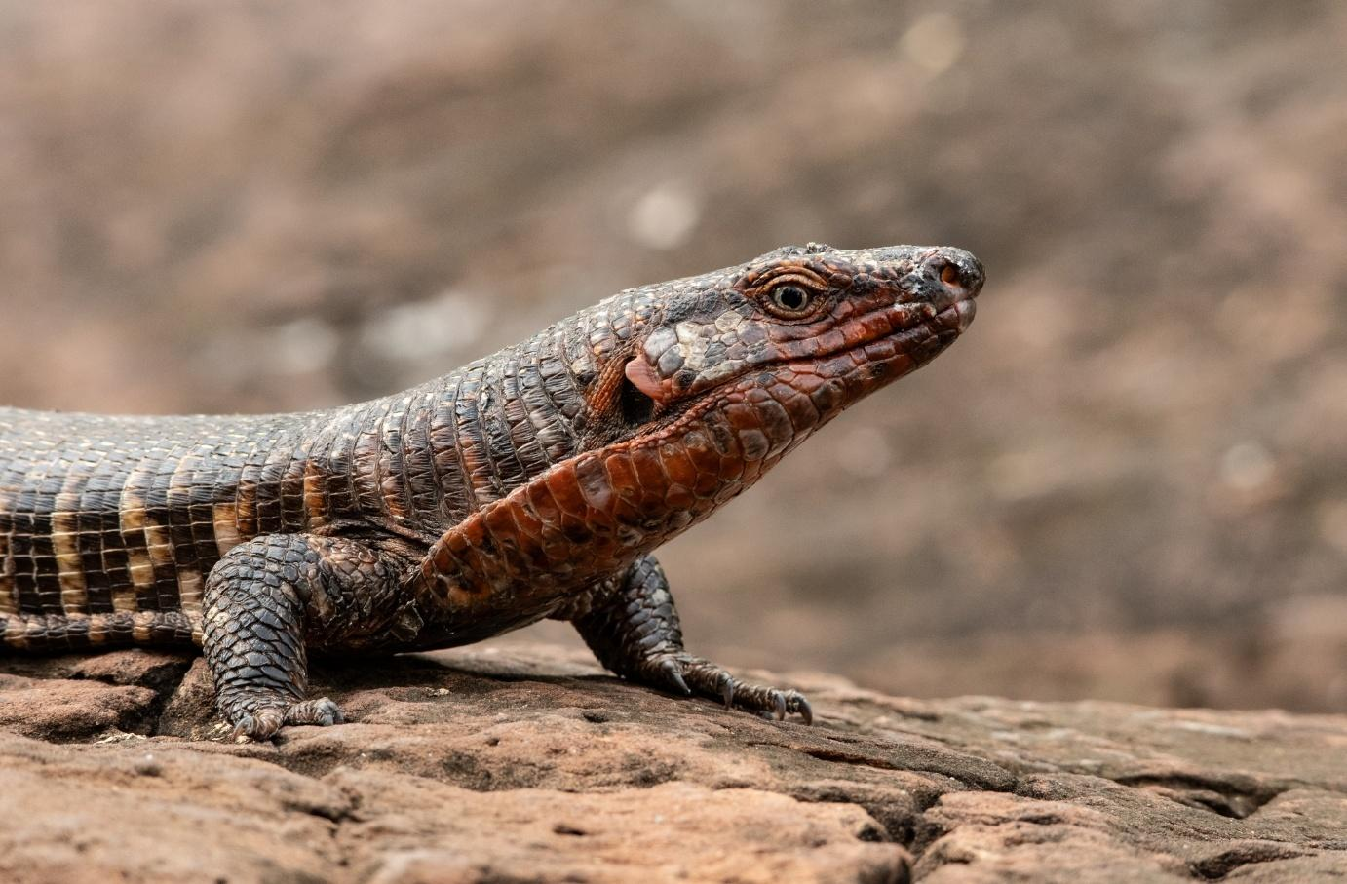

The giant plated lizard isn’t winning any beauty contests, but hey, beauty is subjective. These guys are around half a metre long (2 feet) with a mix of rusty red, black, and sometimes a sassy yellow hue. It’s like they walked through a DIY paint shop blindfolded, but somehow it works.

Their tails are like thick clubs. You almost want them to use it as a weapon, like the reptile version of Thor’s hammer, but no - plated lizards aren’t out here fighting anyone. They prefer the “sit back, soak up the sun, and snack on bugs” lifestyle. Living their best life, really.

When it comes to social skills, the giant plated lizard is… let’s say an introvert. These lizards live in small groups, but they’re not exactly throwing wild lizard parties. Think more like a family reunion where everyone’s on their phones or hiding in their rooms. They only come out to eat or enjoy some good old Vitamin D. Relatable, right?

Despite their warrior look, these lizards are softies when it comes to food. They eat bugs, fruits, and flowers, making them the vegans of the lizard world—if vegans sometimes ate bugs. But here’s the weird part: they’ll occasionally munch on their own shed skin. Why? Who knows? Maybe it’s like their version of comfort food or some weird lizard detox trend.

In the end, the giant plated lizard is like that chill dude in your friend group who’s always unbothered, minding their own business. They don’t go out looking for trouble, they just want to bask in the sun and enjoy a nice crunchy beetle from time to time.

So, the next time you’re in the bush, keep an eye out for these armoured sunbathers. Just don’t expect them to sign autographs. They’re kind of shy.

**Piglet owls: owls and owlets Article by Lucy Stofberg**

Recently, a guest was explaining that they had found a “piglet owl” in their barn back home, claiming it was one of the smallest species of owls in the world. This really caught my attention and imagination - until he corrected himself to the name “pygmy owl.”

The pearl-spotted owlet *(Glaucidium perlatum)* we had just seen in the Sabi Sand looked quite similar to the pygmy owl he described, so we decided to take a closer look at these little owls.

Interestingly, both owlets and pygmy owls belong to the same genus, *Glaucidium*. These small owls primarily prey on small vertebrates and insects, with around 35 species within the *Glaucidium* genus.

The species found in Africa and Southeast Asia are referred to as owlets, while those found in North or South America are called pygmy owls. Despite their different names and locations, these species share several common characteristics: they are small owls with rounded heads, no ear tufts, yellow eyes, and most display a prominent brow.

While *Glaucidium* is a stronghold for small owls, neither the smallest owl in the world nor the smallest owl in Africa belongs to this genus.

The smallest owl in Africa is the African scops owl *(Otus senegalensis)* measuring about 15-17 cm tall and weighing 50-90 grams. Unlike the mostly diurnal owlets, the nocturnal scops have erectile ear tufts and shorter, rounder wings.

The title of the smallest owl species in the world goes to the elf owl, which measures between 12.5 and 14.5 cm. While pygmy owls are similar in size, they have longer tails and distinctive streaks on their underparts, with white, not gold, spotting on their crowns.

Despite my disappointment that they weren't actually called “piglet owls,” this exploration into the world of small owls has sparked a deeper appreciation for their diversity and charm. It's a reminder that nature is full of wonders, waiting to be discovered and celebrated - sometimes even through a delightful miscommunication.

**A long wait for the rain Article Coman Mnisi**

In the last rainy season, we did not receive the amount of rain we expected. Rivers did pick up but not to the extent where they flood for about three weeks to a month. Vegetation was low considering the number of animals that graze and browse. This whole situation led to a quick shortage of grass as areas that had good vegetation attracted lots of grazers.

The animals lost condition drastically by the end of August because of lack of nutrients. There was a serious feeding pressure in places such as riverbeds and along riverbanks because all animals would go there to feed, and by the end of September there was almost nothing for the animals to feed on.

In the months of September malnutrition was a reality for some species. I watched two different prides of lions start hunting zebra and kudu because the ungulates became so weak. Three weeks ago, we saw the Shish Pride feed on a zebra and two hours later, on their way down to the river to drink, they came across another zebra and killed it because it wasn’t showing any strength. In this cycle of life it's the carnivores that are currently thriving.

We were thankful for the 11.5 mm that October brought, but if the tides are to turn we need a significant amount of sustained rain to sink into this parched earth.

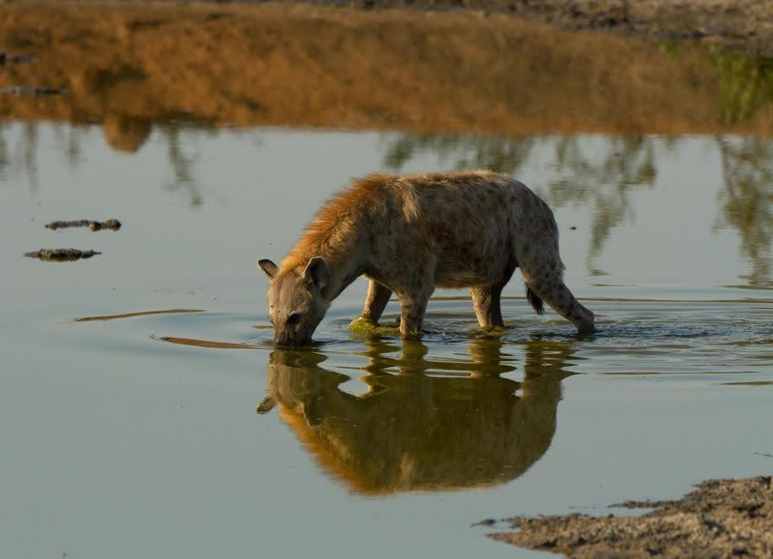

A spotted hyena enjoying a precious resource of water. Image by Marc Eschenlohr.

**October Gallery**

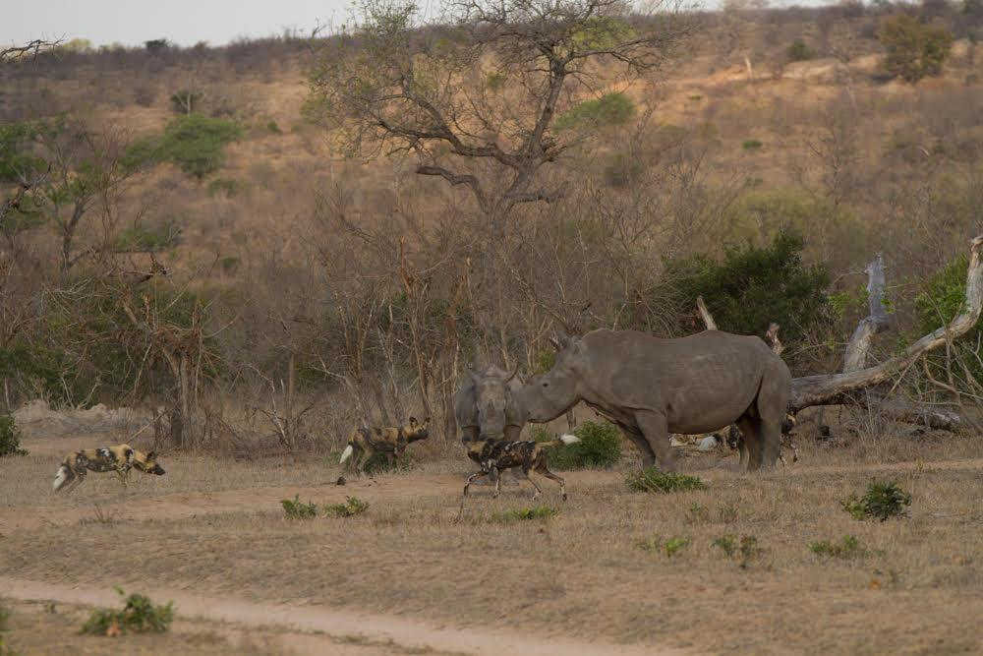

A critically endangered encounter! Image by Marc Eschenlohr.

A white rhino calf - image by Andrew Taylor. African wild dog portrait - images by Marc Eschenlohr.

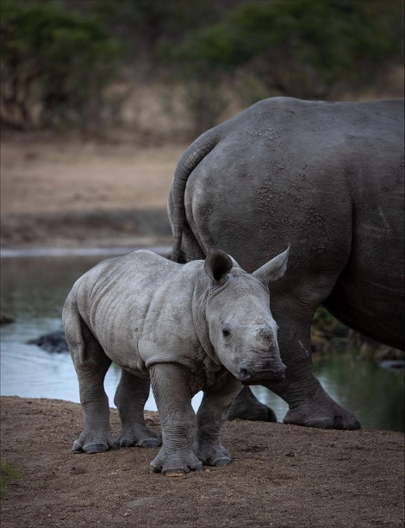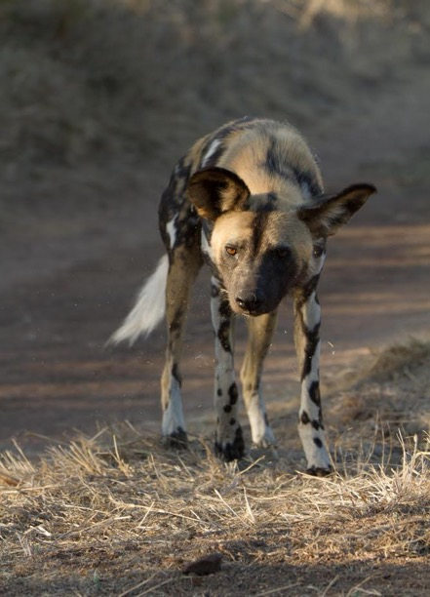

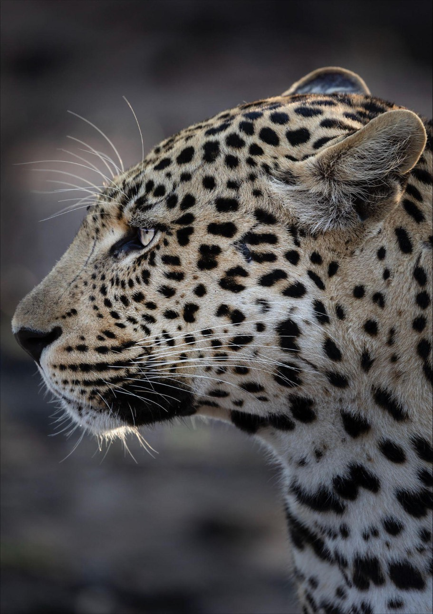

The Ntomi male leopard portrait. Image by Andrew Taylor.

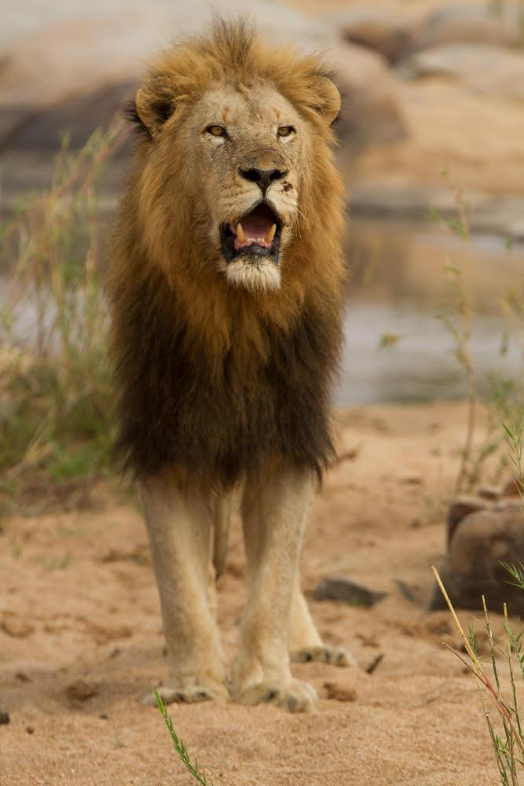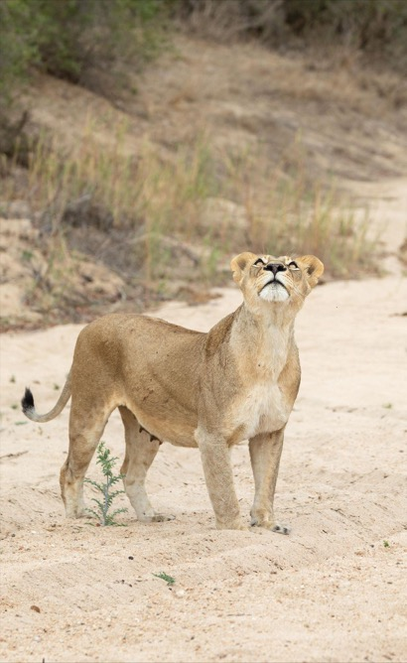

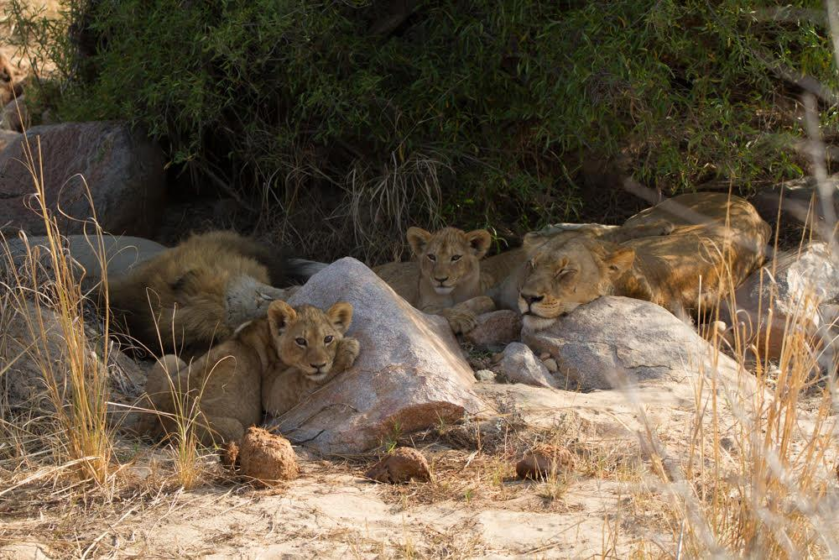

The Tsalala lioness watches as vultures soar above. Image by Andrew Taylor.

A Plains Camp male lion. The Tsalala Pride resting during the heat of the day. Images by Marc Eschenlohr.

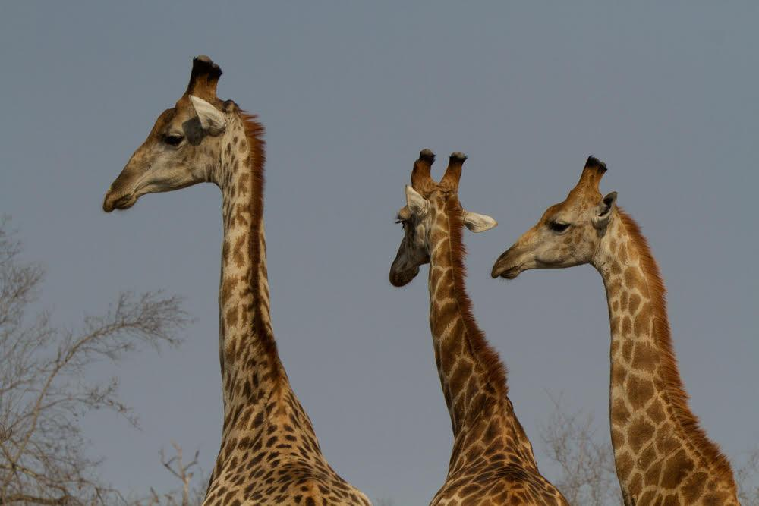

A tower, standing tall.

All smiles with Musa Mayindi. Images by Marc Eschenlohr.

