**24 December 2024**

**Singita introduces Kilima – the quintessential African home**

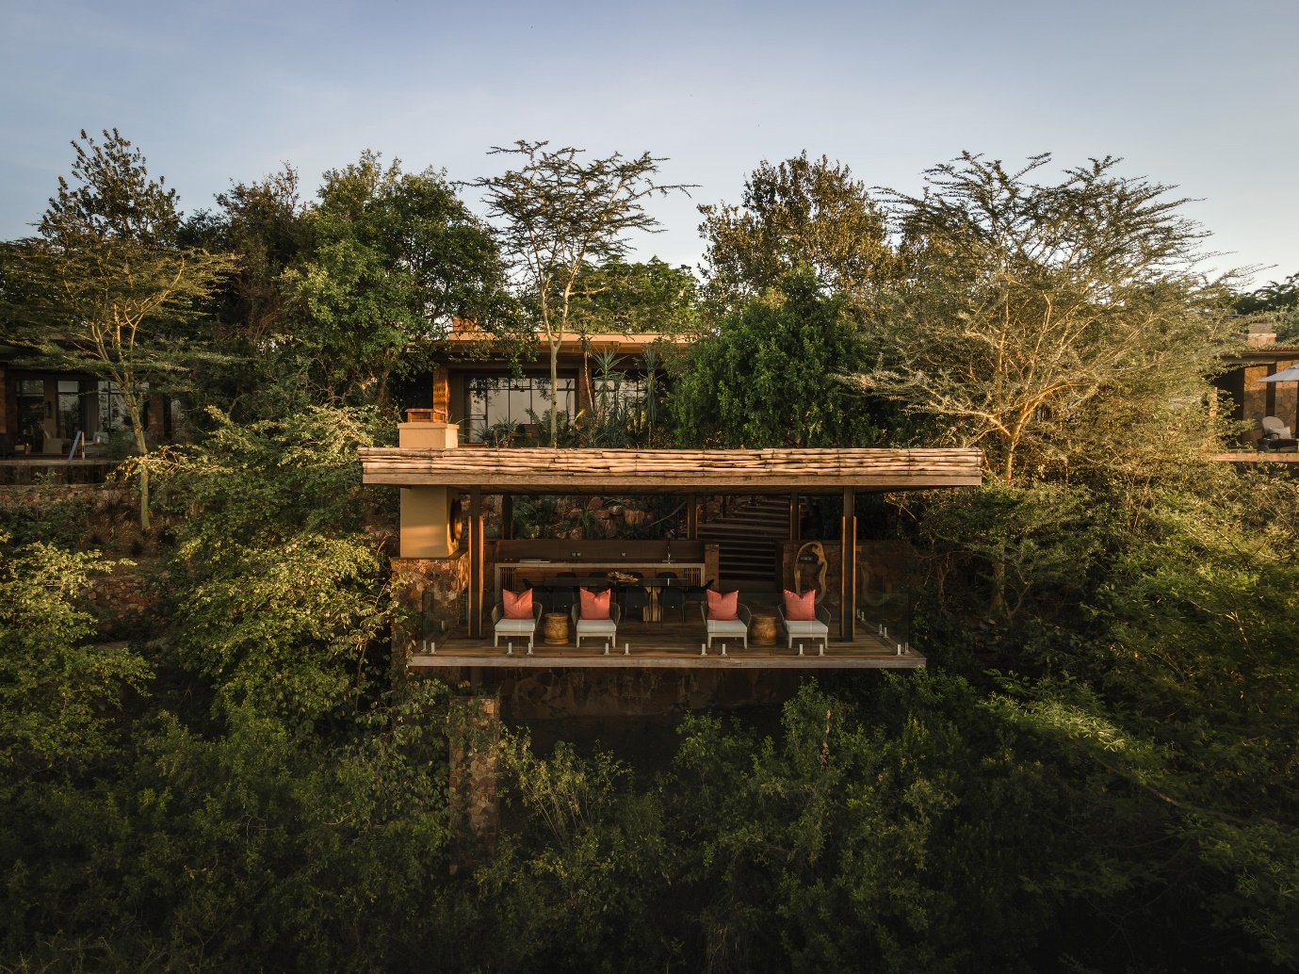

Singita has added another unique property to its Private Villa Collection in Singita Grumeti – one of the most private and peaceful wilderness destinations in Africa. An exclusive-use home, Singita Kilima is a sanctuary that blends experiences that connect guests to nature with the highest level of design and comfort.

A five-suite home located on the side of a hill in the Serengeti, this tranquil retreat is sheltered by ancient trees, and also offers sweeping views of the plains. Spacious living spaces – indoors and out – are conducive to seamless, relaxed gatherings of friends and family.

Surrounded by a lush and established garden filled with precious protected cycads, the villa is enveloped by its surroundings and has the serenity that can only come from a full immersion in nature. Inside, a warm, earthy palette and vibrant patterns converge in comforting but curated spaces that flow intuitively. Natural textures and abundant light create a continuous connection with the villa’s natural setting. While sophisticated, the home’s welcoming feel is courtesy of its eclectic and carefully chosen pieces, which have been layered consciously to create a sense of effortless elegance.

Honouring contemporary African design, art and craftsmanship, the home is simultaneously vibrant and calming. Its spaces invite relaxation as naturally as they do joyful celebration. Here, the pace of living is slow and moves in step with the day. Surrounded by nature, you can witness its miracles unfolding in front of you while dining alfresco, relaxing by the rim-flow pool or watching wildlife in action on the plains below. When occasion calls for it, retreat indoors to the cinema room or fitness centre or unwind enjoying the wellness treatments on offer. Or simply page through one of the many books throughout the villa.

With the same attention to detail you’ll find at any of its properties and a warm and attentive team, Kilima combines the comforts of home with Singita’s commitment to creating an elevated service experience. Dedicated Housekeeping and a private Chef and Field Guide will ensure guests have every freedom to design their stay around the group’s unique interests and needs.

Activities range from exclusive daily game drives and guided walking safaris to tailormade community visits in the concession to experience the work of the Grumeti Fund – Singita’s non-profit conservation partner in Tanzania.

Set in 350,000 acres of pristine land in the sought-after Singita Grumeti in northern Tanzania, this home will offer guests exclusive access to this immense private wilderness and the Great Migration.

Children of all ages are welcome at Singita Kilima. Singita Grumeti’s private landing strip is just a 10-minute drive away, meaning guests will be able to access this rare retreat with ease.

*\* Rates from US $27 300 per night (for up to 10 guests).*

**Ends**

Note to Editors:

**Singita**

Singita is a conservation and ecotourism brand that has been helping to preserve Africa’s wildlife and wilderness for the past 31 years, offering guests exceptional safari experiences at 19 luxury, award-winning lodges, villas and camps across four countries. In partnership with non-profit Funds & Trusts which implement strategic conservation projects in each region, Singita’s 100-year purpose is to preserve and protect large parts of African wilderness for future generations. [www.singita.com](http://www.singita.com)

For reservations: +27 21 683 3424, [enquiries@singita.com](mailto:enquiries@singita.com)  
Press release issued by: Singita Public Relations  
Email: Lisa Carey lisa.c@singita.com