4 February 2025

**Entries open for the second Wagora Bike Ride – raising funds to fight poaching in the Serengeti**

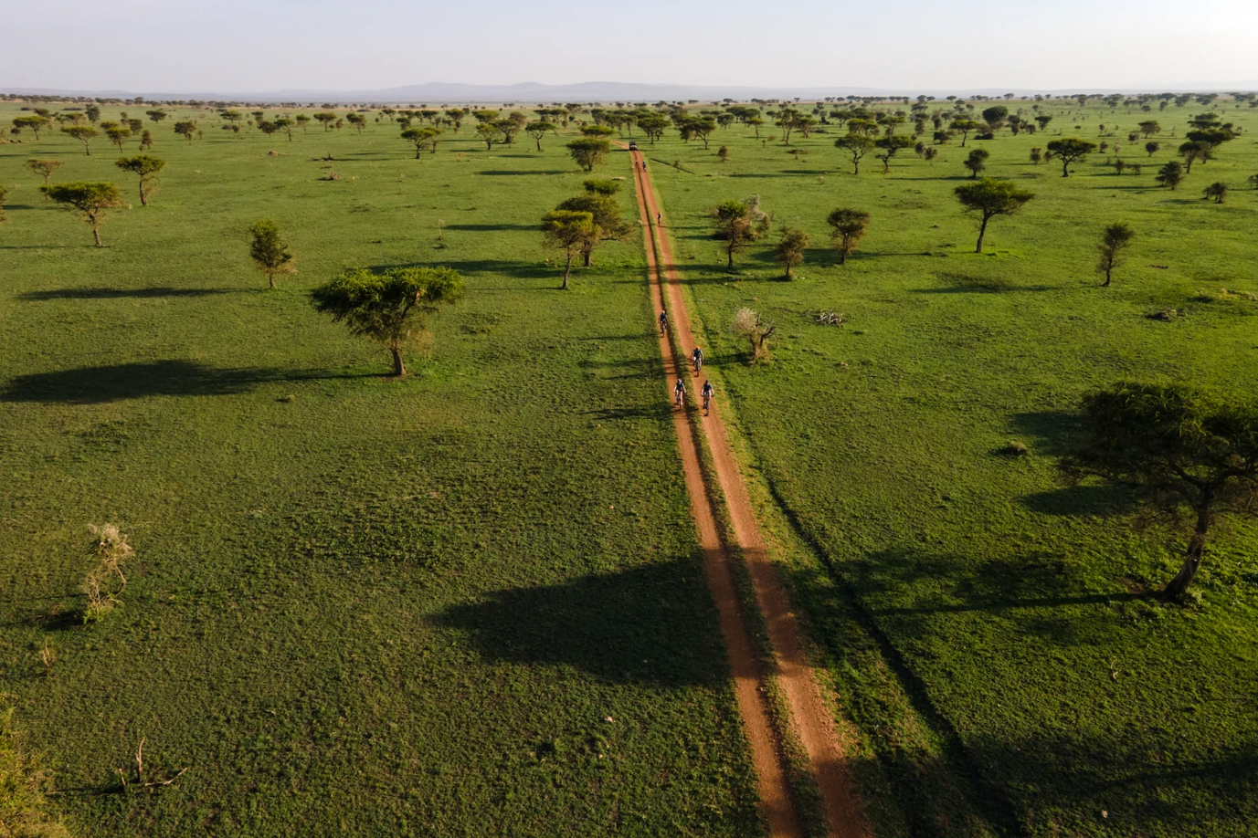

Singita and Grumeti Fund, its conservation partner in Tanzania, have partnered to create the second Wagora Bike Ride, an adventure across the Singita Grumeti reserve in Tanzania, from 27 October to 1 November 2025. A group of up to 18 riders from around the world will experience the Wagora Ride this year. This event is a life-changing opportunity for bike enthusiasts to come together in the Serengeti to ride in support of the Grumeti Fund’s anti-poaching scouts.

The name of the ride pays tribute to Kitaboka Wagora, an anti-poaching scout who was tragically killed by a poacher while on patrol in 2008. His memory continues to inspire others to follow a path of courage and commitment to protect Africa’s wild places for future generations.

This event traverses approximately 150 kilometres over three days through the western corridor of the Serengeti. Endless views and exciting animal sightings are part of the journey, while Grumeti Fund’s Scouts and support vehicles accompany riders for their safety and comfort. The route comprises flat, dirt, gravel, and sand roads with some single-track off-road trails, and no advanced experience is needed to take part.

Participants will stay at Singita Sabora Tented Camp for five nights. This timelessly elegant tented camp epitomises modern safari under canvas, and its airy, calming spaces are the ideal resting place for riders to relax and relive the adventures of the day.

During downtime, participants can visit some of the Grumeti Fund’s facilities, including the Research and Innovation for the Serengeti Ecosystem Centre (RISE) to learn more about the Grumeti Fund’s active conservation efforts. They will also visit to the Joint Operations Centre (JOC), where participants will gain insights about site operations and meet the anti-poaching scouts, dogs and handlers of the canine unit and go on game drives.

All funds raised will go towards supporting the ongoing efforts of the Anti-Poaching unit of Grumeti Fund which works tirelessly to help protect the wildlife here. The donation portion will help fund scout training; equipment; hiring more rangers to patrol the land; and support the training and upkeep of the canine unit and special teams.

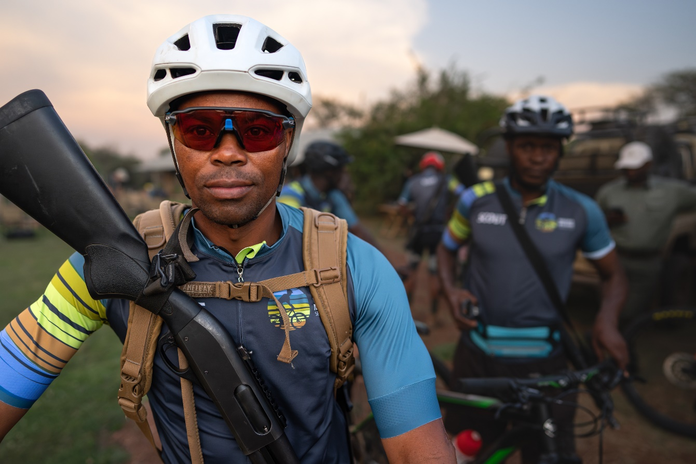

**Riding for a Reason**

The Wagora MTB Ride is not a race, but rather an opportunity to experience the magnificent landscapes of the Serengeti from a unique perspective. Each day starts at sunrise, with a variable route that starts and ends at Singita Sabora.

In addition to armed Anti-Poaching Scouts, there will also be a bike mechanic, who can assist with basic repairs if needed.

This unforgettable experience is US$ 9,150 per person (single) or US$ 6,450 per person (sharing) for an all-inclusive five-night package, including return flights on Grumeti Air from Kilimanjaro International Airport to Singita Grumeti. An additional US tax-deductible donation is paid to the Grumeti Fund – US$ 17,000 per single or US$ 10,000 per person (sharing) – to be used to fight illegal poaching.

Entries are on a first come, first served basis. All solo riders must be 18+ years old (16- and 17-year-old riders will also be permitted if they are accompanied by a parent or guardian). The deadline for payments is 30 June 2025.

The second Wagora Ride follows the incredible success of the Serengeti Girls Run, held every year in support of the Grumeti Fund’s women empowerment projects. For more information, the itinerary and T&Cs, visit: <https://singita.com/conservation/projects/wagora-mtb-ride/>. To secure your space, email Stephanie Schwatlo: Stephanie.S@singita.com.

Ends

Notes to Editors

**About Singita**

Singita is a conservation and ecotourism brand that has been working to preserve Africa’s wildlife and wilderness for the past 31 years, offering guests exceptional safari experiences at 19 luxury, award-winning lodges, and camps across four countries. In partnership with non-profit Funds & Trusts who implement strategic conservation projects in each region, Singita’s 100-year purpose is to preserve and protect large parts of African wilderness for future generations. www.singita.com

**About Grumeti Fund**

The Grumeti Fund is a non-profit organization carrying out wildlife conservation and community development work in the western corridor of the Serengeti ecosystem in Tanzania. Their vision is a world in which people and wildlife live together sustainably, forever. Today dedicated staff help to protect, manage, and monitor the Grumeti concession where the near-barren plains of 22 years ago teem with wildlife once more. www.grumetifund.org.

 Press release issued by: Singita Public Relations Email: Lisa.C@singita.com