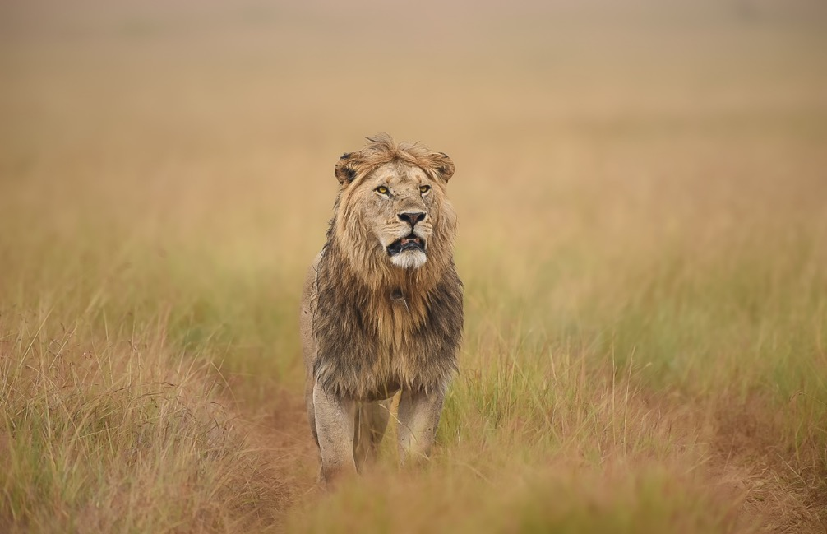

**WILDLIFE REPORT**

**SINGITA GRUMETI & LAMAI, TANZANIA**

**For the month of September, Two Thousand and Twenty-Four**

**Temperature Rainfall Recorded Sunrise & Sunset**

Average minimum: 16°C (60.8°F) Grumeti 212mm Sunrise 06:49

Average maximum: 30°C (86.0°F) Lamai 45 mm Sunset 18:48

Minimum recorded: 15°C (59.0°F)

Maximum recorded: 32°C (89.6°F)

September has been a relatively dry month with only one large 30mm soaking at the very end of the month. The Grumeti River still flows with the level being low, but is still providing drinking water for elephants and other herds of buffaloes and zebras.

Huge numbers of wildebeest are coming back onto the property coming from the north (Lamai and Kogatende). As they head south-west deep into Serengeti National Park we have seen fantastic plains wildlife in general across the reserve. Many thousands of zebras continue to roam the Grumeti Reserve, lovely gazelle numbers, giraffe and eland.

The scorched ground from a fire has started sending up new shoots that attract gazelles in good number as well as zebras and topi.

**Here’s a sightings snapshot for September:**

**Lions:**

Lion sightings this month have been nothing short of awesome! We have had some great viewing of different lion interaction on the property.

* The once shy Momukomule Pride are now fully relaxing with the presence of game viewers and establishing themselves with confidence a short distance away from the north-eastern side of the hill, on the drainage. The pride is getting bigger with nine cubs of different age.
* The Butamtam Pride have been observed this month in the Koroya Hill region, further south towards Chui drainage and the Pundamilia acacia woodlands.
* The lions have fed well with the great number of zebras in the property which make the change of feeding dynamics from mainly buffaloes to zebras and wildebeest.
* Nyasirori Pride continue to be seen south of Sabora plains offering some relaxed sightings close to Sabora camp.
* Ridge Pride has moved to the ridge hills and Sabora plains where they been spending most of their time.

**Leopards:**

Leopard sightings this month have been great.

* The Mbogo drainage female has been seen more frequently around Faru Faru Lodge, and south of the lodge.
* The Serengeti Hill male leopard was seen on the scrapes and at Serengeti Hill.
* The Grumeti North male was seen on several occasions at Grumeti North drainage.
* A shy male has been seen frequently along the Grumeti River at German Bridge area.
* The Momukomule male has been seen east and south of Sasakwa Hill.

**Cheetahs:**

* Cheetahs have started to establish themselves on the property with the returning of their favourite prey species which are Thomson’s and Grant gazelles.
* The resident male has been seen between Sasakwa plains and Sabora plains.
* A female has been seen at Kawanga plains.
* A female has been seen close to Sabora Tented Camp.

**Elephants:**

* We have seen incredible numbers strolling around Sasakwa plains and Sasakwa Dam, drinking and bathing.
* Aggregations of breeding herds have been seen up to 100 strong in the eastern regions of Ikorongo and in the western woodlands.
* Good breeding herds seen in the Triangle and Romoti.

**Buffalos:**

Fantastic buffalo numbers seen all over the reserve!

* A lovely sighting of herds of 300 scattered in different areas of Ikorongo.
* Seeing the buffalo herds coming to drink in the river during the heat of the day provides some exciting viewing! Add a herd of zebras and giraffes in the mix too, with lions ambushing them, and you’ve got what safari dreams are made of!
* Some great buffalo bulls also observed with varied horn sizes, shapes and breadth.
* There are a good number of buffalo bulls grazing up on Sasakwa Hill.
* Many young calves seen within the herds, testament to the years of great conservation efforts.

**Rhinos:**

* The bull (Eric) has been frequently seen browsing on the hill side.
* Zaituni, the orphaned youngster, continues to do very well. She is fully grown now and we hope to see her, in the not too distant future, return to the wilds.
* Other rhino individuals on the reserve are fit and well. All young calves are accounted for.
* The rhino teams continue to keep a close eye on these individuals as they disperse over considerable distances, including Serengeti National Park.

**Other interesting sightings:**

* This month has been rather a special birding month with the early arrival of intra-African migrants.
* A caracal was seen at Sasakwa plains.
* A serval cat has been seen at Nyati plains and south of Sasakwa Hill.
* Huge herds of Topi antelope seen out on the Kawanga plains and west of Gambaranyera plains.

**Sightings for Lamai:**

The wildebeest migration has been moving steadily into the Lamai Triangle and the open plains on the northern side of the river. Mega herds have been crossing both ways - north to south, and south to north.

The open plains have been a refuge for other herbivores like topi, elands, buffalos, elephants, gazelles and zebras.

The cat sighting has been incredible with almost daily sightings of lions, cheetahs and leopards!

**Some short bush stories follow as well as the September gallery of images.**

**Nature drama unfolds Story and photo by Silas Jurawa**

Under the midday sun, a lion and a lioness stealthily approached the Sasakwa Dam, teeming with a large congregation of wildebeest and zebras. With synchronized precision, the lion and lioness caused the herd to panic, targeting a straggler on the fringe of the group. The lioness surged forward with a powerful, purposeful sprint, and the herd of wildebeest and zebras erupted into a chaotic flight. The lions’ teamwork prevailed, and they successfully secured a hard-earned meal that sustained them for a couple of the days on the Grumeti plains. The scene was a dramatic testament to the unforgiving dance of survival in the wild.

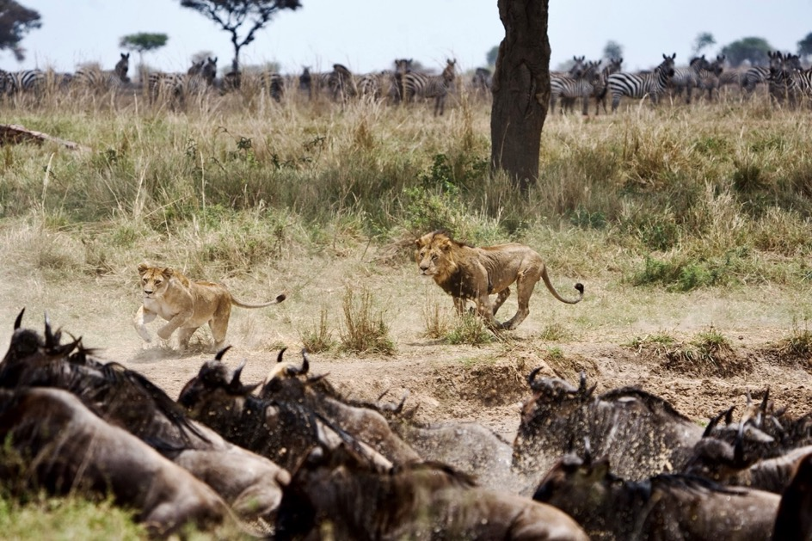

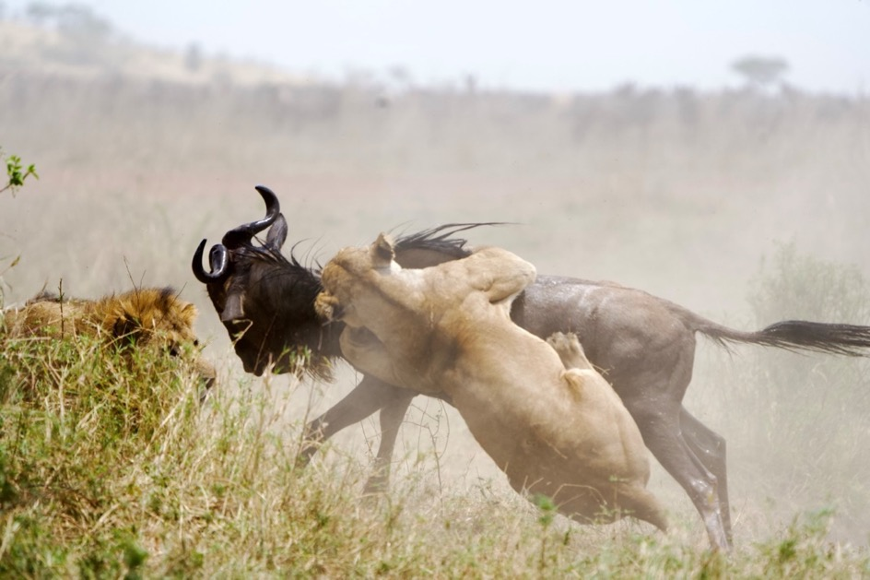

**The Masai giraffe**

Picture by Baraka Mtalo

The Masai giraffe *(Giraffa tippelskirchi)* is the largest giraffe subspecies and is easily recognized by its unique coat pattern. Unlike other giraffes, which typically have more rounded spots, the Masai giraffe has jagged, irregular patches that resemble the shape of oak leaves. These patches are set against a lighter background, providing them with excellent camouflage in the dappled light of their savanna habitats. Native to Kenya and Tanzania, the Masai giraffe thrives in open woodlands and grasslands, where it roams to find umbrella thorn trees, its primary food source.

Other giraffe subspecies include the reticulated giraffe, known for its neat and defined polygonal patches; the northern giraffe, which has three subspecies of its own; and the southern giraffe, found in southern parts of Africa. Each of these giraffe types varies slightly in coat patterns, distribution, and some physical characteristics like height and neck length.

As the tallest land animals on Earth, Masai giraffes are both majestic and essential to this ecosystem at Grumeti, helping to shape the landscape by pruning trees and dispersing seeds.

**Twitter**

Sasakwa Dam has been a hotspot for the great egret as this one has been spending most

of its time fishing and frogging. Picture by Paulo Kivuyo.

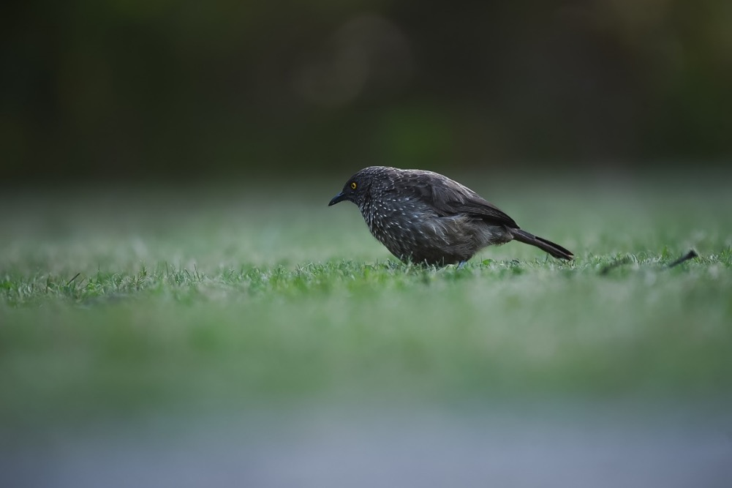

An arrow-marked babbler on a foraging mission. Picture by Paulo Kivuyo.

A Rüppell’s long-tailed starling ready to pounce on an insect. Picture by Paulo Kivuyo.

A grey-headed kingfisher calmly waiting for the insects to start flying. Picture by Paulo Kivuyo.

A seldom seen ostrich nest. Pictured by Clinton Sengenge.

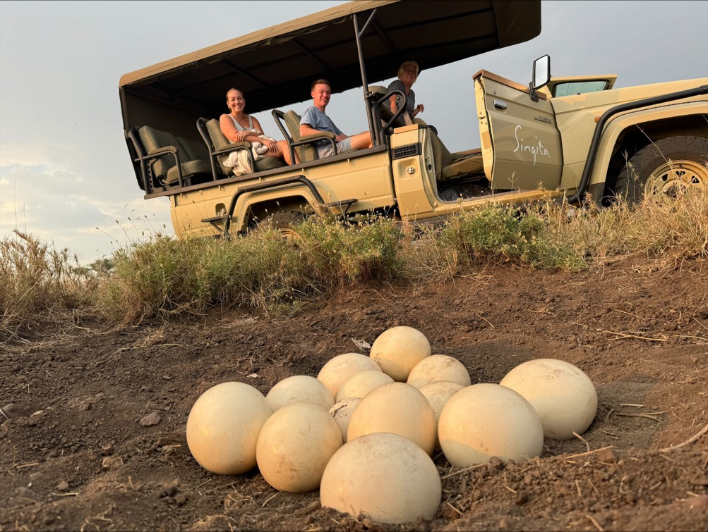

**Photographic portfolio by Dani Sam**

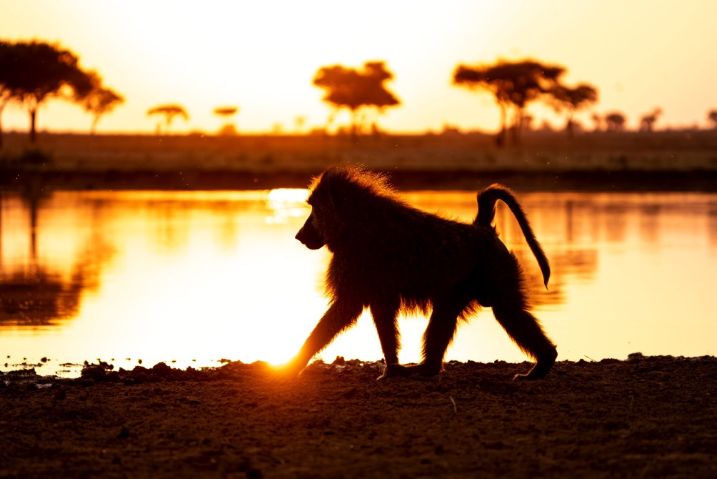

A male olive baboon strolling on Sasakwa Dam wall at dusk.

The number of zebras are increasing as it is the foaling period.

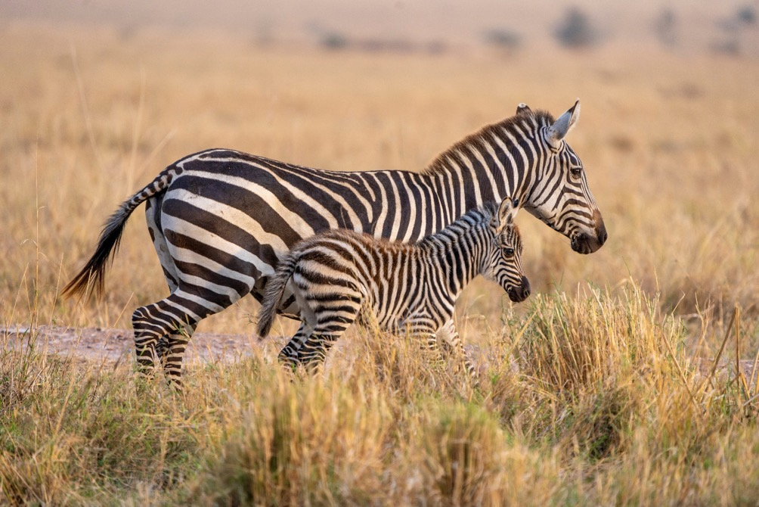

The incredible symbiotic relation between two species – oxpecker and giraffe.

Breeding herd of buffaloes with egrets overhead.

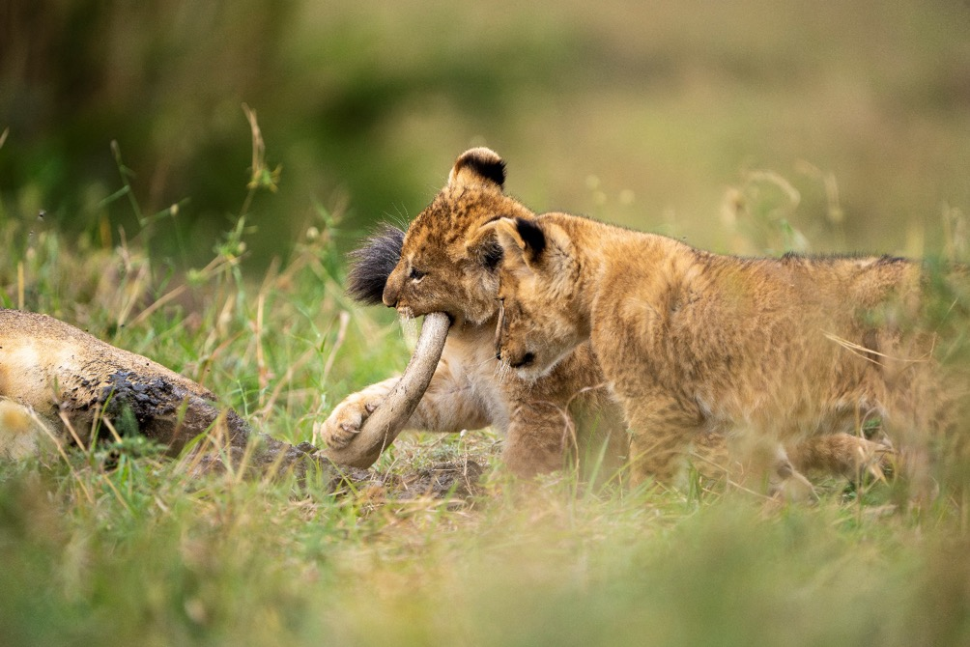

The cubs of the Momukomule pride intent on causing trouble.

A Butamtam male on the prowl.

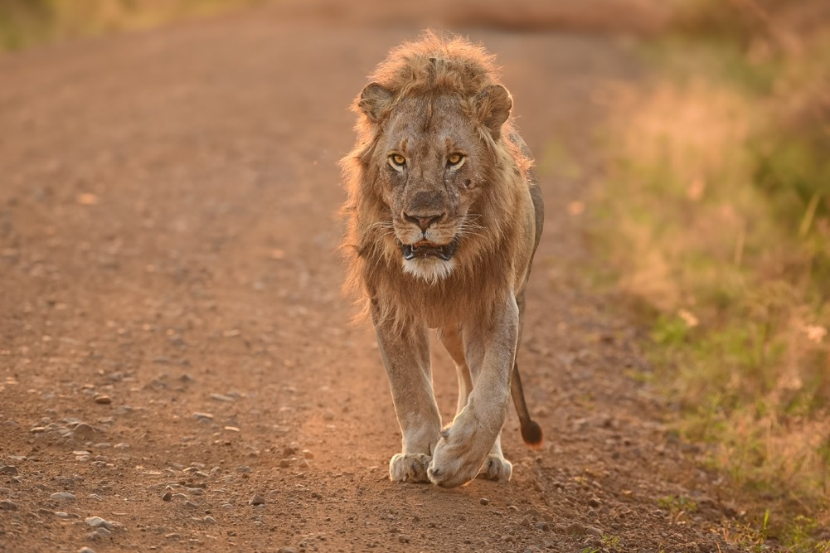

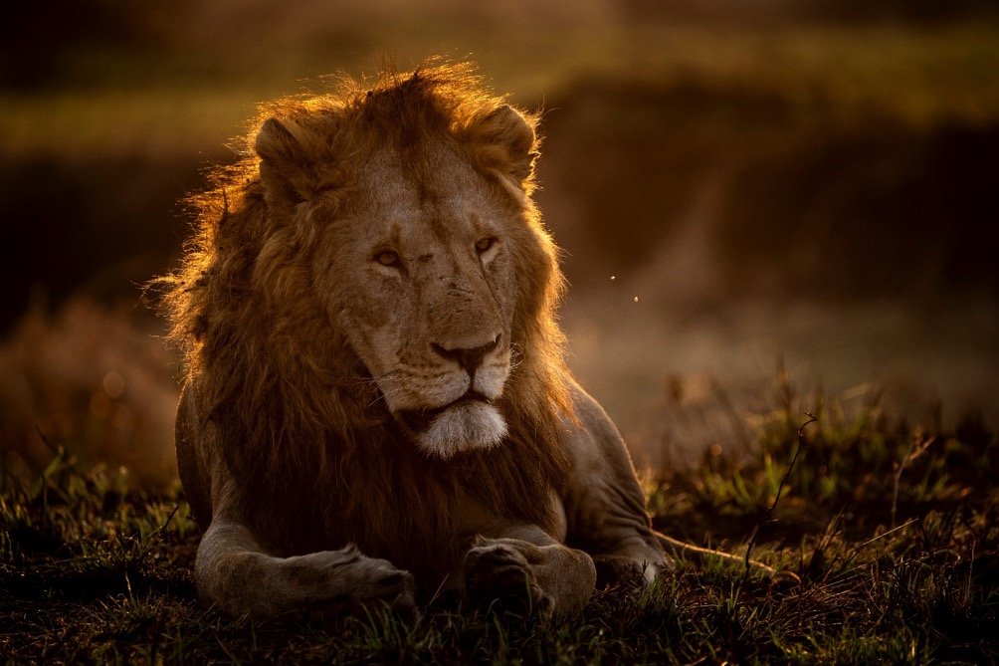

A Momukomule pride male taking a break before the night shift patrol.

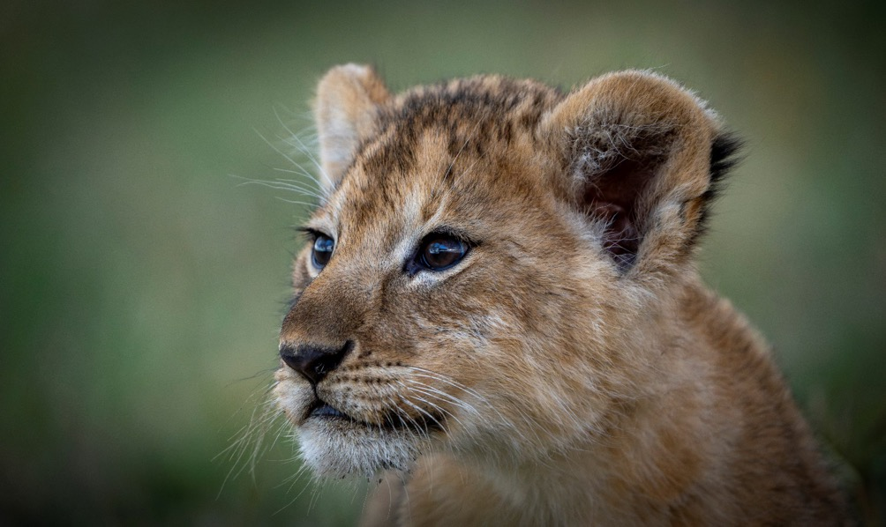

Staring deeply into the future - a lion cub from West Pride.

**September Gallery**

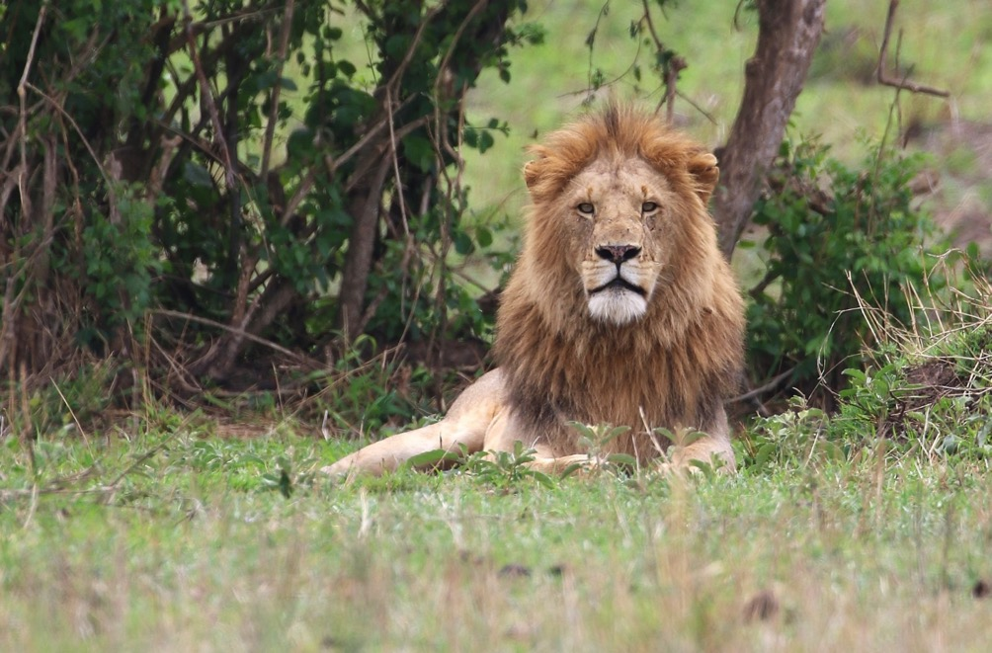

Manchira Pride male. Picture by George Tolchard.

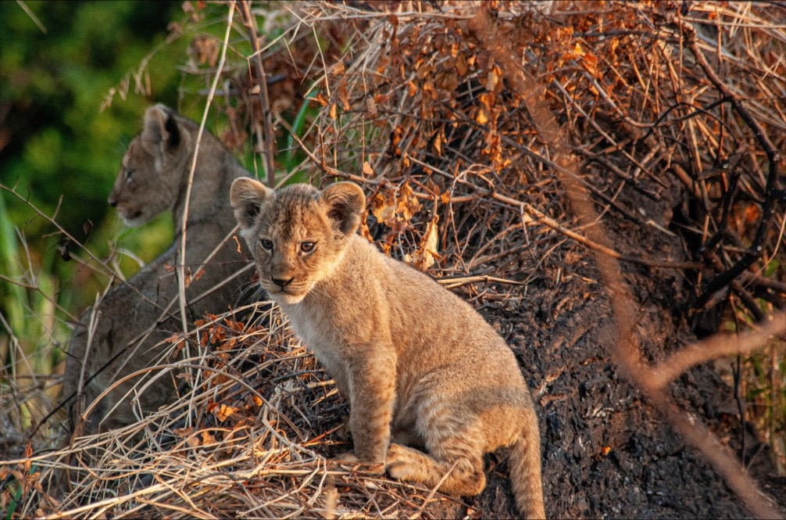

A curious lion cub from Momukomule Pride. Picture by Peterlis Kibwana.

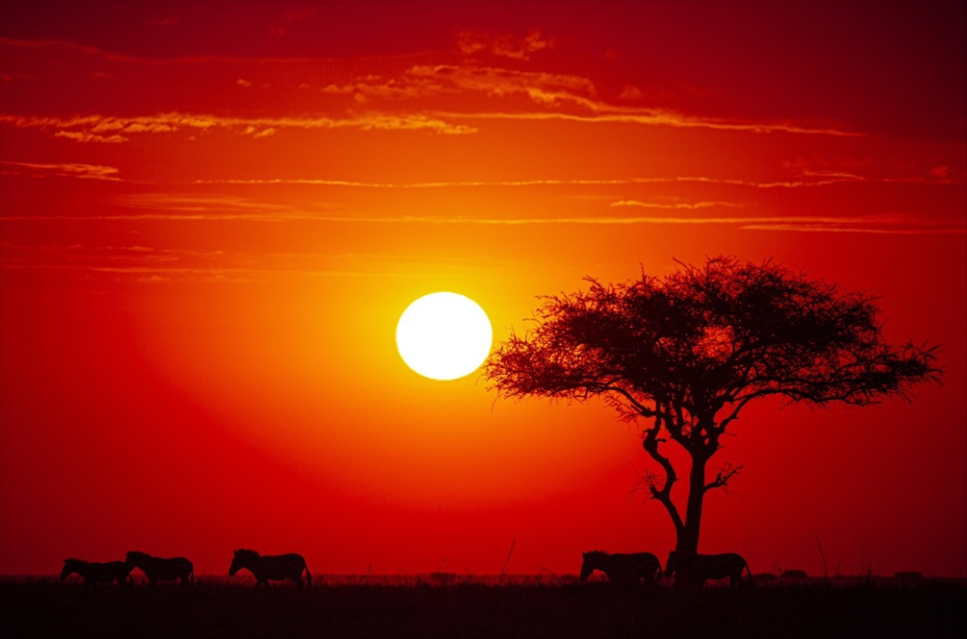

Wandering zebra at dusk on the plains. Picture by Clinton Sengenge.

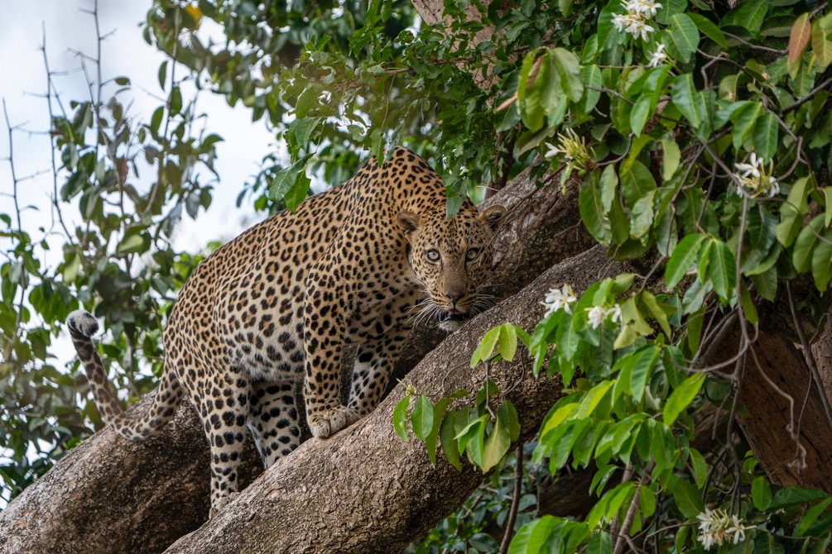

An apprehensive look from the new shy male along Grumeti River. Picture by Silas Jurawa.

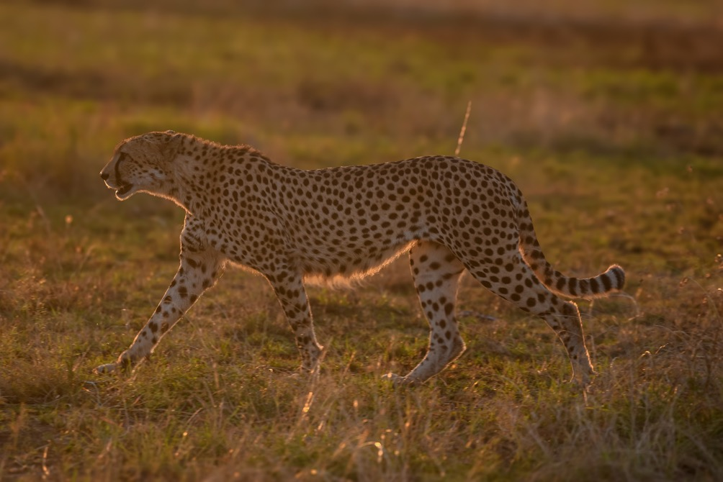

The resident male cheetah on the patrol. Picture by Paulo Kivuyo.

A young elephant showing who will be the next boss! Picture by Saitoti Olekuwai.

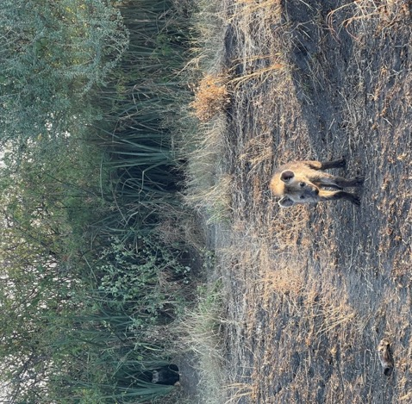

Inquisitive hyena cub. Picture c by Saitoti Olekuwai.

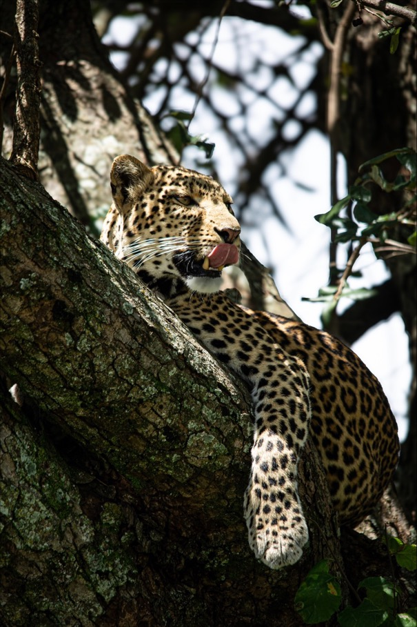

A very relaxed Mbogo drainage female. Pictured by Clinton Sengenge.

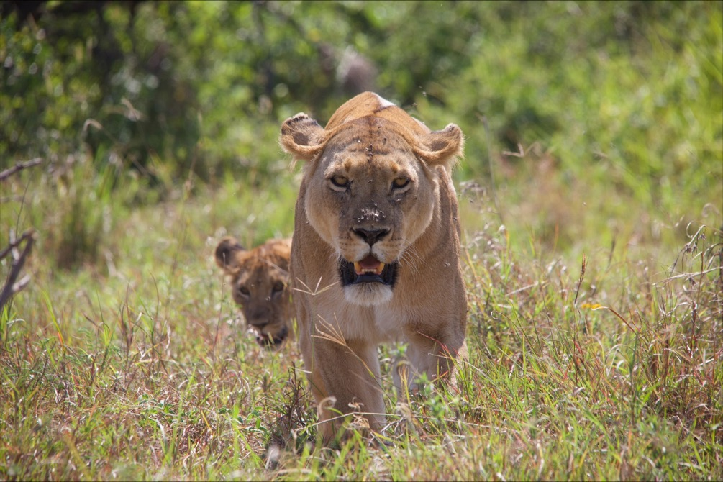

It is getting hot. The lioness from the Butamtam Pride leading a cub into the shade.

The future looks bright. The lion cubs from Momukomule Pride. Picture by Peterlis Kibwana.

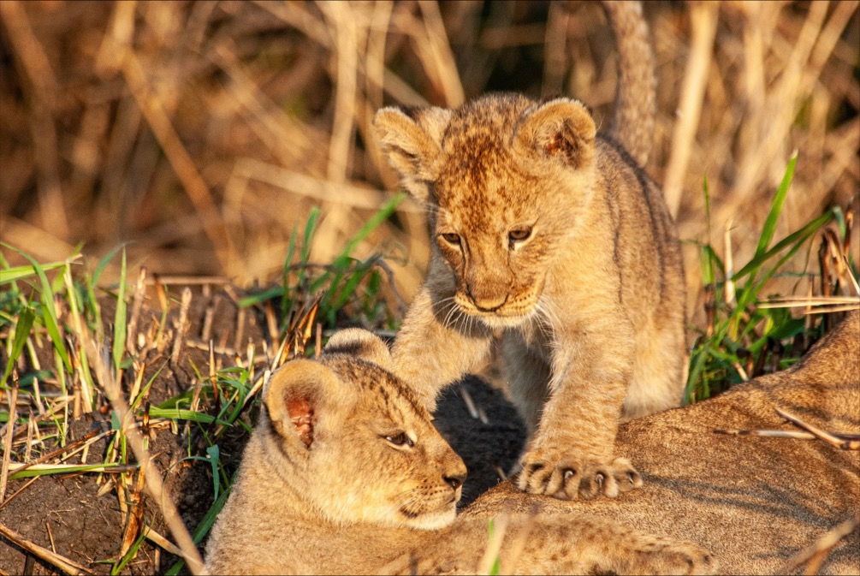

**Report compiled by Saitoti Olekuwai.**