

|  |  |  |  |  |  |  |
| --- | --- | --- | --- | --- | --- | --- |
| e | |  | | | |  |
|  | |  | | | | |
| **Date** |  | August 2021 | **Contact** |  | Angèle Loomans | |
| **Subject** |  | Plateau Plan 1 (public version) | **Telephone** |  | 088. | |
| **From** |  | Transition Team | **Email** |  | agm.loomans@avans.nl | |
|  |  |  |  |  | | | |  |

**PLATEAU PLAN 1**

**Core teams known**

**& routes explored**

**Core teams known & routes explored**

**What are we aiming for, and how?**

The implementation plan for Ambition 2025 was introduced in April 2021. This plan describes a proverbial journey that we will take together as an organisation and stakeholders, proceeding by way of five plateaus.

Each plateau will have its own plan, including building teams and the routes that we will travel. This document is a summary of Plateau Plan 1 (Sept. 2021 – Jan. 2022). A detailed version, the basic document of Plateau Plan 1, can be requested by email at **ambitie20-25@avans.nl.**

With Plateau Plan 1, we are taking an important next step towards producing agile and resilient professionals: people who will continue to develop through their lifetime and who will contribute to a sustainable future. The plan also constitutes a step towards the production of professionals who have the knowledge, skills and insights that they need to work within and contribute to the changing world of which we are all part.

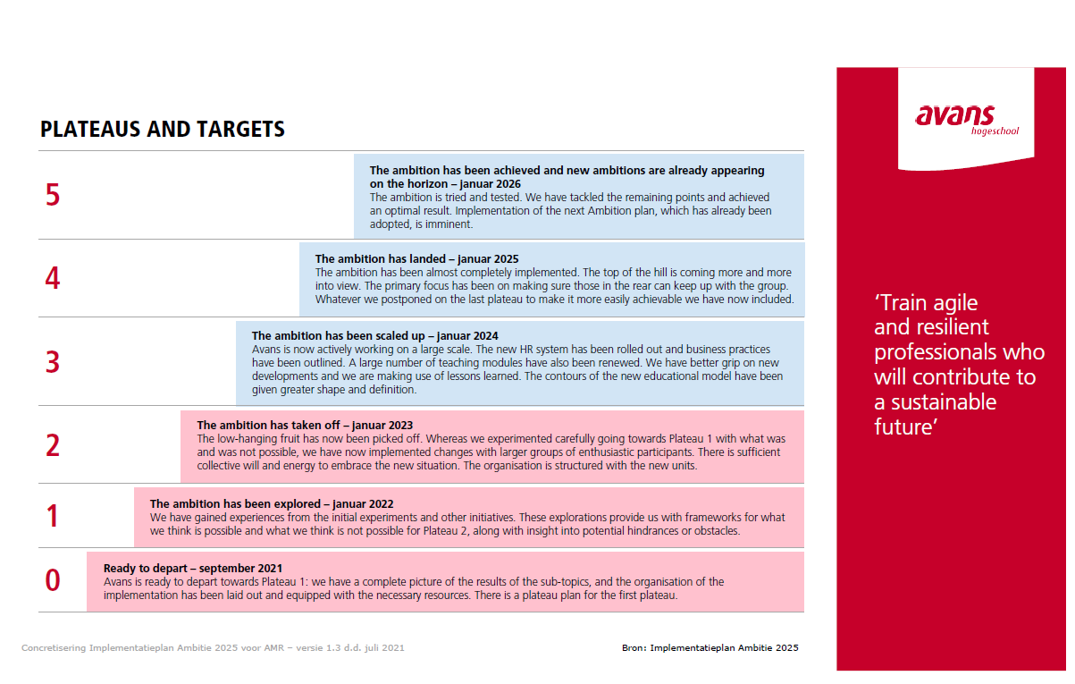

The general objective and title of Plateau 1 is as follows:

**Core teams known & routes explored**

To this end, Plateau 1 has five goals.

1. Take the first step towards flexible education   
   by applying and learning from the education model.
2. Create clarity and establish a future-oriented organisation.
3. Through co-creation, decide who our strategic partners will be.
4. Use technology and data to accelerate the change.
5. Engage in dialogue concerning what we are as a knowledge-based institution.

This document addresses these five goals. For additional information, we refer to the appendices and the basic document.

**Current situation**

The transitional organisation exists; the ‘base camp’ has been set up in Plateau 0. Later (after Plateau 1 has been achieved), the spikes will be in the rockface and multiple routes will have been explored. We know where Plateau 2 is, we know the core teams with whom we will be climbing and we are well-equipped to embark on the climb to Plateau 2.

**Avans vision on change**

Our vision on change is as follows: We are making this transition together. We have adopted a number of principles to ensure a good implementation:

* We will do it together; we are climbing together!
* Our ambition objectives and their impact on students, lecturers, staff and the professional field are decisive in our choices and priorities.
* We are travelling together as a learning organisation, proceeding from our own individual roles and responsibilities. We will have succeeded once everyone has reached the top.
* The work is done where it all happens: in the study programmes.
* With exemplary conduct, direction and dialogue, the Boards guide the teams within their clusters through the transition.
* Collaboration between the line organisation and the transition team is a given.
* A building team facilitates, supports and provides advice.
* Together, we are discovering what is needed to keep climbing together.
* We are standardising in order to stabilise and increase interchangeability.
* We are investing in ‘learning’ and ‘development’ according to the principle of cyclical evaluation and development.

**Initiative Proposals for Plateau 2**

The transition schedule for 2021 is already complete, with the initiatives from Plateau Plan 1. There are still many possibilities for Plateau 2 (2022).

In October 2021, schools, units and centres of expertise will submit their business plans, in which they can note their own initiatives. As a rule, these initiatives will operate independently and under the management of the relevant entity.

For initiatives that call for collaboration with and support from the transition team and transition resources (e.g. time, expertise and funds), there is an application process. The application form at **bijavans.nl** can be used to submit requests to the transition team. This can also be done by email: **ambition20-25@avans.nl.**

The transition team will then assess whether the application falls within the scope of the transition team. If so, the transition team will also determine which building team will take the lead in processing the application. The building team and the applicant will subsequently work together to elaborate the initiative into a decision-making proposal for the core transition team. If the decision is positive, the initiative will be incorporated into the Plateau Plan, including a longer-term perspective.

**Transition team**

The transition team comprises the four building teams and the management team. The building-team leaders and the transition manager together form the transition core team. The transition core team monitors the coherence, sequencing and connection of the plans. It also allocates the resources and monitors progress and risks.

**Role of the transition management team**

The transition management team facilitates communication, monitoring, evaluation and learning. In addition, it supports the transition team with regard to the coherence, sequencing and connection of the plans, as well as with regard to the monitoring of progress and risks. The management serves as a point of contact for cluster directors/Deans, lecturers, ambition drivers and other stakeholders, acting as a connector between schools and building teams, and as a central point of contact for questions concerning Ambition 2025. The composition and stakeholders of the transition management team are listed in Appendix 5.

**Goal 1: Taking the first step towards flexible education**

One central feature of our ambition is enabling freedom of choice for our students. To this end, we have developed a new education model. Using this model, we will launch a number of educational experiments, in which we will apply the education model and use it to answer several learning questions.

The activities performed during the period from September through December 2021 will lead to the following results:

* A number of lecturers and students will have answered learning questions from the education model, specifically with regard to its design and ease of organisation.
* Lecturers will have frameworks that provide direction and a solid footing for the development of free choice and interdisciplinary education.
* Students will perceive that attention is being paid to their well-being throughout their personal learning routes. This falls under the component of Student Well-being.

**We will do this as follows:**

In the last part of 2021, the focus will be on a few experiments, as well as on a number of inspiration sessions. These activities will be exploratory in nature. During the experiments, we will gain experience with the comprehensive approach to educational innovation through the ‘Teacher Design Teams’. In addition, the support structure for the implementation of the education model will be further elaborated.

The following experiments will be started in September 2021:

* **Experiment involving the Blueprint for Development**, in the Avans EduPlatform The following study programmes will participate in this experiment: Business Innovation, Chemistry, Construction Management and Health Technology.
* **Experiment involving the Interdisciplinary track on Blueprint for the Energy Transition**, which brings together Interdisciplinarity, Research and Co-creation. The following schools will participate in this experiment: Security & Public Administration (AVB), Built Environment & Infrastructure (AB&I), Engineering & ICT (AE&I) and Entrepreneurship, Marketing & Innovation (AOMI).
* **Experiment involving Collaboration on ISAT**, with a focus on curriculum structure, shared learning outcomes, profiling towards the professional field and co-creation. We will conduct this experiment with the following study programmes: International Business (Breda and ’s-Hertogenbosch) and Commercial Economics, with Entrepreneurship and Retail Management.
* **Experiment involving Switching the Blueprint for Development**, with a focus on curriculum structure and choosing between adjacent study programmes. The study programmes of AE&I will participate in this experiment.

A portfolio is also being developed, containing both the content guidelines and the preconditions relating to interdisciplinary education and the free-choice modules. The minors also fall under this heading. We will conclude in early 2022 with an institution-wide event – a great opportunity for sharing learning outcomes.

The composition and stakeholders of the Education Building Team are listed in Appendix 1.

**Timeline** 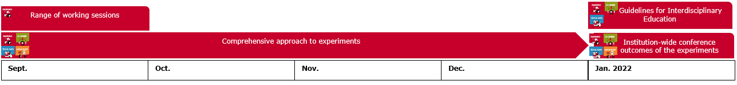

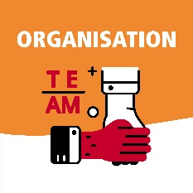**Goal 2: Building a future-oriented organisation**

In order to achieve our Ambition 2025, we are working together to build the foundations and structure of the new organisation. The building team organisation advises on the structure of education, as well as on research, co-creation and the necessary support.

One prominent focus in late 2021 will be the re-clustering of the full-time study programmes. These clusters have been composed for optimal collaboration, in a manner that can realise interdisciplinary and multidisciplinary education, in addition to making it possible to provide education on a small scale. A preliminary cluster structure has since been prepared for 11 clusters, which have yet to be created. This structure has not yet obtained consent from the Avans Joint Consultative Council (AMR).

The activities performed during the period from September through December 2021 will lead to the following results:

* In October, Board members will know the clusters for which they will be responsible.
* Each cluster board will have received a quartermaster assignment and will lead the transition within the cluster or centre of expertise.
* Individual staff members will know the clusters to which they belong.

**We will do this as follows:**

We will provide clarity about the organisation as soon as possible. This also applies to the place of staff members with regard to full-time education and the centres of expertise, so that all those involved will know the locations and positions from which they will start. For the Organisation Building Team, the focus during Plateau Plan 1 will be on creating clarity in this regard.

**Looking ahead to 2022/2023**

The new clusters will be ready to start on 1-9-2022. The designs for the organisation of services by the support services will be ready. Systems will have been arranged as of 1-1-2023.

The composition and stakeholders of the Organisation Building Team are listed in Appendix 2.

**Timeline**

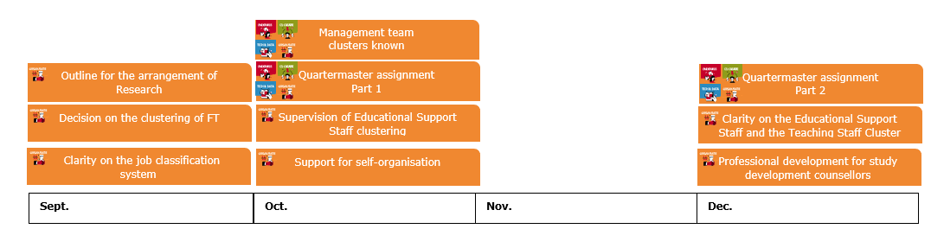

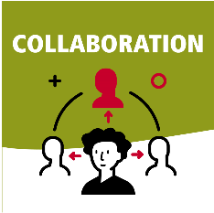**Goal 3: Identification of strategic partners in co-creation**

In order to achieve our Ambition 2025, we will be looking much more beyond the walls of Avans and making more connections with the outside world. We will do this by establishing bonds with sustainable, strategic partners and by making the ‘outside-in’ thinking of Avans commonplace.

For our Ambition 2025, we aim to achieve the following with regard to co-creation:

1. The organisation of relationship management will be arranged.
2. The internal and external information facilities will be operational.
3. Relationships will have been established around themes and areas of focus.
4. A tried and tested manifesto on co-creation will be complete.

to the following results:

* Each cluster will have insight into the internal relationships of their strategic partners, based on sociograms of stakeholders.
* Each planned centre of expertise will receive insight into the internal relationships of potential strategic partners, based on sociograms of stakeholders.
* Insight will be provided with regard to effective factors for co-creation and strategic relationship management by learning from current experiences or experiments and multidisciplinary cross-over projects. These may include the AMX Week, the Urban Living Labs and the learning communities, amongst other projects.

**We will do this as follows:**

Each cluster will participate in the Co-creation Building Team by taking part in three tracks and by contributing relationship managers or lecturers who are involved in the study programme. We will collaborate with each intended centre of expertise on the design of the sociograms of the stakeholders. These sociograms will provide insight into the further development of the intended ambitions relating to strategic relationships.

The composition and stakeholders of the Co-creation Building Team are listed in Appendix 3.

**Timeline**



**Goal 4: Acceleration with technology and data**

Technology and data are important ‘enablers’ for the achievement of our Ambition 2025, but they are not ends in themselves. The Technology & Data Building Team will support developments according to the ‘Value4Education’ process model.

The activities performed during the period from September through December 2021 will lead to the following results:

* Students of Industrial Engineering & Management (AvD) will choose flexible education through the Avans Study Path.
* Lecturers of Industrial Engineering & Management (AvD) and the full-time experiments will work with the Avans EduPlatform.
* Every student and lecturer will be able to use the new learning management system, Brightspace.
* Students will use apps that provide them with insight into their personal academic circumstances.
* The story on the digital transformation as part of Ambition 2025 will have been elaborated further.

**We will do this as follows:**

We will work with an agile ICT organisation. For example, this means that ‘product owners’ will develop digital products and periodically collect feedback on them, together with students, lecturers and support staff. We will also devote every possible effort to the developments and experiments relating to flexible education, organisation and co-creation.

Based on the experiences of students, staff and the professional field, we will provide a digital environment that is increasingly experienced as seamless, personal and connected. We will proceed from a single platform concept. Products that we have developed for students will be used for staff as well. We will also work according to the central question of how we can improve our ability to learn and work in a data-supportive manner.

The composition and stakeholders of the Technology & Data Building Team Building Team are listed in Appendix 4.

**Timeline**

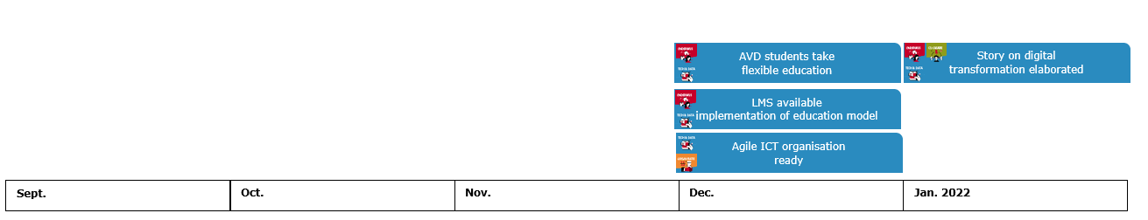

**Goal 5: Avans as a knowledge-based institution**

The activities performed during the period from September through December 2021 will lead to the following results for the sub-topic of Research:

* + We will know what we are as a knowledge-based institution.
  + We will build the organisation surrounding the adopted priorities (e.g. in centres of expertise).
  + Each centre of expertise will have a quartermaster, who will work with several study programmes to explore the manner of organisation and its impact on education and the professional field.

Direction on the sub-topic of Research will rest with the Centre for Learning and Innovation (LIC) through the Research and Outcomes programme.

**Resources needed and possible risks**

Achieving the objectives and ambitions will require resources. The Ambition 2025 implementation plan provides an indication of the financial resources required for each component. These funds have been reserved as a budget for the entire ambition period.

In order to allow for proper direction while making use of advancing insight, a specific budget will be prepared for each plateau, including for Plateau 1. These costs comprise only additional expenditures above and beyond the existing expenditures. Examples include the deployment of people not included in the budget, the replacement of staff and/or out-of-pocket costs.

**Points for attention**

The following points constitute a potential risk and have the full attention of the transition team:

* The expectations of the stakeholders for 2022.
* The need to stay in contact and engage in dialogue with the clusters and schools.
* The need to request connection through the Budget and annual plan for 2022 according to the application procedure, as managed by the transition team.
* The new composition of the Executive Board.
* The new composition of the Avans Joint Consultative Council (AMR).
* The new director of the Centre for Learning and Innovation (LIC) and the relationship with the Research component.
* Sentiments surrounding the formation of new clusters.
* Culture and leadership, including collaboration and knowledge exchange.
* The lack of finalised decision-making on the ambition (e.g. by the AMR and Supervisory Board).
* The chance of resource under-expenditure due to insufficient operational capacity in organisational units.

**Identified risks**

Several risks are also identified in the implementation plan for Ambition 2025. We are explicitly following three risks that have been identified for Plateau 1:

**Absorption capacity, implementation capacity and workload**

Signals have been received from within the organisation and the Avans Joint Consultative Council with regard to the increase in work pressure and burden for lecturers due to activities involved in the implementation. This relates to both implementation capacity and absorption capacity (i.e. the extent to which a change actually takes hold).

**Research**

One of the most important points of concern that has emerged is the position of research. At present, research falls under the ‘limited direction’ of the transition team. In practice, this means that the transition team ascertains what the plans are and how they contribute to achieving Ambition 2025. As indicated by the various meetings with stakeholders, research is an essential part of realising the ambition, and it would be more logical to add Research to the transition team as a building team.

**Representation of ambassadors and students**

If we constantly share the story of Ambition 2025 with the same people, we run a risk that they will no longer be able to consider it from a fresh perspective. At various times, we would like to have other staff and students look at it with us (along with the existing group of ambassadors), so that we can continue to gather fresh insights.

**One more thing...**

This document is a summary of the basic document for Plateau Plan 1. For the more detailed basic document and any questions, please contact **ambitie20-25@avans.nl.**