Sygic – Twisty route

The following guide is valid for both Android and iOS operating systems.
It is possible to enable this function on both phone and cluster side.
- Enabling Twisty route on phone side

- Open Sygic GPS Navigation & Maps on your smartphone;
- Create a route in the Sygic app (see this tutorial “Starting the route” for more details);
- Tap on “Options”;
- Enable the “Twisty route” option;
- Tap on “Done”;
- Sygic's algorithm will recalculate your route and show you a more twisty route;
- Tap on “Start” to start your itinerary;
- If you want to see the route on the cluster: launch Ducati Connect and the itinerary will be displayed within the Sygic virtual app.
3
2
1

6
5
4
8
7
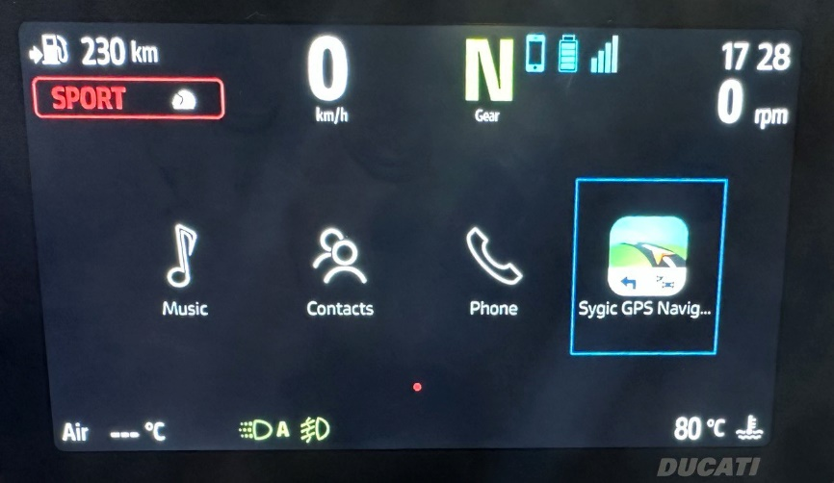
8

- Enabling Twisty route on cluster side

- Launch Ducati Connect on your smartphone (Note: you have to pair your smartphone and the cluster via Bluetooth first);
- Wait for the completion of the connection procedure;
- On the main screen of the cluster, tap on “Ducati Connect”;
- Open the Sygic virtual app;
- Search for a route or open a previously saved route;
- Tap on “Get directions”;
- Tap on the options symbol ;
- Enable the “Twisty route” option;
- Sygic's algorithm will recalculate your route and show you a more twisty route;
- Go back (Note: you can either tap on the “back arrow” or long press to the left the multicontroller placed on the handlebar)
- Tap on “Start” to start your itinerary.
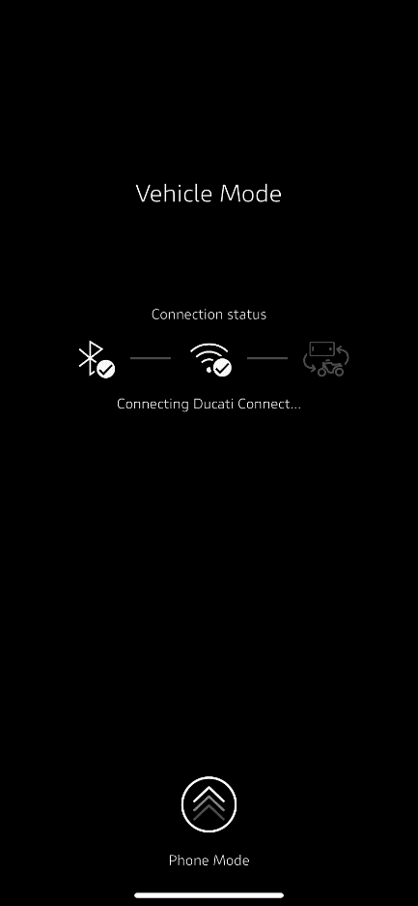
2
1
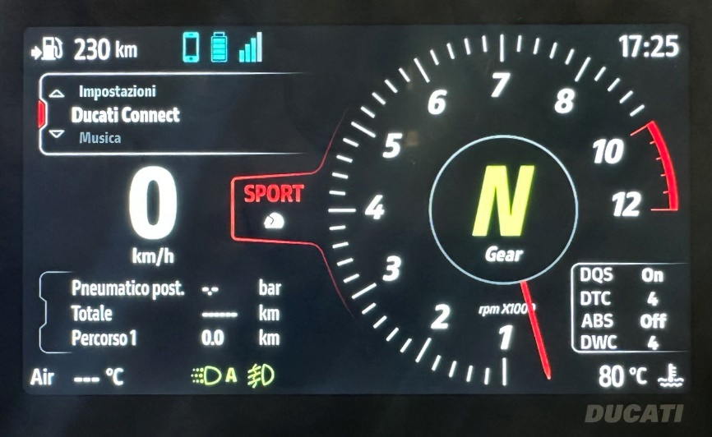
3
4

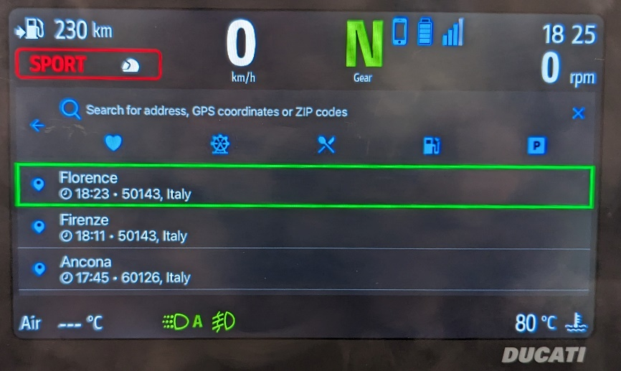
5
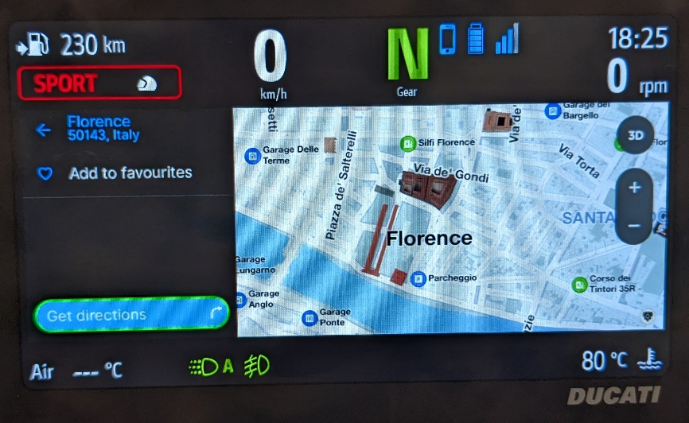
6
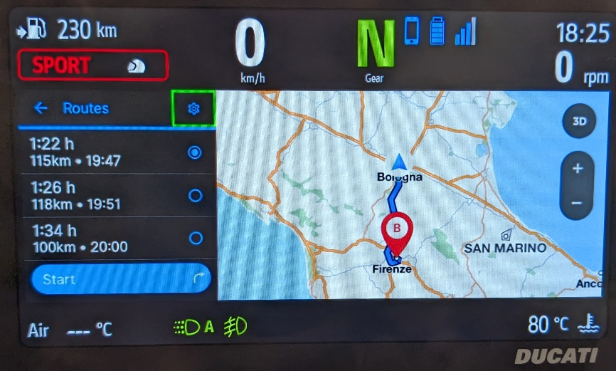
7
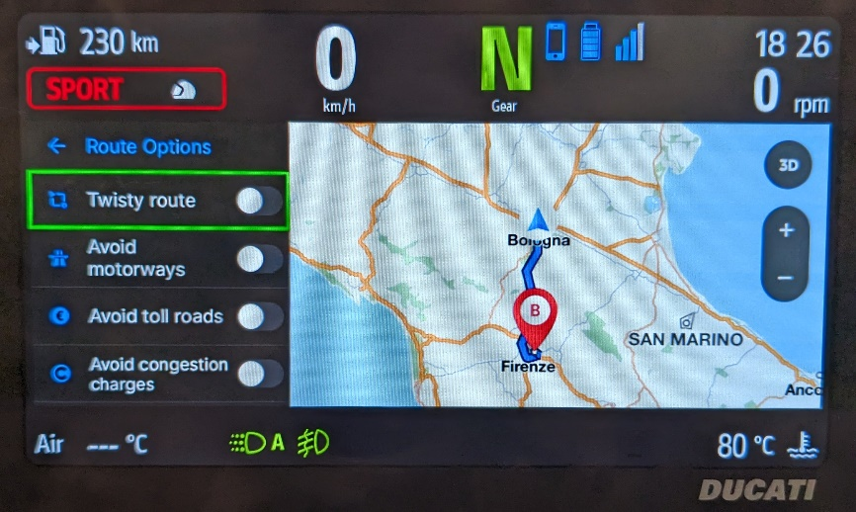
8
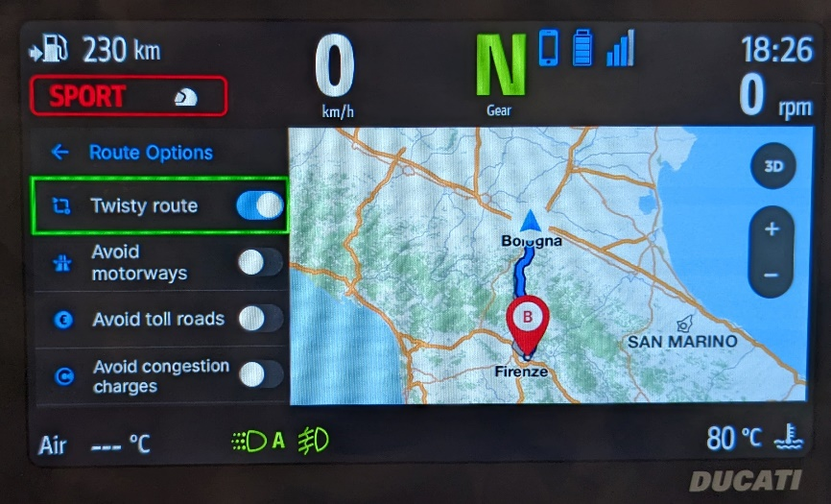
9
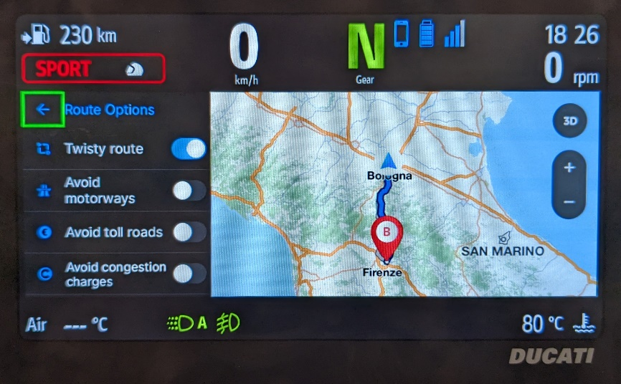
10
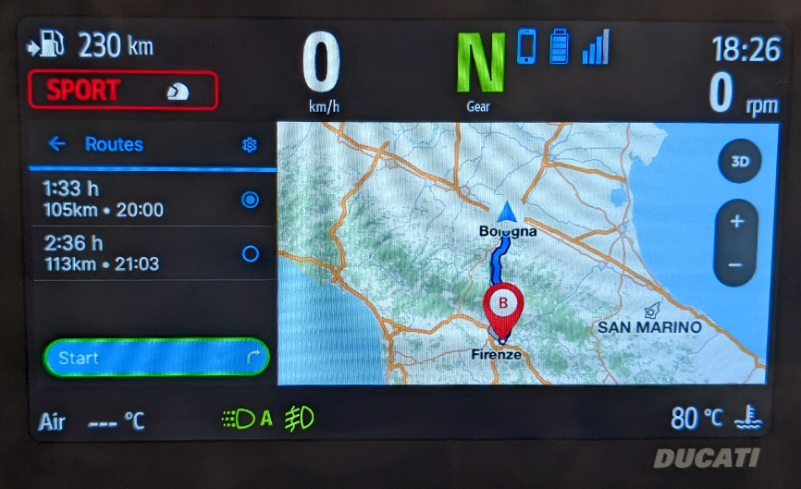
11

