Sygic – Import/Export GPX

Starting with version 22.0.4 (Android) and 22.0.3 (iOS) of Sygic GPS Navigation, users have the possibility to import/export .gpx files in/from the app.

- Import procedure
If you already have a .gpx file on your device (in files, e-mail, in messenger, etc.), and would like to use it with Sygic, it is enough to tap on the file to open it and select the Sygic GPS Navigation app. The route will be displayed in the app afterward.

Android steps
- Find the .gpx file on your device;
- Tap on the file;
- Select the Sygic app to open the file and tap on “Just once” or “Always” depending on your preferences (Note: If Sygic is the only app installed which can open .gpx files, this step is skipped and the file is automatically opened in Sygic);
- The route is displayed in the Sygic app.

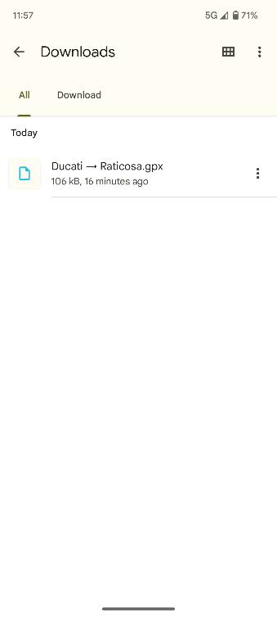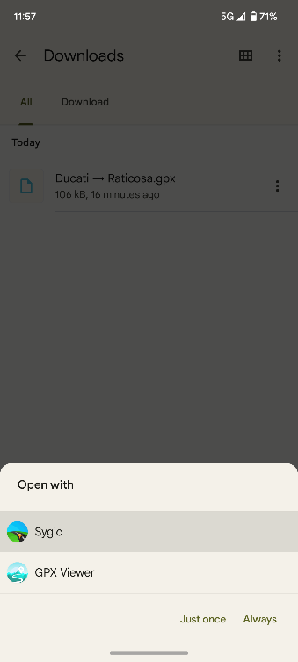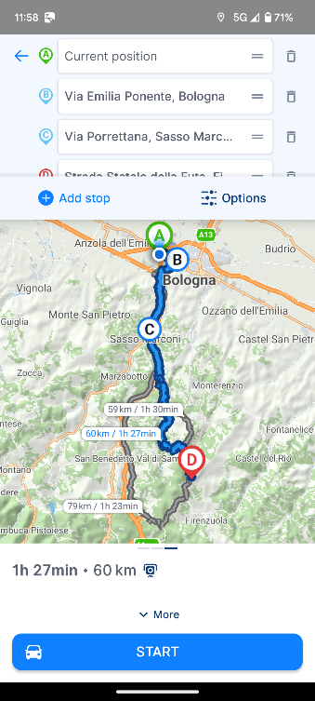
3
4
1
2

iOS steps
- Find the .gpx file on your device;
- Tap on the file;
- Tap the Share button ;
- Select the Sygic app to open the file and tap it;
- The route is displayed in the Sygic app.

1
2
3
5
4

- Export procedure
If you would like to export a route from the Sygic GPS Navigation app, please follow these instructions (valid for both iOS and Android operating systems):

- Create a route in the Sygic GPS Navigation app (see this tutorial Starting the route for more details);
- Swipe up the information bar at the bottom of the screen;
- Tap on “Export”;
- Select where would you like to export the file.

4
3
2
1

