The cold weather report. In January I receive supplies from Clark’s and, while I have been away some, have completed some of the interior work through January and February
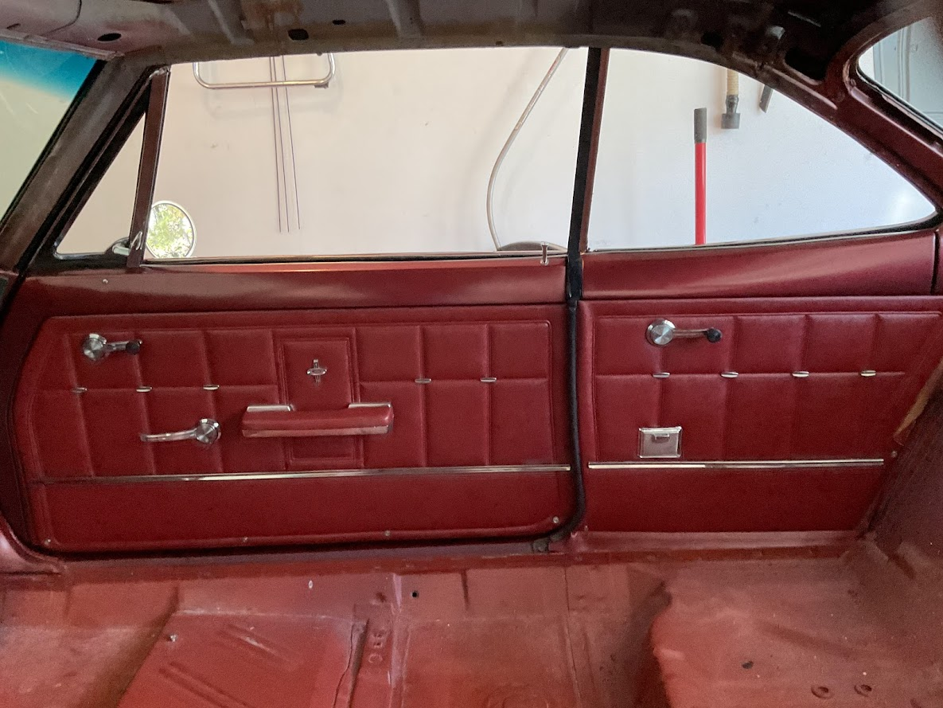First up on the work pile was door cards. After receiving the new ones, I pulled the old ones out of storage and removed and cleaned all the chrome pieces from the old cards and ‘super glued’ them to the new door cards. New snap posts and plastic receivers were installed on the cards and in the car. In looking at the screws at the bottom on the door I figured out they were self-drilling and tapping so that was easy. I also quickly buffed the rear panel ash trays, glad to report they look unused. The original papers were installed behind the cards and I am happy with the results.
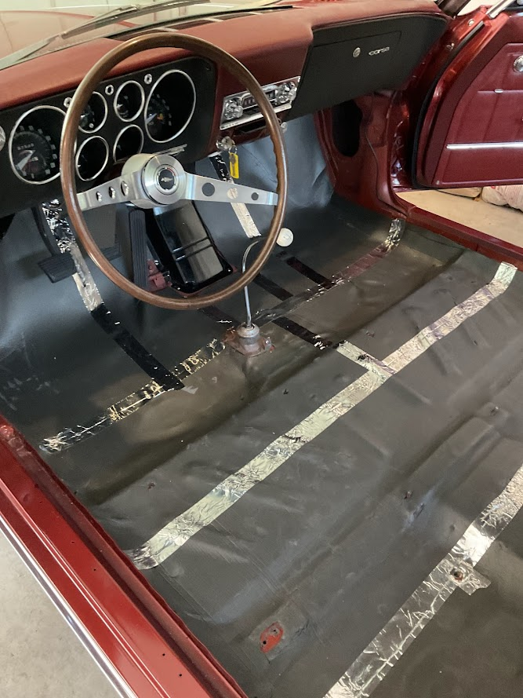
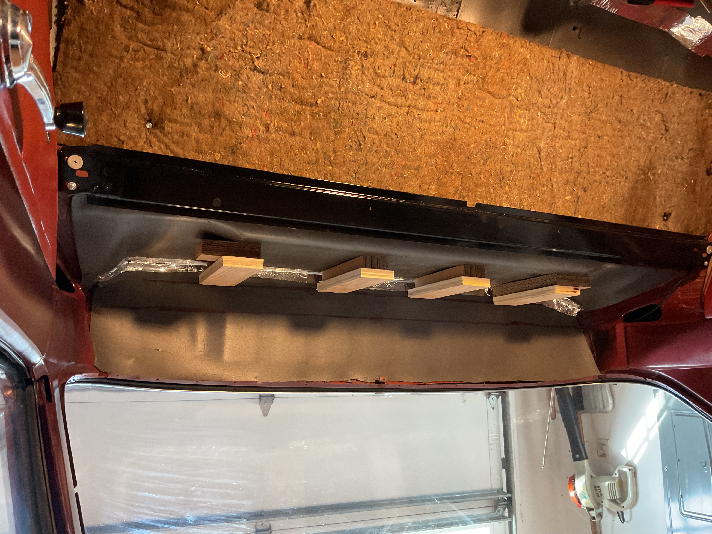Next up was sound insulation materials on the floor and rear area of the car. I used Siless ¼” material that I ordered from Amazon. The installation was time consuming but pretty forgiving once I got started and worked out a process. It took about 1 1/3 boxes of the matrial to cover front to rear of the car. The brown area below the rear shelf is the factory insulation pad which was salvageable from the disassembly process. You can also see at the top I needed to add ¾ plywood to the to of the cardboard spacers I ordered from Clark’s to have the shelf support at the right height.
Ultimately I pulled those pieces (Plywood + Cardboard) out and substituted a full size piece of 1 ½” rigid foam insulation sitting on top of the ¼” sound proofing to make the right height spacer.

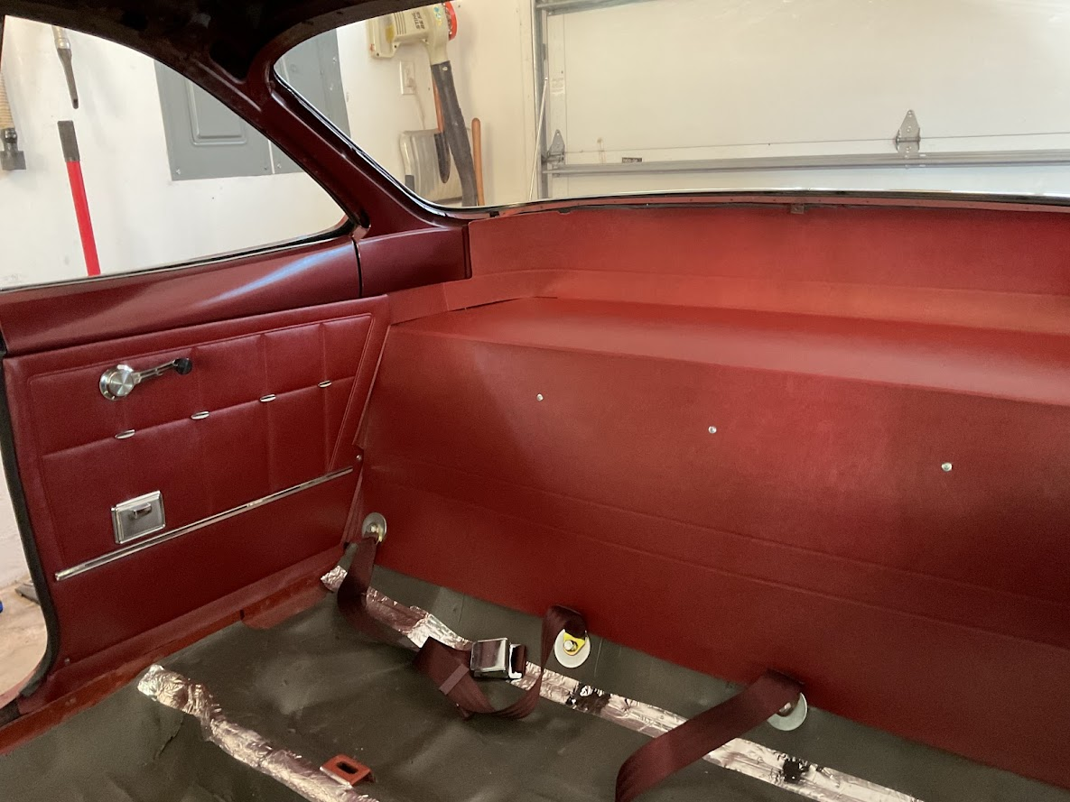The finished product looks pretty good. New seat belts also as the black original were pretty moldy and corroded.

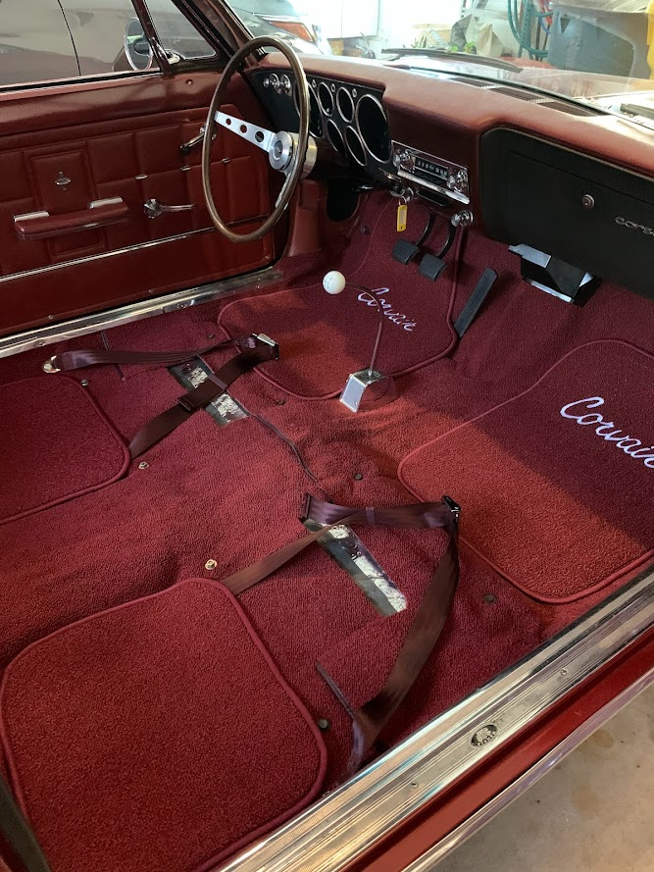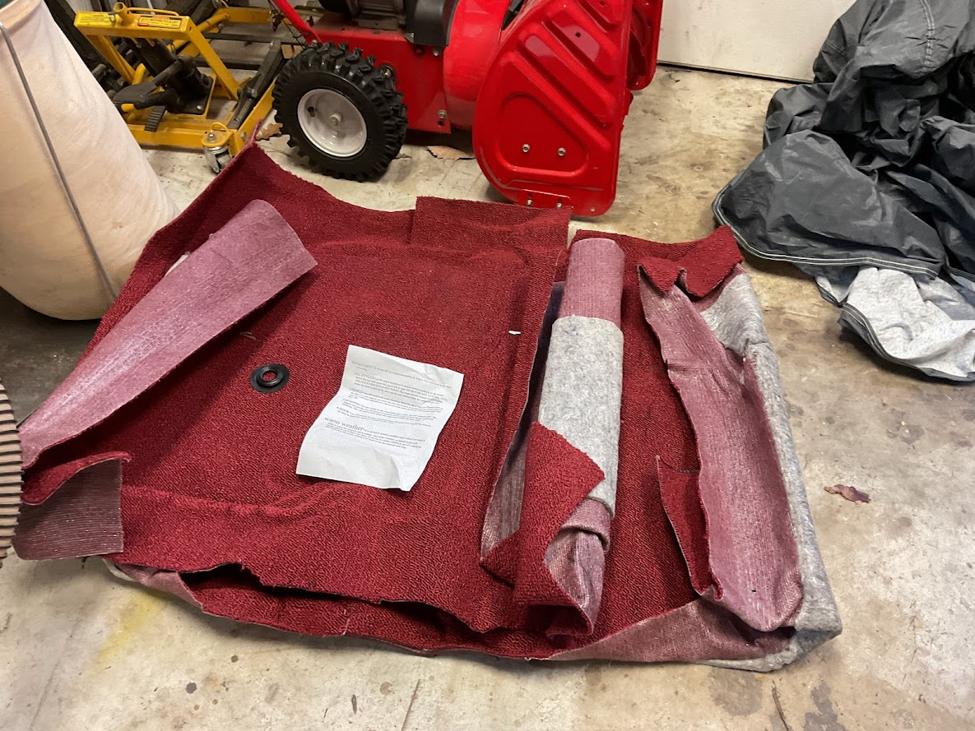Last up was carpet and the door sill aluminum pieces. Took my time and used a small steamer that I had to help soften the carpet and allow me to get it pushed in place.

Next up will be recovering the seats. I have 1000 hog rings on hand and a ¼” staple gun. So far I have finished the rear seat bottom and am working on the seat bock. Not looking forward to the bucket seats but they need to be done.
Finally for this installment I have talked to my painter and am taking a pile of the small interior pieces to him to be painted to match the inside of the car.
Next month, and hopefully the conclusion to the story Seat Covering/Installation; small painted painted part installation, an alignment by Mike Coale, and a headliner installation (maybe or maybe not by me) The goal is on the road by 1 April!!!

