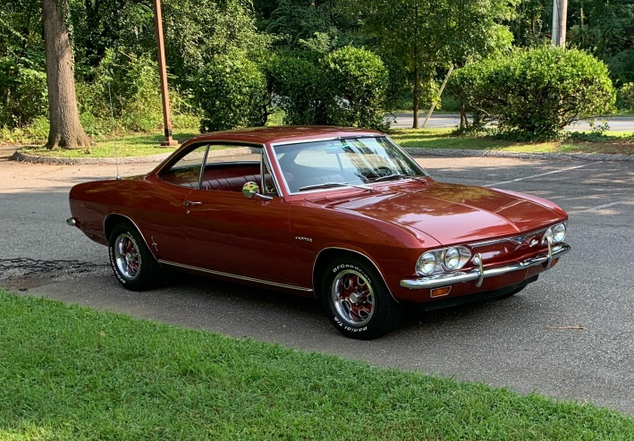
1966 Corsa Restoration or the never ending saga of finding the gremlins. Since I got the car back on the road last spring I have been able to accumulate about 500 miles on the car, including the Rock Hall Car Show. During that time the car has had a constant problem with being hard to shift, particularly 1-2nd shift, and clutch chatter. Since the weather was breaking, It was time to pull the driveline back out and start trying to figure out what was wrong.
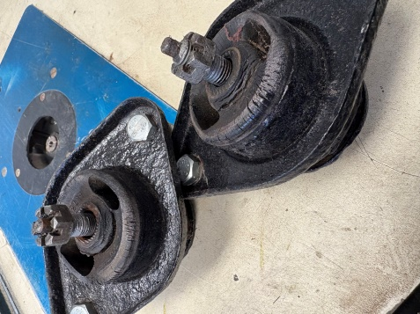
With the car back in the garage and up on jack stands I successfully removed the drive line, only breaking the backup light switch in the process (Clark’s is sending me a new one). I have a motorcycle jack which does a great job of balancing the engine and a small dolly to hold up the transmission end.
First up, with everything out of the way, was to replace the forward engine mounts. I should have done it the first time I had everything out, but for some reason decided they were OK to reuse. This time I bit the bullet and purchased new ones and did the change out. From the looks of the old ones…I think this was a good decision. You can see that the 1966 originals were breaking around the center bolt.
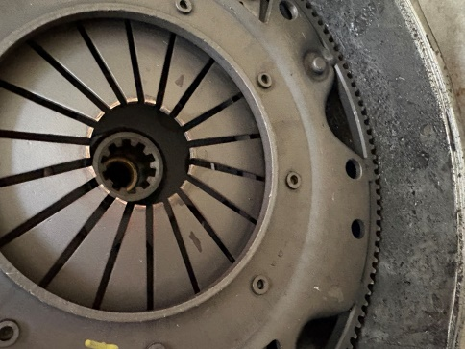
After I pulled the differential/transmission from the engine the pressure plate was showing and clearly something was amiss. I put 2 marks on the fingers, one at about 4 o’clock and one about 7. The fingers on the lower side of the circle are about 1/16 to 1/8 inch below those on the upper side. The bronze colored wear strip on the tips of the fingers was much less on the lower fingers than on the top fingers.
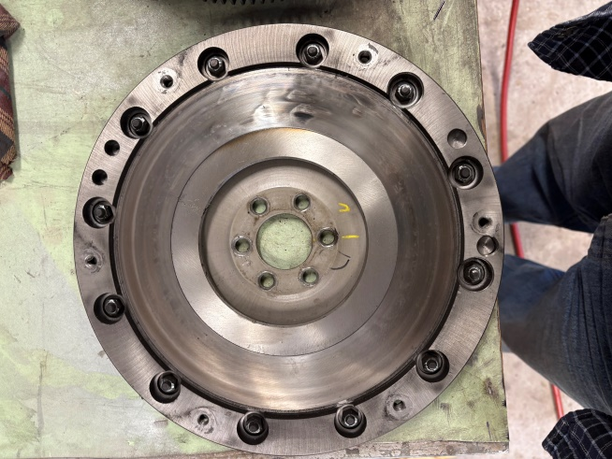
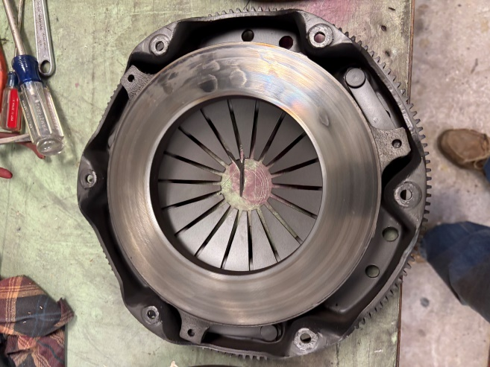
The throw-out bearing, while a little beaten up around the fork area was smooth and was reusable. When I separated the pressure pate off and pulled the flywheel it was evident there were wear spots of clutch consistent with spots to create chatter. I also pulled the side plate off of the transmission but could find no evidence of any abnormal wear on the synchronizer pieces or the gears. Jim Simpson came over and we both went through the transmission and clutch pack and decided the clutch was the overall culprit. The disk looked fine but the pressure plate and flywheel needed to be replaced or re-machined.
A big thank you goes out to Corvair Ranch, who I originally purchased the clutch parts from in mid-2023, but has agreed to replace the parts. I’m going up next week to make the trade, then a week to two to put it back together.
Hopefully next month I can tell you everything is back together and working as it should.

