Wheels and Walks Monitoring and Evaluation Toolkit

Monitoring

Overview
The overall purpose of the Wheels and Walks programme is to support more people walking, wheeling and cycling across Greater Manchester. To demonstrate the impact your programmes we’ve designed the following to be captured; (1) what’s being delivered, (2) the current activity behaviour levels of participants, (3) the change in behaviour of participants and (4) the overall impact of your group.

Your Role in Collecting Data
We ask that you, or leaders within your group, support the collection of this information. There are documents you’ll need to complete yourself, and surveys to share with participants. If these can be done within the timeframes we’ve set out it would benefit the accuracy of the information being collected.

Data to Collect
Type of collection | Who completes it | Overview | How to complete it
1. Initial participant survey | Participants | - Participants complete this survey when they attend their first activity  - They only complete this survey once | The group distributes the survey to the participants:  - Digitally  - Paper  - Other methods determined by the groups
2. Follow-up participant survey | Participants | This is the same survey, but repeated at:  - At 6 weeks  - At 6 months  - At 12 months | The group distributes the survey to the participants:  - Digitally*  - Paper  - Other methods determined by the groups
3. Activity Tracker (reporting on your activity) | The group / activity leader | Record what activity you’ve delivered and how many people attended.  - Update it after every activity  - Report it back to TfGM every 3 months | - Digital spreadsheet  - Or your own collection method
4. Evaluation | The group / activity leader | At 12 months (upon completion of the programme). | Interview or survey (tbc)
*for anyone who completes the survey digitally we automatically send them the follow-up survey at 6 weeks, 6 months and 12 months.

Activity Tracker
Our activity tracker is a basic way to capture what activity you’ve delivered, when, and how many people participated. If you collect this data by alternative means then there’s no obligation to use our tracker, as long as you can share the information with us every 3 months.

Timeline for Collecting Data
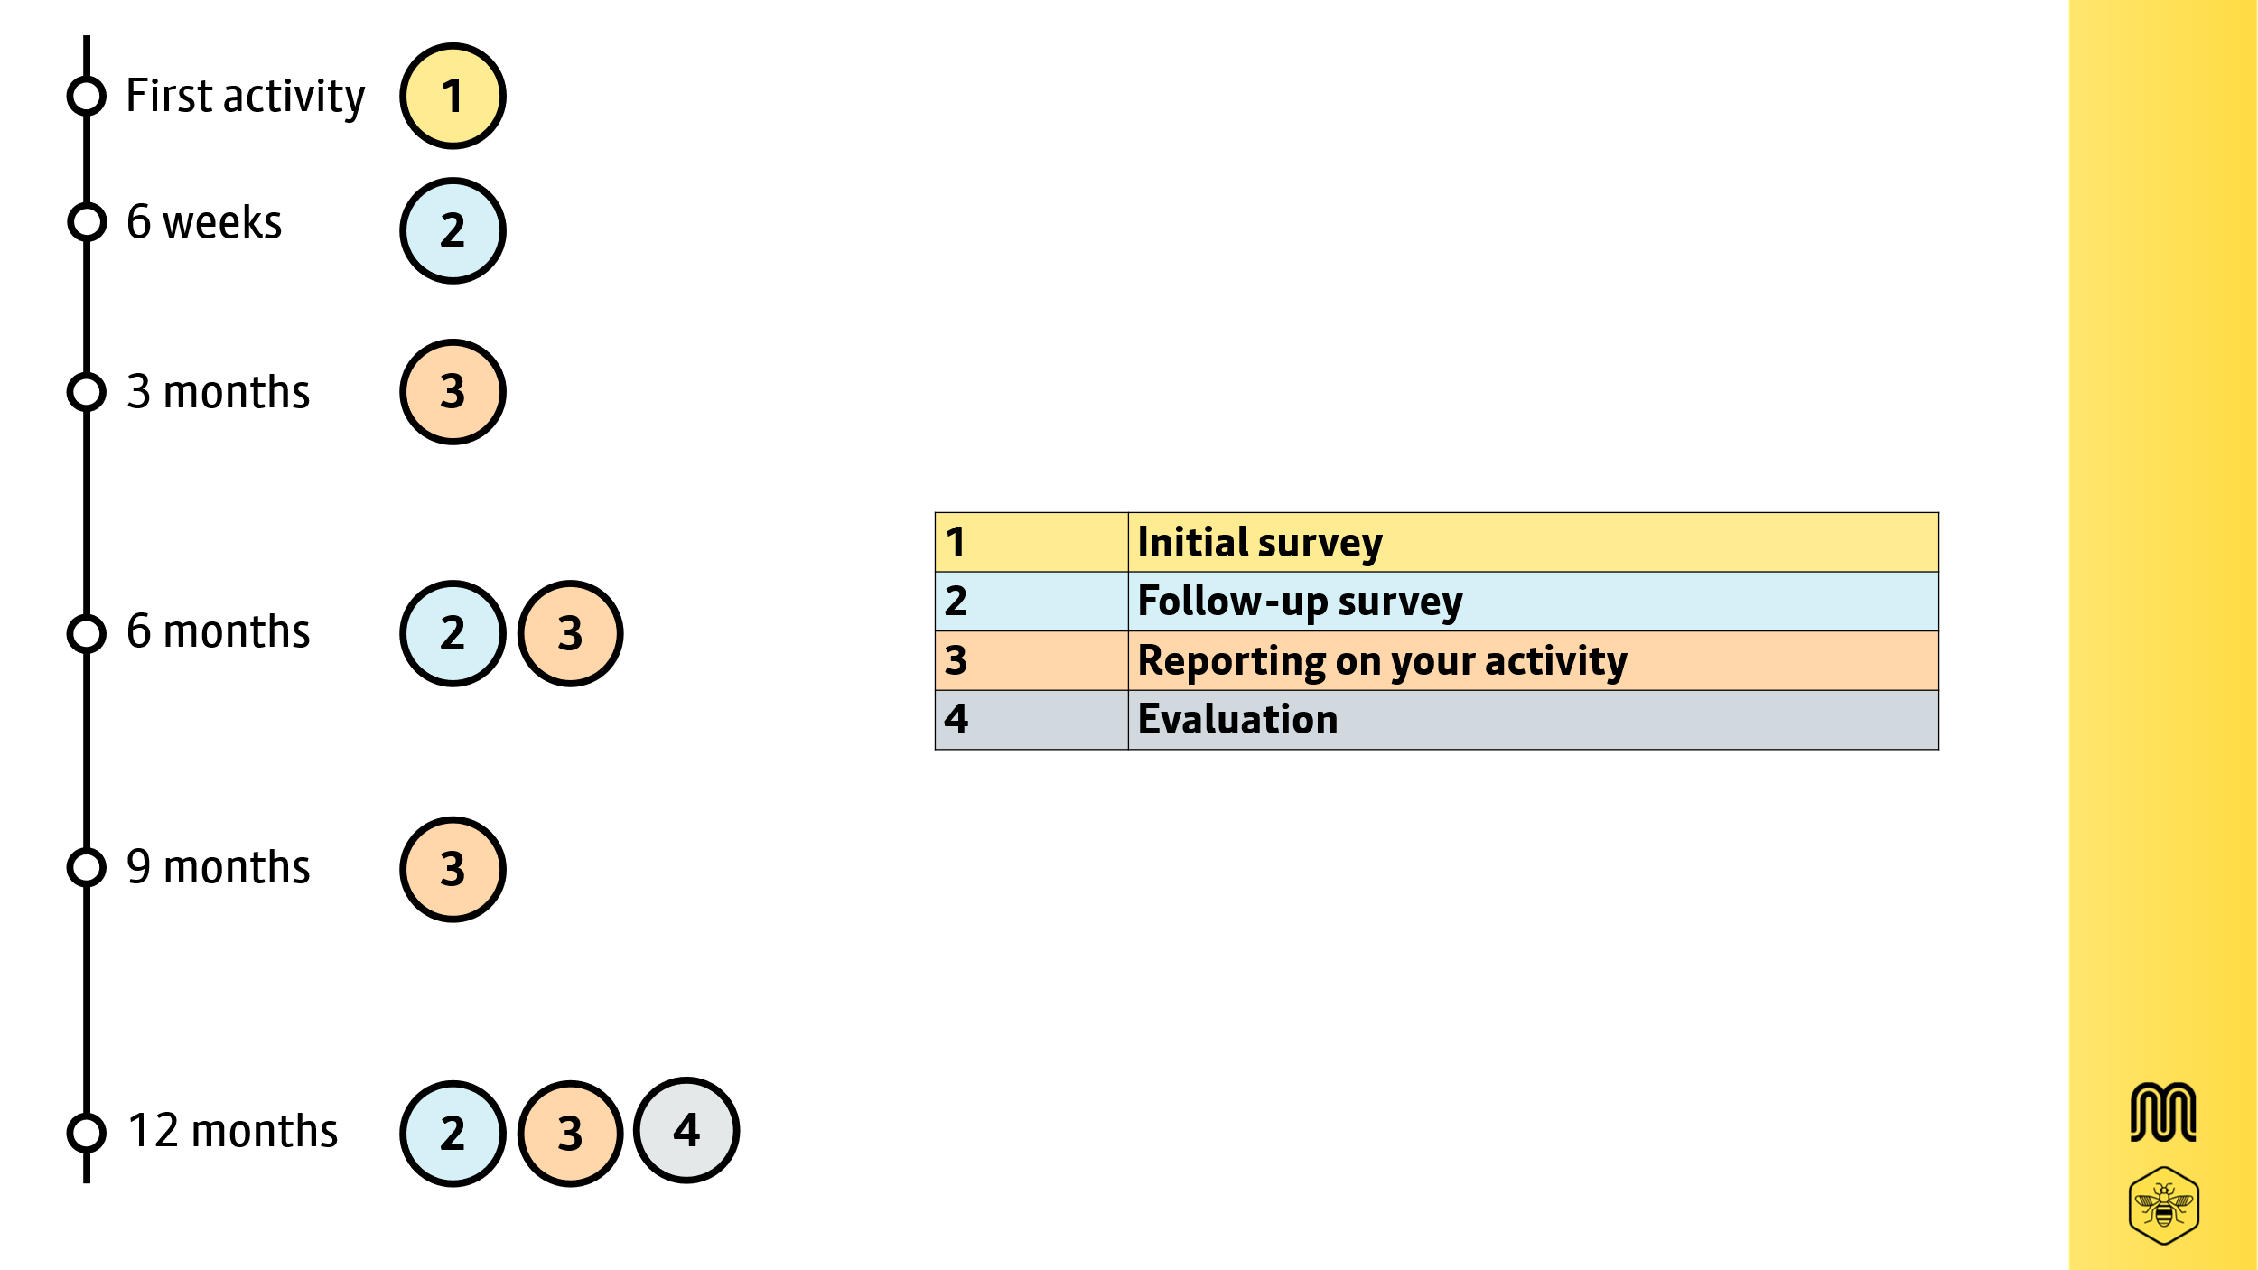

Collecting the Data
From our experience collecting data can be extremely challenging, and we appreciate any effort you make to collecting as much data as possible. Here are some tips that might help:
- Create empathy. Explain to participants that your funding is based on collecting data and it supports the funding of future activities.
- Make it an event. Create 10 minutes during or after an activity for everyone to sit down and complete the survey. Biscuit, cuppa and a pen. This can work better for groups who need support completing surveys.
- Use all digital means. Use an iPad or tablet to collect the surveys digitally. Send timely reminders via whatsapp groups or emails.
- Get verbal commitments. Get the participant to commit to a day when they’re going to complete it, i.e. that night or before the next activity.
- Gameify it. Celebrate those who have complete surveys.

Inclusion and Accessibility of the Surveys
Where you see potential challenges for participants completing forms please contact us (wheelsandwalks@tfgm.com) and we can work together to create accessible and inclusive versions.

Children (under 16)
If your participants are children (under 16) it is essential that the survey is sent to their parents/carer/guardian for them to complete on the children’s behalf. This is to ensure the research complies with legislation and standards around research with children.

Supporting Emails / Communications
When collecting data, in person or distributing the surveys digitally, you may want to include some context as to why you’re asking participants to provide their information.

Wording for Participants Aged 16 and Over
As you may be aware, some of [GROUP] activities are being delivered through support received by Transport for Greater Manchester (TfGM), known as the ‘Wheels and Walks’ project. As such, there is a requirement to monitor the impact on the people that are participating. TfGM are keen to hear the views and experiences of the people participating in these activities and how it has impacted them.
We would be very grateful if you could complete this survey before you participate in your next activity. It should take less than 10 minutes to complete, and will ask about current behaviour (in walking, wheeling or cycling), levels of physical activity and attitudes and barriers you might have to walking and cycling.
The data will be handled in accordance with Data Protection and GDPR (General Data Protection Regulation ) requirements , which means you have rights in relation to your personal data, and more information on this can be found within the survey itself, and also the privacy notice here (https://tfgm.com/privacy-policy).

Wording for Participants Under 16
As you may be aware, some of [GROUP] activities are being delivered through support received by Transport for Greater Manchester (TfGM), known as the ‘Wheels and Walks’ project. As such, there is a requirement to monitor the impact on the people that are participating. TfGM are keen to hear the views and experiences of the people participating in these activities and how it has impacted them.
We would be very grateful if you could complete this survey on behalf of your child before they participate in the next activity. It should take less than 10 minutes to complete, and will ask about current behaviours (in walking, wheeling or cycling), levels of physical activity and attitudes and barriers they might have to walking and cycling.
The data will be handled in accordance with Data Protection and GDPR (General Data Protection Regulation ) requirements , which means you have rights in relation to your personal data, and more information on this can be found within the survey itself, and also the privacy notice here (https://tfgm.com/privacy-policy).

Privacy Notice
Both the digital and paper versions of the surveys have a privacy notice and a web link to TfGM’s privacy policy. If questions arise then please refer them to our online Privacy policy | Bee Network | Powered by TfGM. If they still have questions please ask them to email wheelsandwalks@tfgm.com.

Paper Versions of Surveys
A link has been provided to download and print paper versions of the surveys. If you prefer us to print copies and post them please let us know how many and your postal address.
When paper versions are complete, please keep them secure, ideally locked away until they’re ready to be returned.
If you are wanting to return surveys please drop us a message. A member of the team may be in the location to collect in person. However if returning paper surveys by post please ensure they’re sealed. Request a signature upon delivery and keep a copy of the receipt. Our postal address is:

FAO Tommy Morrisroe
Active Travel Team
TfGM
2 Piccadilly Place
Manchester
M1 3BG

Evaluation
Details on how we will collectively evaluate Wheels and Walks will be provided nearer the closure of your programmes.

