Transport for Greater Manchester Wheels and Walks Initial Survey
Completing this survey
 | You can complete this survey on your computer.
 | When you open the survey on your computer you will be able to click on the tick boxes.
 | When the survey is complete please email it to: wheelsandwalks@tfgm.com
 | You can also print out this survey, and fill it in with a pen.
 | If you have filled it in with a pen please post your completed survey to:  Active Travel Team  TfGM  2 Piccadilly Place  Manchester, M1 3BG

About this survey
 | We have some questions for you to answer.
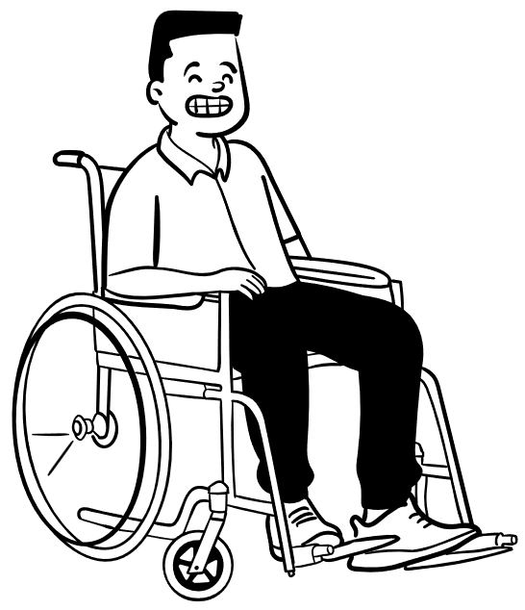  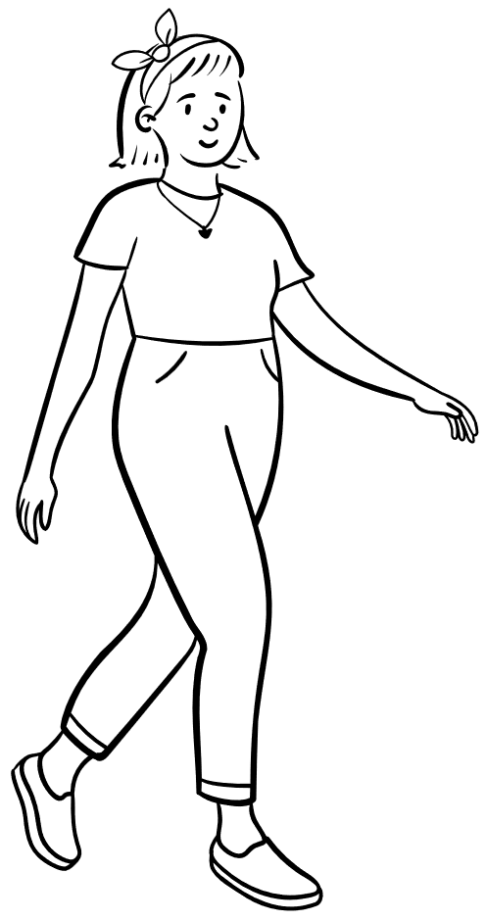  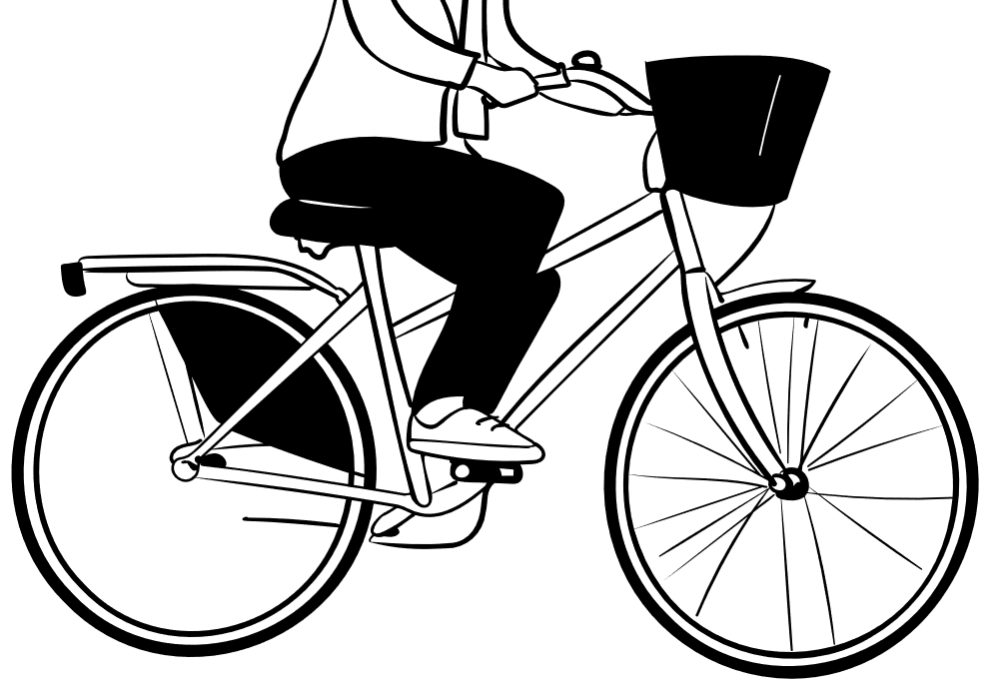 | The questions are about your walking, wheeling or cycling habits.
   | We will also ask what group you are taking part with.  We will also ask questions about you

General questions
Question 1:   | What is the date today?
Question 2:   | What is the name of the group or organisation you are taking part with?

- If you walk with this group please only complete the walking questions.

- If you wheel with this group please only complete the wheeling questions.

- If you cycle with this group please only complete the cycling questions.

Now please answer the questions about the activity you are doing

Questions About Your Walking

Question 1:  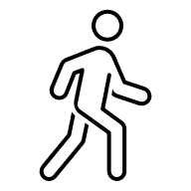 | On average, how many days a week do you walk? Tick one.  ☐ 0 day a week  ☐ 1 day a week  ☐ 2 days a week  ☐ 3 days a week  ☐ 4 days a week  ☐ 5 days a week  ☐ 6 days a week  ☐ 7 days a week

Question 2:                     | Do you walk to get to any of these places? Tick the ones you so.  ☐ Work  ☐ Unpaid / voluntary work  ☐ Education (as a pupil)  ☐ Health or medical visit  ☐ Shopping  ☐ Entertainment / recreation  ☐ Social / visit friends or relatives  ☐ To get on a bus, train or tram  ☐ None of the above  ☐ Other (please write this below)
Question 3:       | Do you enjoy walking?  ☐ Yes. I enjoy walking.  ☐ I sometimes enjoy walking.  ☐ I do not enjoy walking.

Questions About Your Wheeling

Question 1: | On average, how many days a week do you wheel? Tick one.  ☐ 0 day a week  ☐ 1 day a week  ☐ 2 days a week  ☐ 3 days a week  ☐ 4 days a week  ☐ 5 days a week  ☐ 6 days a week  ☐ 7 days a week

Question 2: | Do you wheel to get to any of these places? Tick the ones you so.  ☐ Work  ☐ Unpaid / voluntary work  ☐ Education (as a pupil)  ☐ Health or medical visit  ☐ Shopping  ☐ Entertainment / recreation  ☐ Social / visit friends or relatives  ☐ To get on a bus, train or tram  ☐ None of the above  ☐ Other (please write this below)
Question 3: | Do you enjoy wheeling?  ☐ Yes. I enjoy wheeling.  ☐ I sometimes enjoy wheeling.  ☐ I do not enjoy wheeling.

Questions About Your Cycling

Question 1:   | On average, how many days a week do you cycle? Tick one.  ☐ 0 day a week  ☐ 1 day a week  ☐ 2 days a week  ☐ 3 days a week  ☐ 4 days a week  ☐ 5 days a week  ☐ 6 days a week  ☐ 7 days a week

Question 2: | Do you cycle to get to any of these places? Tick the ones you so.  ☐ Work  ☐ Unpaid / voluntary work  ☐ Education (as a pupil)  ☐ Health or medical visit  ☐ Shopping  ☐ Entertainment / recreation  ☐ Social / visit friends or relatives  ☐ To get on a bus, train or tram  ☐ None of the above  ☐ Other (please write this below)

Question 3: | Do you enjoy cycling?  ☐ Yes. I enjoy cycling.  ☐ I sometimes enjoy cycling.  ☐ I do not enjoy cycling.

Question About You
  Question 1: | What is your postcode please?
  Question 2: | How old are you?  ☐ Under 16  ☐ 16  ☐ 17-18  ☐ 19-24  ☐ 25-34  ☐ 35-44  ☐ 45-54  ☐ 55-59  ☐ 60-64  ☐ 65-74  ☐ 75+  ☐ Prefer not to say
Question 3:              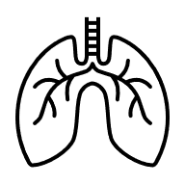     | Are your day-to-day activities limited because of a long-term health problem or disability?  ☐ No  ☐ Yes, mobility or walking difficulty  ☐ Yes, wheelchair user  ☐ Yes, manual dexterity (affecting ability to use hands to do everyday tasks)  (there are more options on the next page)  ☐ Yes, deaf, hearing loss or hard of hearing  ☐ Yes, blindness or partial sight  ☐ Yes, difficulty speaking  ☐ Yes, mental health condition  ☐ Yes, conditions affecting ability to learn, understand, concentrate or read  ☐ Yes, lung condition/breathing difficulties  ☐ Prefer not to say  ☐ Other (What health problem or disability limits your activities?):

