Transport for Greater Manchester Wheels and Walks Follow-Up Survey
Completing this survey
 | You can complete this survey on your computer.
 | When you open the survey on your computer you will be able to click on the tick boxes.
 | When the survey is complete please email it to: wheelsandwalks@tfgm.com
 | You can also print this survey, and fill it in with a pen.
 | Please post your completed survey to:  Active Travel Team  TfGM  2 Piccadilly Place  Manchester, M1 3BG

About this survey
 | We have some questions for you to answer.
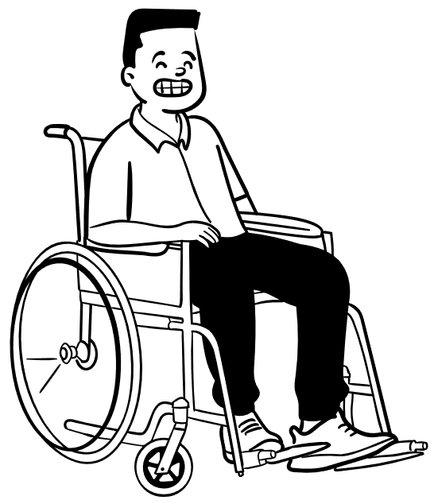  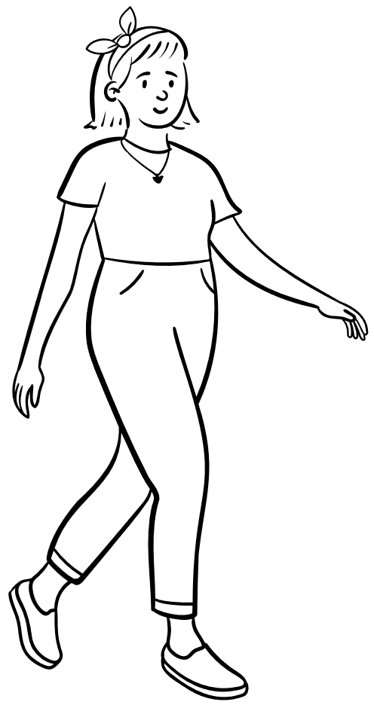  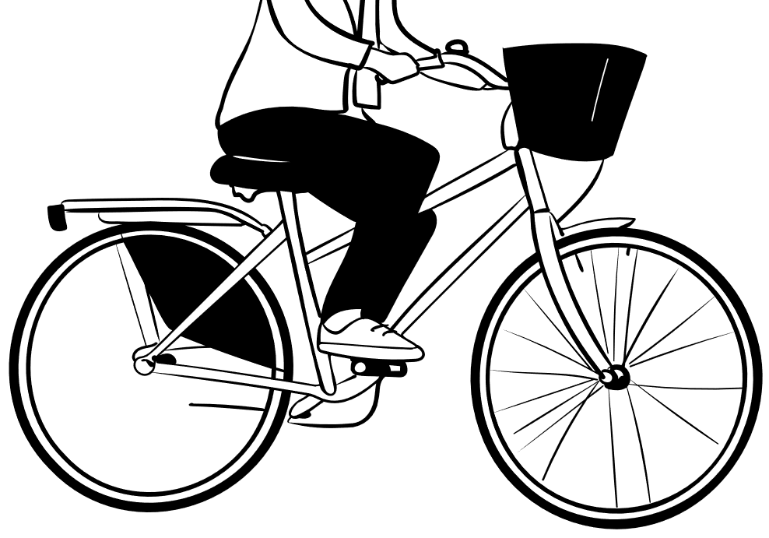 | The questions are about your walking, wheeling or cycling habits.
 | Please only tick one box for each question.

General questions
Question 1:   | What is the date today?
Question 2:   | What is the name of the group or organisation you are taking part with?

x
- If you walk with this group please only complete the walking questions.

- If you wheel with this group please only complete the wheeling questions.

- If you cycle with this group please only complete the cycling questions.

Questions about Walking

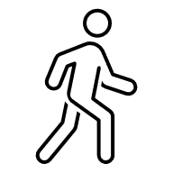     | Question 1  Think about how often you walked before you started walking with this group. Are you walking more now?  ☐ Yes, I walk more now than before I joined the group.  ☐ I walk the same now as I did before I joined the group.  ☐ No, I walk less now than before I joined the group.

 | Question 2  Think about when you are not walking with this group.  Do you walk to other places more now than before you joined this group?  For example, do you walk to the shops more now?  ☐ Yes, I walk more now.  ☐ I walk about the same amount.  ☐ I walk less now.
     | Question 3  Think about much you enjoy walking.  Do you enjoy walking more now than before you joined the group?  ☐ Yes, I enjoy walking more now.  ☐ I enjoy walking about the same.  ☐ I enjoy walking less now.

Questions about Wheeling

Question 1
Think about how often you wheeled before you started wheeling with this group. Are you wheeling more now?

☐ Yes, I wheel more now than before I joined the group.

☐ I wheel the same now as I did before I joined the group.

☐ No, I wheel less now than before I joined the group.

Question 2
Think about when you are not wheeling with this group.
Do you wheel to other places more now than before you joined this group?
For example, do you wheel to the shops more now?

☐ Yes, I wheel more now.

☐ I wheel about the same amount.

☐ I wheel less now.
Question 3
Think about much you enjoy wheeling.
Do you enjoy wheeling more now than before you joined the group?

☐ Yes, I enjoy wheeling more now.

☐ I enjoy wheeling about the same.

☐ I enjoy wheeling less now.

Questions about Cycling

Question 1
Think about how often you cycled before you started cycling with this group. Are you cycling more now?

☐ Yes, I cycle more now than before I joined the group.

☐ I cycle the same now as I did before I joined the group.

☐ No, I cycle less now than before I joined the group.

Question 2
Think about when you are not cycling with this group.
Do you cycle to other places more now than before you joined this group?
For example, do you cycle to the shops more now?

☐ Yes, I cycle more now.

☐ I cycle about the same amount.

☐ I cycle less now.
Question 3
Think about much you enjoy cycling.
Do you enjoy cycling more now than before you joined the group?

☐ Yes, I enjoy cycling more now.

☐ I enjoy cycling about the same.

☐ I enjoy cycling less now.

Question About You
  Question 1: | What is your postcode please?
  Question 2: | How old are you?  ☐ Under 16  ☐ 16  ☐ 17-18  ☐ 19-24  ☐ 25-34  ☐ 35-44  ☐ 45-54  ☐ 55-59  ☐ 60-64  ☐ 65-74  ☐ 75+  ☐ Prefer not to say
Question 3:                   | Are your day-to-day activities limited because of a long-term health problem or disability?  ☐ No  ☐ Yes, mobility or walking difficulty  ☐ Yes, wheelchair user  ☐ Yes, manual dexterity (affecting ability to use hands to do everyday tasks)  (there are more options on the next page)  ☐ Yes, deaf, hearing loss or hard of hearing  ☐ Yes, blindness or partial sight  ☐ Yes, difficulty speaking  ☐ Yes, mental health condition  ☐ Yes, conditions affecting ability to learn, understand, concentrate or read  ☐ Yes, lung condition/breathing difficulties  ☐ Prefer not to say  ☐ Other (What health problem or disability limits your activities?):

x

