Bike Library Grant Application Form

Before completing the application form, please make sure you have read the Bike Library Guidance Notes document.
For any queries, you can contact Transport for Greater Manchester’s (TfGM) Active Travel team at active.travel@tfgm.com. If you would like to speak to a member of the team, please email with your phone number and a conversation will be arranged.
Section 1: Organisation details

1.1 Contact details
Name of organisation:

Lead contact:

Position in the organisation:

Contact address including postcode:

Local Authority area(s):
Contact Tel:
E-mail:
Website:

Facebook/Twitter:

1.2 What is the legal / charitable status of your organisation
☐ Charity
☐ Company limited by guarantee Company number ……………….
☐ Charitable Trust
☐ Community Association
☐ Community Interest Company Registered number …………….
☐ Constituted Group
☐ Co-operative
☐ Friends Society
☐ Registered Charity Registered number ……………….
☐ Charitable Incorporated Organisation
☐ Not Constituted
☐ Social Enterprise
1.3 How long has the organisation been operating
Section 2: Project Details

2.1 Overall description of Bike Library
Please provide an overview of the bike library you have planned. What does the bike library look and feel like – e.g. location, when will it open, who will be the staff to assist, how will bikes be donated, type of bikes provided, who is the library for, how long do you expect loans to be for, how will you ensure the project is sustainable.
Location:
Opening Days / Times:
Staffing / Volunteers:
Source of Bikes:
Types of Bikes, including Adapted Bikes:
Intended Audience(s):
Intended loan duration(s):
Sustainability Plan:
Where the bike library is an expansion of your current enterprise, please be clear how this funding contributes to activity over and above what you already do:

2.1.1 Any other relevant information not covered by the above:
2.2 Will you be working in partnership in order to deliver the library Yes / No
If yes, please list your partners and what role they will have in the project.

2.3 Who are you targeting the bike library at? Please tick all that apply:
Young children |  | Adults
School age children |  | Families
16 to 18 year olds |  | Unemployed
Disabled people/people with learning disabilities (incl adapted cycles) |  | Jobseekers
Recently employed/entering training
Other (please specify):

2.4 Project timetable
Please include key milestones in terms of implementing your bike library (e.g. premises, staffing, collection/purchase of bikes, bikes ready to be loaned etc)
Premises Agreed | Staffing / Volunteers in Place: | Bikes Sourced and Ready to Loan | Supporting Processes in Place | Forecast Launch Date
Input Date: | Input Date: | Input Date: | Input Date: | Input Date:

2.4.1. Accompanying Notes / Clarifications to the above:
2.5 Location of bike library and any donation station/s*
*Please read the guidance notes document for an explanation of what is meant by donation station
Please list the specific sites that you will operate your bike library from, including full site postcodes. Please also include sites for donation stations.

2.6 Bike donations
If you will be reliant on bike donations, please outline how you will go about securing donations.
TfGM will look to support donations where possible and can provide advice.

2.7 Cycle maintenance
Please specify how you will manage the maintenance and repair of cycles.

Do you have staff or volunteers that are trained to a recognised industry standard, such as Cytech or City & Guilds? Yes / No
2.8 Staffing
How will the project be managed and staffed? How many staff or volunteers are expected to be part of the project?

2.9 Sustainability of the bike library
Please add any plans or opportunities you have or are aware to maintain the bike library beyond the initial grant.

2.10 How many bikes and loans do you expect in the first year?
Please provide an explanation as to how you have arrived at these figures.

2.11 Marketing and Engagement
How are you going to engage and communicate with your target audience/s? How will you encourage donations? How will you promote the bike library to encourage users to use access the library?
(NB TfGM will look to provide materials and support in this area too)

2.13 Experience
If your organisation or partner organisation has experience of delivering similar projects, please outline here

2.14 Monitoring and Evaluation

Across all libraries, evidence will be required to demonstrate what is achieved. Reimbursements will be conditional on evidence of monthly data submissions.

Monthly reporting submission will be required to confirm:

- New and Total Members
- Number of Bike Loans (including by day breakdown)
- Durations of Bike Loans
- Average and Maximum number of Bike Loans per Member.

Here’s an example of what the submission form looks like:

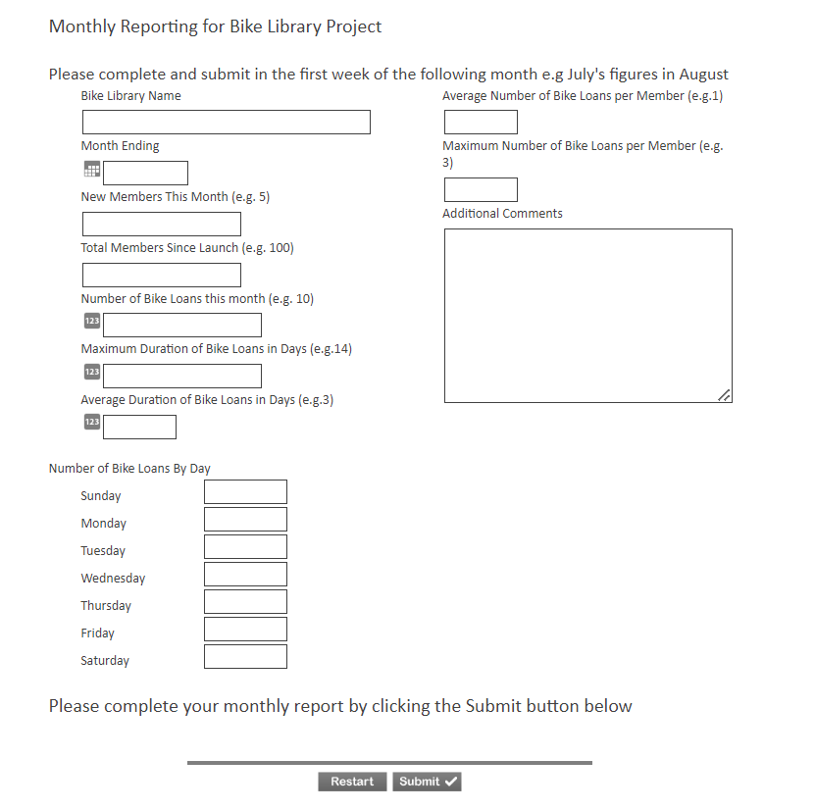

Are you willing and able to complete this on a monthly basis? Yes / No

Are you willing to collate and submit case studies of library usage? Yes / No

How will you additionally monitor the progress and measure the success of the project?

Including the below:

2.14.1 How will you manage finances?
2.14.2 How will you plan for the delivery and implementation of your project?
2.14.3 How will you measure what you have delivered (outputs)?
2.14.4 How will you evidence that your project has made a difference (outcomes)
2.15 Are you in receipt of other relevant funding? Yes / No
If yes, please provide details

2.16 Are you currently involved in delivery of other active travel related projects, TfGM funded or not?

Yes / No

If yes, please provide details

Section 3: Financials

 | 3.1 Please provide a detailed breakdown of the grant requested (up to a maximum of £5,000)
Budget heading  (e.g. storage, equipment, training etc) |  | Breakdown of activity and costs  (How have you worked out your costings?) | When costs will be payable | Amount requested (£) and when required
Revenue Costs

Equipment / Tools / Parts

Relevant Promotional Events

Training Costs

One-Off Transport Costs

Volunteer Expenses

Storage Costs

Reasonable Capital Costs

Other

TOTAL

 | 3.2 Please provide details of any match funding or in-kind support that will also contribute to this project (please detail whether this is money or volunteer time (estimated equivalent £11.09 per/ hr), rent free room hire, other resources etc.

Section 4: Conflict of interest

Does anyone on your management committee / board have a prior connection, affiliation or interest in Transport for Greater Manchester? E.g. employee

Yes / No If yes, please state relationship:

Section 5: Check list

Please confirm that your organisation has the relevant supporting information required by TfGM. All successful applicants will be required to supply a copy of these documents as part of the grant agreement, prior to any funding being released.

Required supporting information | Please tick
Governing document (constitution / terms of reference) that has been signed by two or more members
Bank account in organisation’s name with at least two unrelated signatories (we will require a copy of a bank statement)
Insurance - public liability and employers’ liability (if you employ staff)

Safeguarding policy

Section 6: Conditions of grant

Please review the following before submitting your application.

If successful in full or part, we confirm that we accept the following conditions:

- We will only spend the grant money in accordance with our grant application form. If there is a need to change the use of the grant, we will request permission from Transport for Greater Manchester (TfGM) as soon as possible.
- If the main contact leaves the group or can no longer fulfil their responsibilities, or someone takes over responsibility for the grant on behalf of the group, we will inform TfGM immediately.
- We will ensure the group makes the project as accessible as possible and agree to implement and ensure equal opportunities.
- We will ensure we have adequate insurance to carry out the project and that staff, volunteers, trainers and consultants are suitably qualified and trained and we will supply copies of documents if requested.
- We acknowledge responsibility for all risk assessment and health and safety checks for the project.
- We will ensure that all volunteers and staff working with any vulnerable people are DBS checked and adhere to the safeguarding policies and procedures we have as an organisation and we will supply copies of these if requested.
- TfGM representatives can visit the project for monitoring and evaluation purposes.
- We will support monitoring, evaluation and data protection, in line with guidance from TfGM
- We will submit monitoring and evaluation data monthly in line with the requirements set out by TfGM. We understand that failure to do so may mean that funding reimbursements will not be made, and that this also could influence future funding applications
- At the end of the project (within a year of receipt of the grant) we will produce a short report and case study (including photos and beneficiaries feedback) outlining how the funding benefited individuals and the group, and others that you worked with.
- We will ensure that the above report and case study is given to TfGM in the required timescales and understand that failure to do so will influence future funding application decisions.
- We accept that we may be asked to return this grant should TfGM deem the evidence provided by us in our end of grant report is unsatisfactory. This will also apply if TfGM discovers that money has been spent on items not specified in the original application form and grant offer.
- All original receipts will be kept and copies made available for TfGM.
- We will repay any money unspent during the project lifetime to TfGM within a month of our project ending.
- We understand that if we don't meet these terms and conditions our grant may be withdrawn.
- We will provide a welcoming, caring and good service that does not discriminate against any individual.

Declaration

- I certify that the information contained in this application is correct. I understand that if in any way the information is not correct the application may be disqualified or any grant awarded will be payable on request.
- If the information changes in any way I will inform TfGM as soon as possible.

Lead contact for this project:
Role within organisation:
Signature:
Date:

Other contact for the organisation

Role within organisation:
Signature
Date:
Please send your completed application by email before close of business on the 26th May 2023:

Email: active.travel@tfgm.com

Please add “Bike Library Grant Application” in the subject field

