Wheels and Walks
Application Guidance
Contents
Wheels and Walks Application Guidance 1
Before you apply: checklist 3
Get in touch 3
About Wheels and Walks 4
Programme timeframes 5
A guide to writing your application 6
Eligibility criteria 8
Grant criteria 9
What can grants be used for: 9
What can grants not be used for: 9
Payments of grants 10
Providing quotes in your application 10
VAT 10
The declaration 10
Assessment and evaluation of your application 11
How we’ll grade your application 11
Guidance for non-scoring questions 12
Answering the Scored Questions 14
Question 1 14
Question 1 guidance 14
Question 2 15
Question 2 guidance 15
Question 3 16
Question 3 guidance 16
Question 4 17
Question 4 guidance 17
UK Subsidy Control Regime and Minimum Financial Assistance (MFA) 18

Before you apply: checklist
Before you start your application make sure your group meets read and understood the following:
☐ Your group meets the eligibility criteria and has a community or charity bank account.
☐ You can deliver your activity within the timeframes.
☐ Understand that not all the funding is paid upfront and we require evidence of spend.
☐ Your activity will be risk assessed, insured and meets required safeguarding policies and procedures.

Get in touch
Once you’ve read through the application guidance if you require further support or have questions about Wheels and Walks please contact the team via:
E-mail: WheelsandWalks@tfgm.com Telephone: 07766363196

About Wheels and Walks
The Wheels and Walks programme is designed to support community-based groups with more than funding, so they can support people in their communities to walk, wheel or cycle.
TfGM’s Aim |  | By 2040 TfGM want 50% of all journeys in Greater Manchester to be made by public transport, on foot or by bike, especially those shorter journeys around local neighbourhoods. Enabling us to deliver a healthier, greener and more productive city-region.

Wheels and Walks Aim |  |  |  | To enable thriving and aspiring community groups to be self-sustaining communities for walking, wheeling and cycling.
 |  | How TfGM will achieve this |  |  | How YOU can achieve this
 |  | - Support community-based groups to deliver walking, wheeling and cycling activity in their local areas.  - Provide groups with up to £5,000 of grant funding.  - Support groups with training and development opportunities.  - Facilitate networking and knowledge sharing across other groups, local authorities and organisations.  - Connect groups to opportunities within and outside of TfGM. |  |  | - Design your programme to meet the needs of your communities.  - Deliver a programme that increase behaviour in walking, wheeling or cycling.  - Be a community champion towards your activity and active travel.  - Be open to other opportunities to grow and develop you and your group.  - Complete any monitoring and evaluation and tell us success stories  - Encourage active travel to your audiences

Programme timeframes

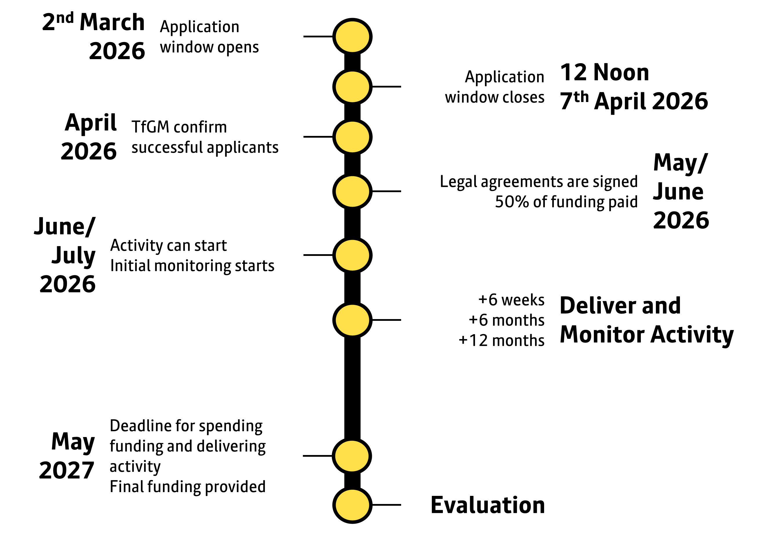

Advice
Before you put pen to paper we want to provide you with guidance on how to approach writing your application. You may already know what you want to deliver, and how you’ll do it – and that’s great. Or you may know that you want to help a specific community, but not sure on what to deliver.
This short guide will help you transfer that idea into this application.

START
- Write your goal
  - In one sentence write down what your programme is wanting to achieve. Think about who is taking part and what the activity is. For example; ‘want to support blind adults to walk independently locally’, or ‘support more women feeling safe so they can cycle regularly with children’.

- Identify your audience.
  - Be specific about them. Identify characteristics that might prevent them from taking part in your activity (gender, age, social, cultural, religious, location, etc).
  - Refer to Question 1 Guidance for more details.

- List their barriers
  - For each characteristic research and evidence why it stops them from taking part in that activity. TfGM, Sport England, Sustrans and many others all have research, data or evidence on different audiences for walking, wheeling and cycling. Have you your own data from other programmes or initiatives?
  - Now write down how this relates to their active travel behaviour. Would this barrier stop them from walking, wheeling or cycling to places?
  - Refer to Question 1 and 3 Guidance for more details.

- Design your activity
  - Think about each barrier towards their participation first. Now write how you’ll design your activity to reduce or overcome that barrier. You may be able to overcome many barriers through one action.
  - Now think about how designing your activity can support them to actively travel.
  - Now think about how that activity can be sustained, or how that person can continue doing that activity, beyond our 12 month support period.
  - Refer to Question 1, 3 and 4 Guidance for more details.

- List what you’ll need.
  - For every action write down what you’ll need. Think about the physical items but also the non-physical things; e.g. equipment, recruiting volunteers, training volunteers, marketing, development sessions.
  - Then split these items into two categories;
    - What you need ‘funding’ for from TfGM (a maximum of £5,000).
    - What you need ‘support’ for. This can be TfGM but also other organisations.
  - Refer to Question 2 Guidance for more details.

- Write a timeline.
  - What will happen and when. It’s important you know the order.
  - Think about milestones. For example when your first activity will be. When you’ll market it. When you’ll purchased everything you need to deliver the activity.
  - You don’t need to write everything down, but it’s important to understand and consider what needs to happen.
  - Refer to Question 2 Guidance for more details.

- Check in with TfGM
  - We’re hosting in-person drop-in sessions across Greater Manchester for you to discuss your ideas and applications with us, as well as an online session. We’re happy to discuss your ideas and help stimulate thoughts and considerations.

- Apply.
  - Via email or post.
  - Please also attach any supporting evidence to your application.

FINISH

Eligibility criteria
To ensure the grant money reaches the right groups and communities we have set eligibility criteria below. If your group is not listed below then please contact WheelsandWalks@tfgm.com
Eligible Groups | Ineligible Groups
- Voluntary and community organisation  - Registered charity  - Social enterprise  - Group of organisations, if they are led by a voluntary and community organisations or social enterprise  - Community interest companies (with two or more directors)  - An education provider, e.g. primary and secondary schools, further and higher education  - An NHS Healthcare provider, e.g. NHS Trust, GP Practice | - Individuals  - Sole traders  - Anyone who is applying on behalf of another organisation.  - Organisations without at least two unconnected people on the board or committee  - Companies that are aimed at generating profits for private distribution

Grant criteria
We’ve listed what the grants can and cannot be used for below. If you need clarity on any of the items listed please contact the team.

What can grants be used for:
- Delivery of an activity that increases participation in Active Travel– e.g. group cycle training, led rides, guided walks, themed walks, walks that include support for disabled people.
- Community based training – e.g. bike fix workshops, maintenance sessions.
- Purchase of physical assets – e.g. cycles, trailers, storage, tools, walking equipment, maps.
- Developing creative assets – e.g. podcasts, community art project, signage.
- Promotional activity e.g. posters, leaflets, videos.
- Establishing a community bike tool library or installing a public cycle maintenance station.
- Improving lighting or accessibility of a route - e.g. barrier/step free access points or resting places, braille signage, barrier removal.
- Maintaining a footpath or cycleway.
- Creating a pocket park or active travel corridor.
- Producing maps or trails that help or encourage people access their green spaces.
- A small portion of the grant can support the management and coordination of all aspects relating to the project.
All proposals that fund either capital or revenue items that fulfil the purpose of this measure will be considered.

What can grants not be used for:
- Any activity that does not contribute to the grant purposes outlined in this guidance.
- Purchases made prior to grant application and approval.
- Costs incurred bidding for the grant.
- The costs of obtaining planning permission.
- Day-to-day operational costs of an organisation including overheads.
- Match funding items more than £5,000.

Payments of grants
Grants will be paid in two stages:
- 50% will be paid upfront of any activity occurring. The necessary legal and financial agreements need to be in place first.
- The remaining 50% will be paid upon completion of your items listed. To claim your grant you should submit evidence of spend to TfGM, who will arrange for payment. All costs are calculated including VAT.
TfGM are flexible to the needs of individual groups and situations. If more than 50% of grant funding is needed upfront this must be declared by the group and will be reviewed by TfGM on a case-by-case basis.

Providing quotes in your application
Bids should be accompanied by current quotes from reputable suppliers for the goods and services you intend to procure. In line with TfGM’s procurement policy, the following quotes are required:
- 2 written or verbal quotes for goods/services up to £1,000
- 3 written quotes for goods/services between £1,001 and £10,000
Web links to retailer websites will suffice in place of formal written quotes if pricing (including any optional extras) is clearly displayed on the site.

VAT
If you can claim back the VAT on items then please state this when listing your costs.
If you are unable to claim back VAT on items please state this too. When including VAT your total cost must not exceed £5,000.

The declaration
Once you’re application has been approved we’ll ask you to sign a declaration. Signing this does not enter you into a legal agreement. The declaration lists what’s expected when joining the Wheels and Walks programme, and by signing it we can proceed to formalising it through a legal agreement.

Assessment and evaluation of your application
The application will be assessed on the following criteria (which is aligned to individual questions set out in the application form).

How we’ll grade your application
0 The proposal does not demonstrate an understanding of the requirement and issues and/or there is a major risk that the intended outcomes / performance standards will not be achieved or delivered. The level of evidence in support of the proposal is either unacceptable or non-existent.
1 The proposal demonstrates extremely limited understanding of the requirements and issues. There is a significant risk that the majority of the intended outcomes / performance standards will not be achieved or delivered. The level of evidence in support of the proposal is deficient in the majority of areas and overall shows significantly more weaknesses than strengths.
2 The proposal demonstrates some understanding of the requirements and issues, although there is a risk that some of the intended outcomes / performance standards will not be achieved or delivered. The level of evidence in support of the proposal is deficient in some areas and requires the evaluator to make assumptions. Overall the proposal is equally balanced in respect of strengths and weaknesses.
3 The proposal demonstrates a reasonable understanding of the requirements and issues and provides an acceptable degree of confidence that the intended outcomes / performance standards will be achieved and delivered. Overall the proposal evidences more strengths than weaknesses.
4 The proposal demonstrates a good understanding of the requirements and issues and provides a high degree of confidence that the intended outcomes / performance standards will be achieved and delivered. The level of evidence fully supports the proposal and meets expectations.
5 The proposal demonstrates a comprehensive understanding of the requirements and issues and provides an exceptional degree of confidence that the intended outcomes / performance standards will be achieved and exceeded to the benefit of TfGM. The level of evidence clearly demonstrates an ability to deliver.

Guidance for non-scoring questions
Some questions are clear on what information we need. For some of the open questions we’ve provided further clarity on the information we require:
Section | Question | Explanation
3 | What is the main Local Authority your activity will be delivered in? | We only require the main local authority your activity will be delivered in, even if you’re delivering across more than one local authority. Please select the local authority you will deliver the most activity in.  If you’re delivering activity equally across all of Greater Manchester then please select Greater Manchester wide.
3 | Who is/are your key target audience(s)?  Please provide further detail of your target audience | Please select the main demographic of your audience. If your audience has multiple demographic attributes, then please select the main demographic you’ve designed your activity to support.  In the box below we’ve provided an open text box for you to describe your audience. This is a chance to explain who they are.  Avoid referencing their barriers or issues as this is a scored question in the application form.
4 | In one sentence describe your programme | We will use this sentence when describing your activity in promotional materials or to stakeholders. For examples:  - Encouraging black and ethnic 14-25 years to hike through a programme of local hikes in Salford, wider education around health and providing equipment.  - Encouraging older people in Oldham to be less socially isolated through a regular walking group and socialising at a café.  - Supporting women and girls to cycle in Stockport through the provision of loaning bikes, equipment, providing coaching sessions, and delivering led-rides.
4 | What activity will your programme focus on? | Some clarity on the activity:  - Walking: where people are on foot.  - Wheeling: includes wheelchairs and scooting.  - Cycling: includes disability cycling and e-bikes.  When providing further details please be specific about what the activity is. There is space below to write every type of activity you’ll deliver so please keep this section simple.
4 | Please provide some details of the activity / activities you’ll be delivering. | Please detail all the different types of activities you’ll be delivering. Activities can be anything that supports your audience towards participating in the activity, and can include training, education, development, or similar sessions.  Please list every different activity you’ll deliver. For example:  By providing this information it gives us an indication of what you’ll be delivering and what impact it may have. This information is not scored.
  Please list the activities you’ll be delivering: | Please tell us how many times you’ll deliver each activity | On average how many people will attend each activity
  A weekly bike ride | 25 | 8
  Fix your bike workshop | 3 | 10

Answering the Scored Questions
There are four questions each worth a different amount.

Question 1
Please tell us the barriers (i.e. what is stopping) your audience has from taking part in your activity? How have you designed your activity to support your target audience in overcoming those barriers?
This is a scored question worth 25% of your overall score.
Question 1 guidance
We want to know how well you know your audience and how you’ve designed your activity to meet their needs.
In the left column write what barriers your audiences has towards your activity, writing one barrier per line. Here’s what to consider when writing about your audiences’ barriers:
- Consider all the individual characteristics of your audience; age, gender, economic, cultural, social, etc.
- Relate each characteristic to your activity. Tell us what stops them from taking part.
- Are any of these local issues or barriers?
- Evidence each one. Use statistics or anecdotal data.
In the right column write the actions and how you’ve designed your activity to overcome this barrier. Include:
- What will you deliver in relation to that barrier.
- How you’ve designed it to meet their needs.
- How your activity is appropriate to your audience.
- How it will increase participation in your activity.
There’s an additional text box to provide further details should you need.

Question 2
Please outline your plan. During the 12 months of TfGM’s support what will happen and when. Please include any documents or visuals to support your 12 month plan.
This is a scored question worth 25% of your overall score.

Question 2 guidance
We want to know what will happen and when.
When writing your 12 month plan we advise you approach it by a month by month perspective. So for example write what will happen in month 1, month 2 etc.
Consider the following when answering this question:
- The order that things need to happen.
- How much time it will take to achieve it. And consider what if things might take longer than expected.
- Setting up your activity. What items you need before you start. What training or recruitment is required.
- Risk assessments, safeguarding and GDPR measures.
- How you’ll market your activity to your audience.
- What activity you will deliver and when it will commence. Where will it be delivered. Who will deliver it.
- Any milestones you want to achieve and when.
If you have a graph, chart, calendar or any other visual way of showcasing your plan please attach it to your application.

Question 3
How will your activity encourage active travel in your target audience?
This is a scored question worth 20% of your overall score.

Question 3 guidance
We want to know how your activity can increase active travel in your audience.
Highlight how you’ve designed your programme to not only increase participation in your activity (e.g. walking or cycling), but how you’ve also designed it so that person might use that activity to get to places. Consider:
- Reference any of their barriers towards active travel (or reference their barriers towards the activity and how this might relate to active travel).
- How have you designed your programme to increase active travel in that activity.
- What are you delivering that will support their active travel behaviour.
- Identify if your audience has a strong reliance on car travel.
- And/or a reluctance towards active travel.

Question 4
What support will you put in place to encourage people to continue in the activity beyond the 12months of support?
This is a scored question worth 30% of your overall score.

Question 4 guidance
We want to know how you’re designing your programme so those who take part will continue that activity beyond our funding.
- What activity will continue beyond the funding.
- How will your activity be sustained. Consider how you’ll fund the activity, the venue, training requirements, retention of volunteers, access and use of equipment, retention of existing participants.
- What aspects might not continue,
- What level of safety, safeguarding and GPDR will remain.
- How will your audience continue in that activity. What signposting to other opportunities will occur.
- Demonstrate or evidence a high level of confidence in them continuing the activity themselves.
- Explain how your audience will continue any active travel in your activity.

UK Subsidy Control Regime and Minimum Financial Assistance (MFA)
TfGM is offering this grant as a Minimum Financial Assistance (MFA) subsidy under the Subsidy Control Act (2022). The MFA regulation allows an enterprise to receive up to £315,000 of subsidies in total over three fiscal years.
MFA Subsidy Control will apply to any charities, social enterprises and not-for-profits engaged in economic activity (i.e. putting goods and services on a market) as the substantive means of funding their activities, whether or not a profit is made. This includes education providers whose services are principally funded through private resources, for example the resources of students and parents, or through the operator’s own commercial revenues.
MFA does not apply to NHS healthcare services or education services organised within the national education system, which are both funded through public funds and supervised by the UK Government or are principally funded, whether directly or indirectly, through public resources.
Public authorities awarding subsidies as MFA must follow certain procedural requirements. Before awarding an MFA subsidy a public authority has to provide the intended recipient enterprise with an ‘MFA notification’.
An MFA notification means a written statement:
- explaining that the public authority is proposing to give to the enterprise a subsidy by way of MFA
- specifying the gross value amount of the assistance, and
- requesting written confirmation from the enterprise that the MFA threshold of £315,000 will not be exceeded by the enterprise receiving the proposed assistance
The public authority can only award the subsidy when it has received this confirmation.
This guidance, in conjunction with section 6 of the application serves, as TfGM’s MFA notification.
If your organisation receives or has received public subsidy in the form of State Aid or UK Subsidy, it should keep records of all subsidies received.
MFA subsidies or comparable types of subsidies (see section 42(8) of the Subsidy Control Act) is cumulated over this and the previous two financial years, as specified in section 36(1) of the Subsidy Control Act (2022).
The MFA threshold period for this funding is between March 2024 to May 2026.
Receipt of an application with question 6 completed will serve as the applicant’s written confirmation that receipt of a grant from TfGM for the total amount sought will not exceed the organisation’s Minimum Financial Assistance threshold.
If an applicant is successful, the public authority must give the intended beneficiary an ‘MFA confirmation’. This is a written statement which confirms:
- that the subsidy is given as MFA
- the date on which it is given
- the gross value amount of the assistance
Link to website - The UK Subsidy Control Act.
Should your organisation’s bid be successful, your grant agreement will serve as the MFA confirmation.

