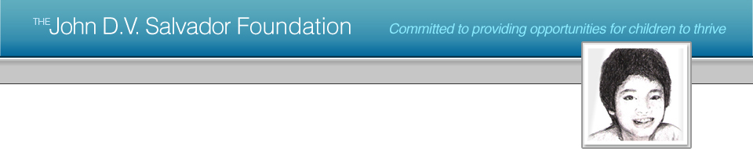
Donate to The John D.V. Salvador Foundation

Name: Mr/Mrs/Ms/Other:____________________________________

Last Name: ______________________________________________

Address (line 1): __________________________________________

Address (line 2): __________________________________________

City / Province: ___________________________________________

Zip/Post Code:____________________________________________

Country: _________________________________________________

E-mail: ___________________________________________________

Phone: ______________________ Fax: ________________________

Donation Amount: USD $ / GBP £ _____

О I would like a receipt for tax deduction to be posted to me.

The John D.V. Salvador Foundation - USA is a 501(c)(3) organization with
Tax ID Number: 56-2535579. All donations are 100% tax deductible under U.S. Law.

The John D.V. Salvador Foundation - UK is a UK Registered Charity with
Registered Charity No.: 1113085.

*Please make checks / money orders payable to ‘ The JDVS Foundation ’ and send along with this DONATION FORM to the relevant JDVS Foundation address:

For donations in USD $: For donations in GBP £:

The JDVS Foundation-USA The JDVS Foundation-UK
PO Box 245 9 Stanhope Place
New York, New York 10276 London W2 2HH
USA UNITED KINGDOM

