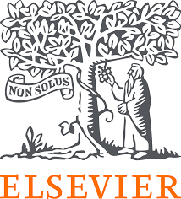
Group Work for Faculty: Create a Digital Teaching Learning Module (TLM) to conduct the teaching methodology Pre-Clinical Case Based Learning using digital resources on the disease condition Ischemic Heart Disease(IHD)?
Name of all the faculty participants in the group:
Lead faculty who will make large group presentation:
* In the very beginning please nominate a group member who will present this group activity during the large group presentation
* Please create Digital TLM on the disease condition using the collection dashboard made available to you. Choose select competencies from new MBBS curriculum, so that you can complete the Digital TLM as per your lecture plan and time available
* You may like to take a screen shot for each resource link picked in Digital TLM

Please note that the Digital TLM provided here were originally created by educators like you during the face-face workshops and have been appropriately adapted. The versions shared are for sample purposes — you’re welcome to add, delete, or modify the resources as per your context and suitability.

Question 1 – Outline the teaching–learning- (formative) assessment methods you plan to use over the next class/ few weeks to complete the topic or module. Enumerate the steps you will follow during this period and the expected learning outcomes after each step. COMPETENCIES
GM2.2 Discuss the aetiology of risk factors both modifiable and non-modifiable of atherosclerosis and IHD
GM2.6 Elicit document and present an appropriate history that includes onset evolution, presentation risk factors, family history, comorbid conditions, complications, medication, history of atherosclerosis, IHD and coronary syndromes
Question 2 – From the NMC MBBS curriculum, identify the competencies your group would like to address for the given topic. Design a digital teaching–learning module that incorporates e-resources. Use the collection dashboard provided to locate direct URLs of relevant content (cases, videos, skills videos, images, assessments) along with screenshots of the content you plan to use across subject(s).
IHD (Ischemic Heart Disease) | TLM | Assessment
GM2.2 Discuss the aetiology of risk factors both modifiable and non-modifiable of atherosclerosis and IHD  GM2.6 Elicit document and present an appropriate history that includes onset evolution, presentation risk factors, family history, comorbid conditions, complications, medication, history of atherosclerosis, IHD and coronary syndromes | URLs for PRE READING  https://www.clinicalkey.com/student/content/book/3-s2.0-B9780729544245000040#hl0001349  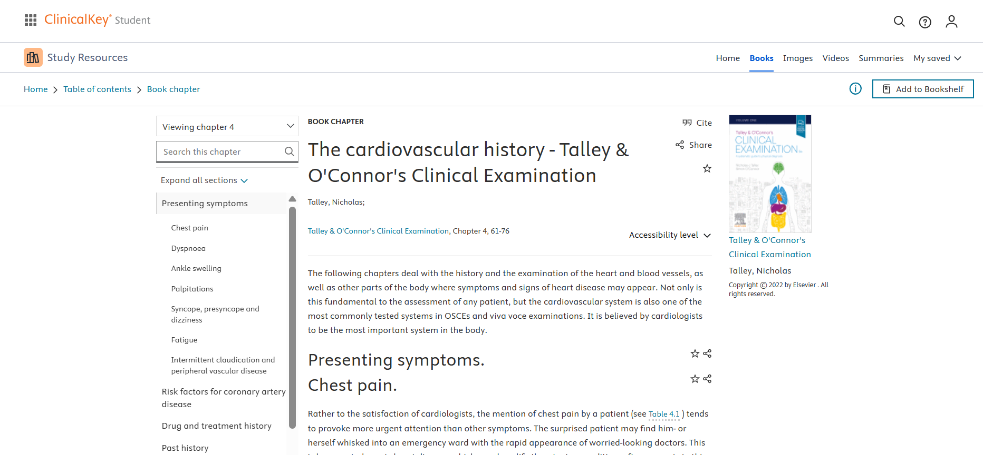  https://www.osmosis.org/learn/Anatomy_of_the_heart  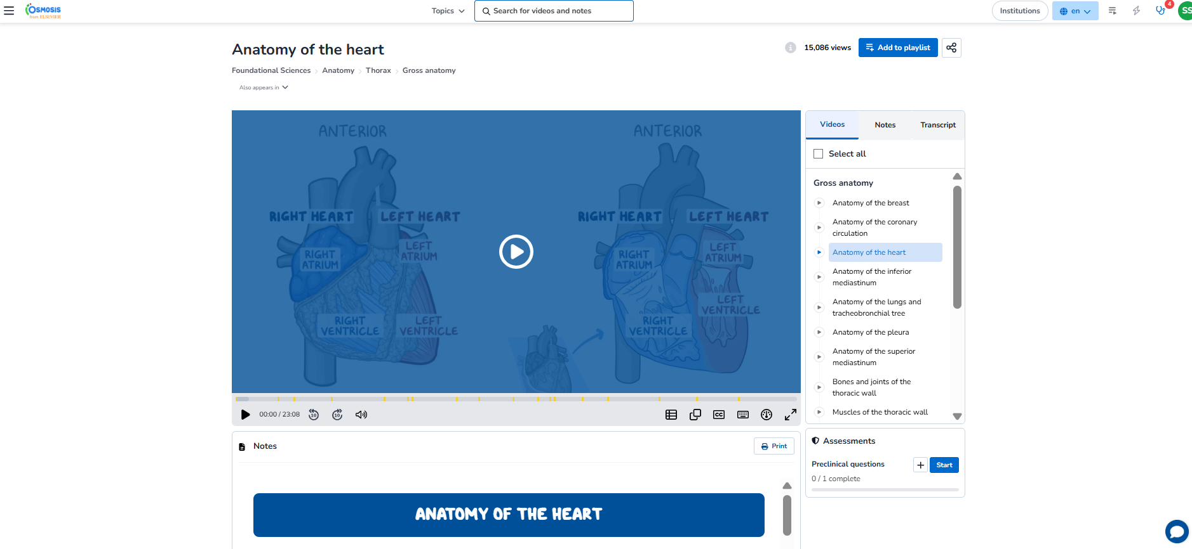  https://www.clinicalkey.com/student/content/book/3-s2.0-B9780702081590000050#hl0000938  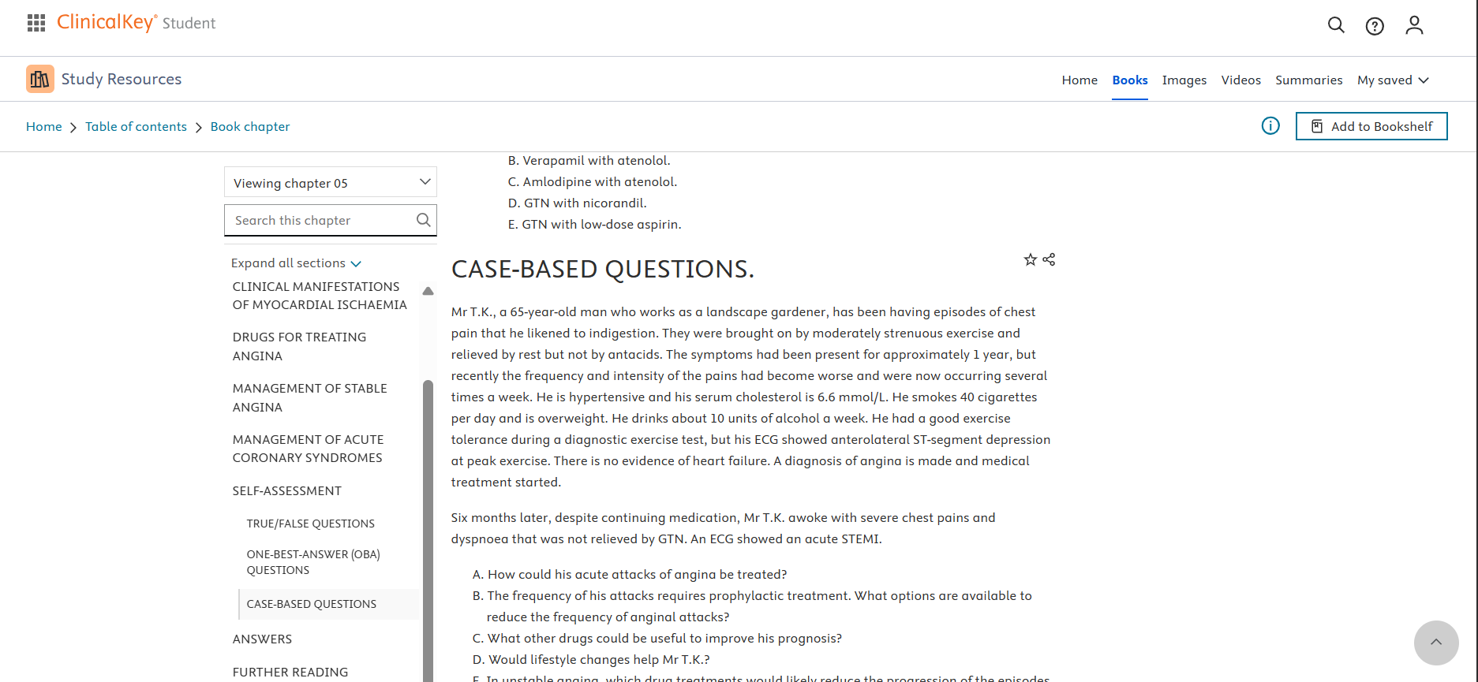  https://www.osmosis.org/learn/Coronary_artery_disease:_Clinical_sciences  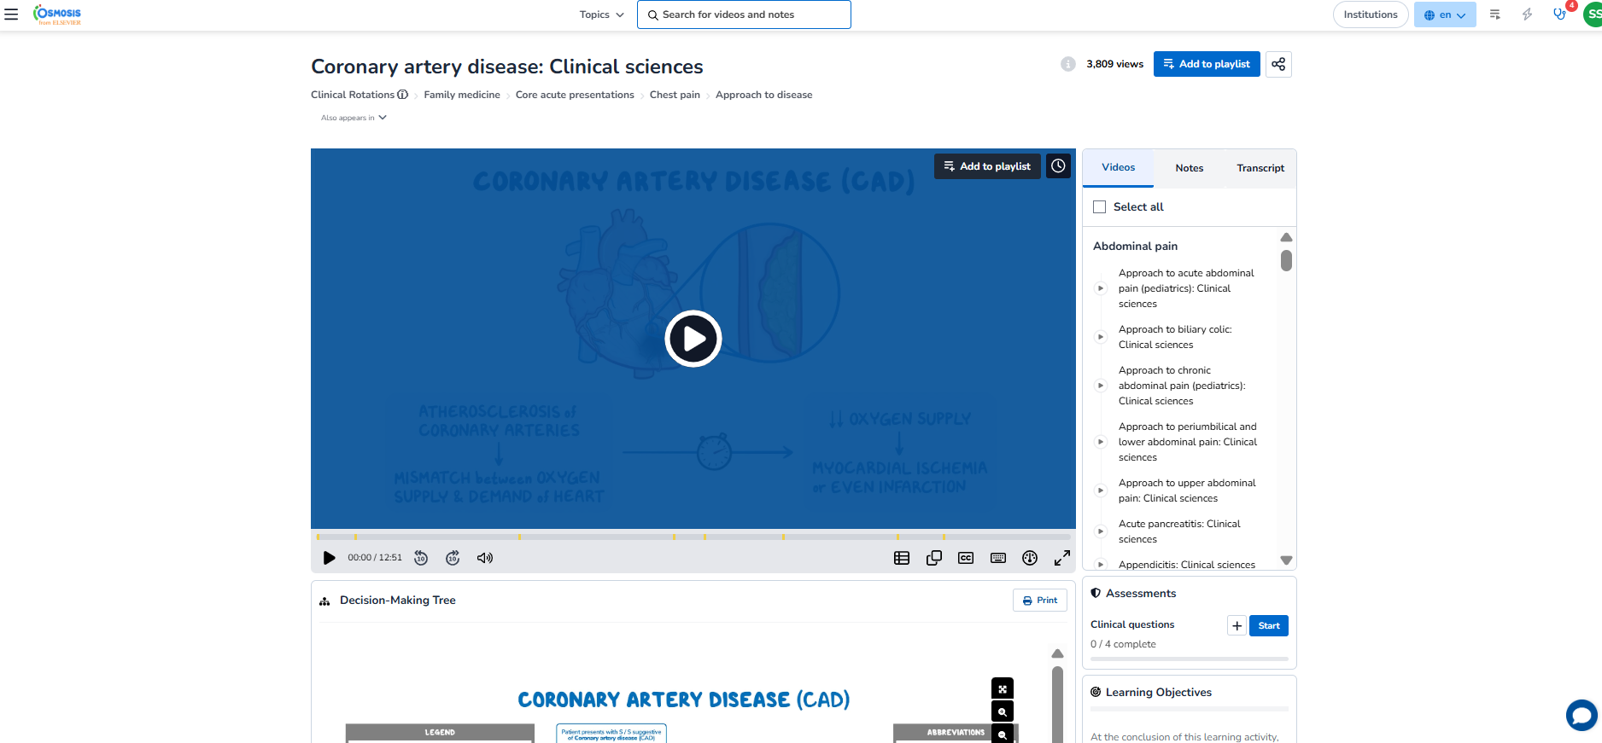  Case –URL for CBL discussion  https://www.clinicalkey.com/student/content/book/3-s2.0-B9780323358095000278  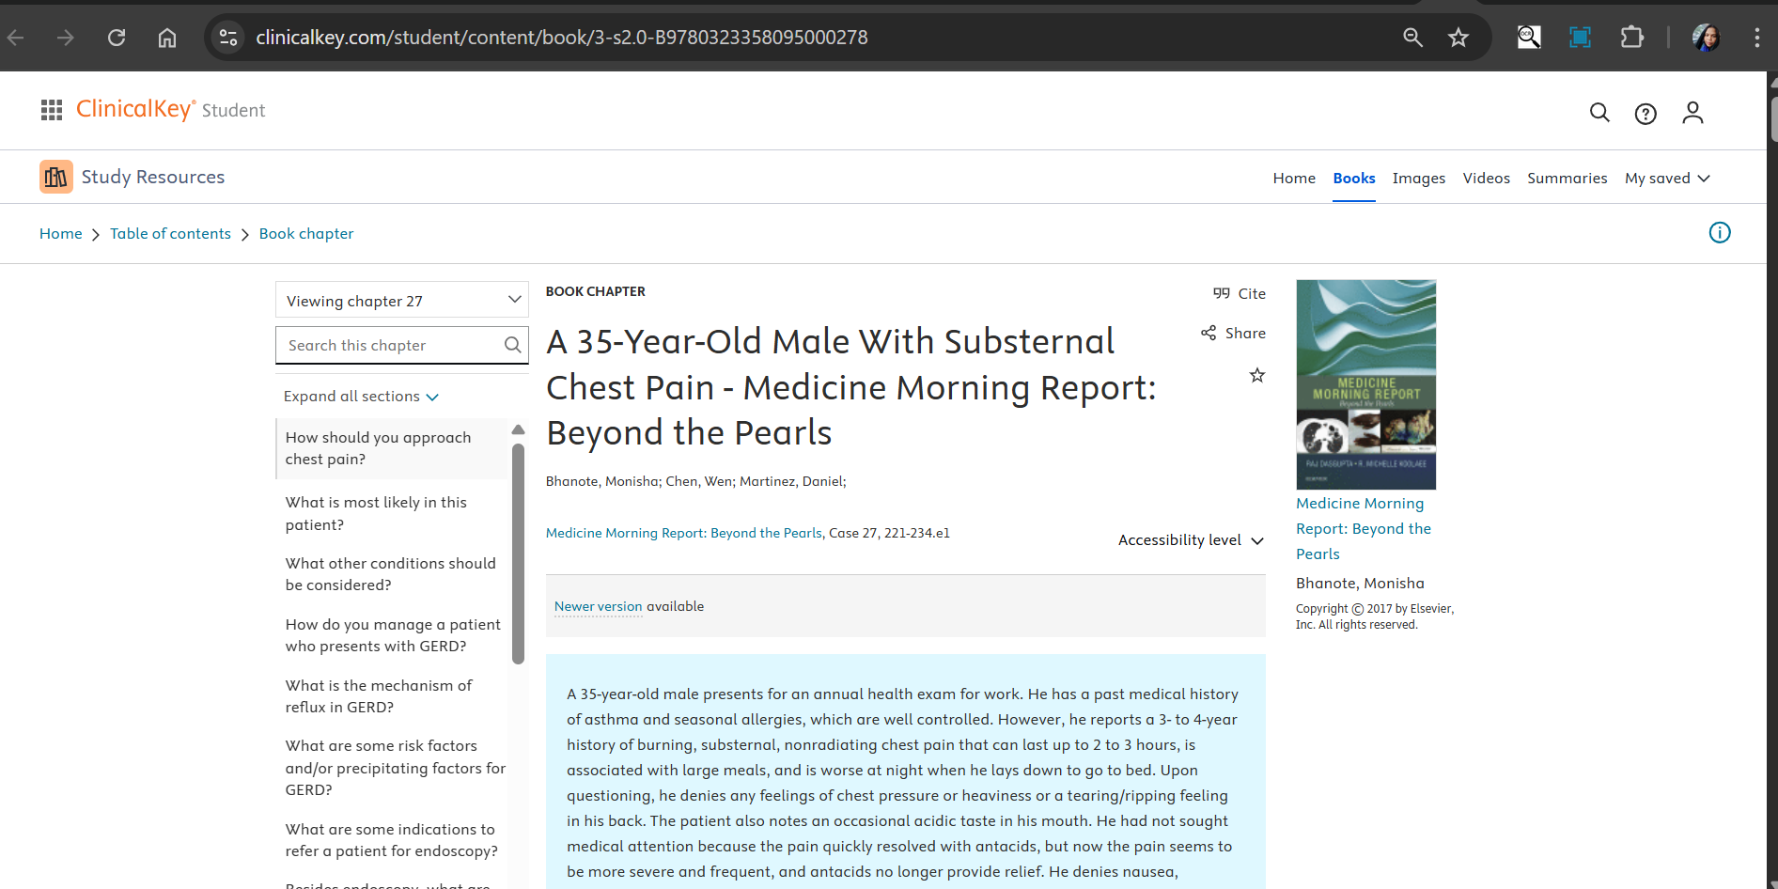 | https://www.osmosis.org/learn-quiz/Coronary_artery_disease%3A_Clinical_sciences/step2/questions  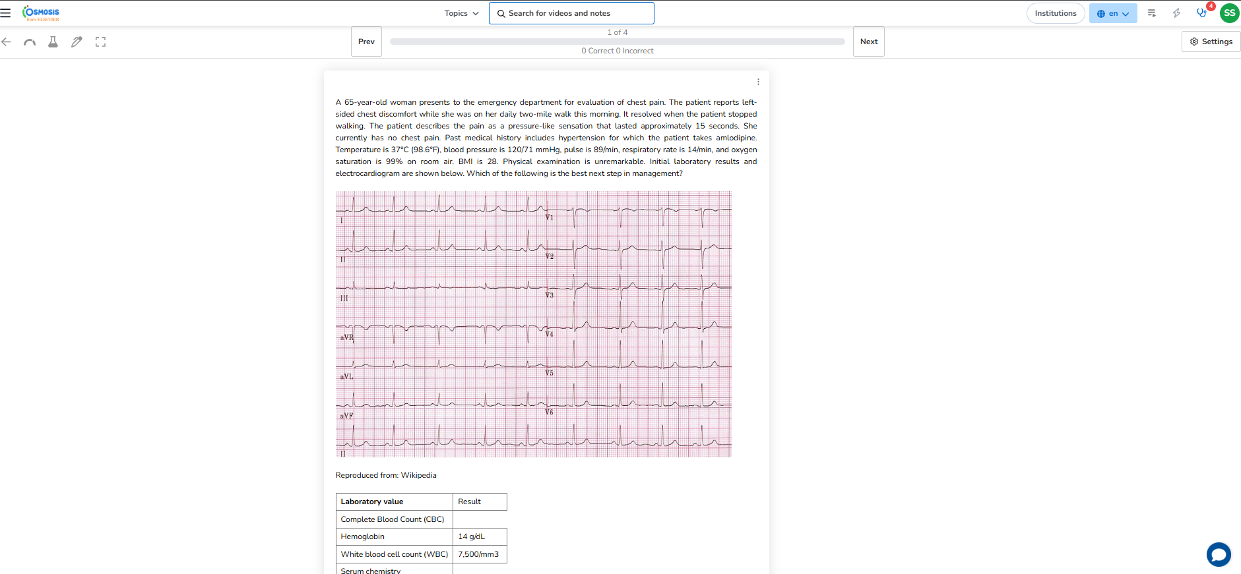

Question 3 - Also, please mention which other Medical Education teaching methodologies/ pedagogies you may like to pick to complete the topic/ module Self Directed Learning, Bedside clinics
Question 4 – If you were to include a component of AETCOM, please pick a resource and share the direct URL(s) + screen shots here.
https://www.clinicalkey.com/student/content/book/3-s2.0-B9780702078682000014#hl0000992
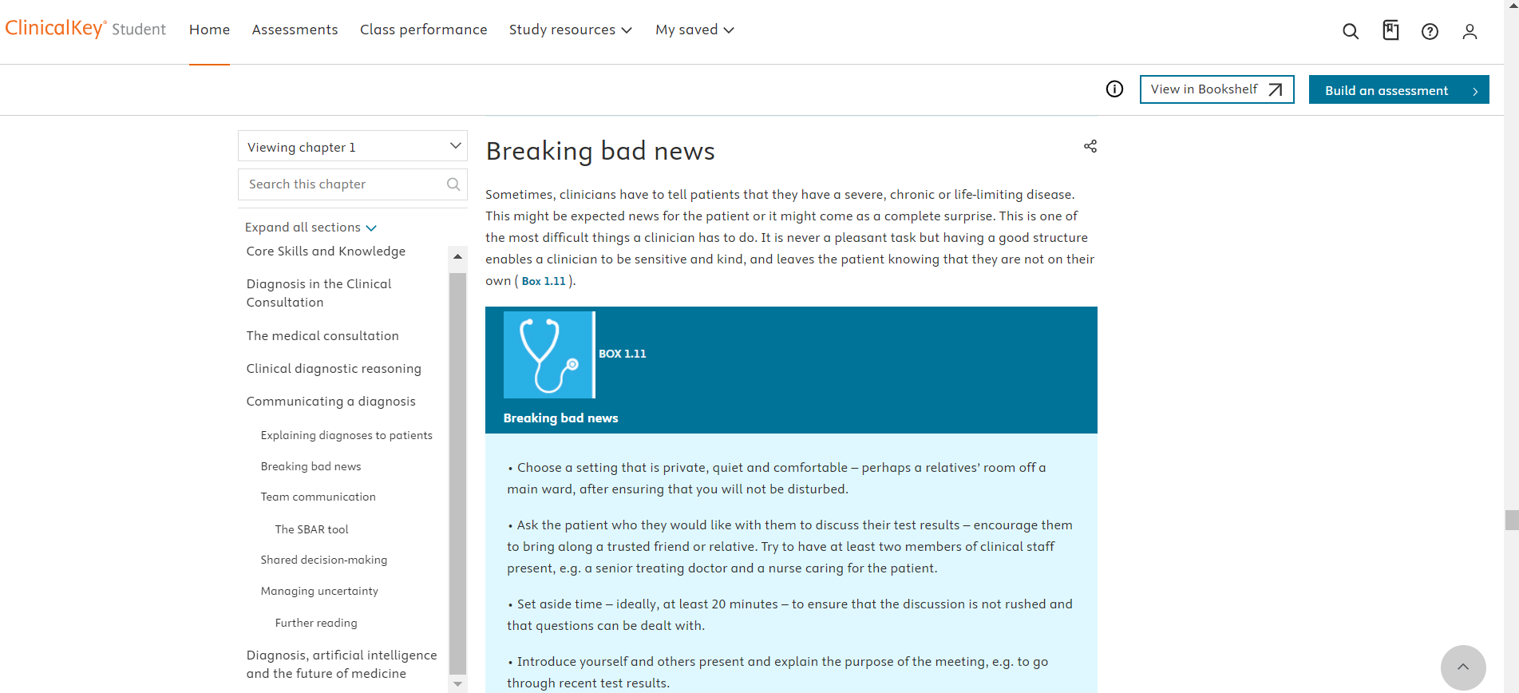
Question 5 - How would you define success for your students at the end of this topic/ module? How would you measure that?
Formative assessments using case-based scenarios. Case resolution using small group discussion one week later. Students and Faculty feedback

