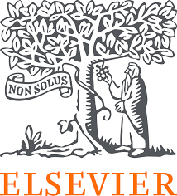
Group Work for Faculty: Create a Digital Teaching Learning Module (TLM) to conduct the teaching methodology Early Clinical Exposure (ECE) using digital resources on the disease condition Diabetes Mellitus?

Name of all the faculty participants in the group:
Lead faculty who will make large group presentation:

* In the very beginning please nominate a group member who will present this group activity during the large group presentation
* Please create Digital TLM on the disease condition using the collection dashboard made available to you. Choose select competencies from new MBBS curriculum, so that you can complete the Digital TLM as per your lecture plan and time available
* You may like to take a screen shot for each resource link picked in Digital TLM

Please note that the Digital TLM provided here were originally created by educators like you during the face-face workshops and have been appropriately adapted. The versions shared are for sample purposes — you’re welcome to add, delete, or modify the resources as per your context and suitability.

Question 1 – Outline the teaching–learning- (formative) assessment methods you plan to use over the next class/ few weeks to complete the topic or module. Enumerate the steps you will follow during this period and the expected learning outcomes after each step.
COMPETENCY BC 3.5 -3.6
Describe the types, Biochemical changes, complications and laboratory investigations related to diabetes & other carbohydrate metal disorders. Interpret the results of analytes associated with metabolism of carbohydrates and other laboratory investigations related to disorders of carbohydrate metabolism.

Learning objectives:
- Describe the carbohydrate metabolism in diabetes mellitus
- To discuss the clinical features of diabetes mellitus
- To enumerate complications of diabetes meliitus

Question 2 – From the NMC MBBS curriculum, identify the competencies your group would like to address for the given topic. Design a digital teaching–learning module that incorporates e-resources. Use the collection dashboard provided to locate direct URLs of relevant content (cases, videos, skills videos, images, assessments) along with screenshots of the content you plan to use across subject(s).
Diabetes | TLM | Assessment
COMPETENCY BI 3.5  Describe and discuss the regulation functions and integration of carbohydrate along with associated diseases/disorders. | Provide Direct URLs of Cases -Trigger case link https://www.clinicalkey.com/student/content/book/3-s2.0-B9780323358095000084  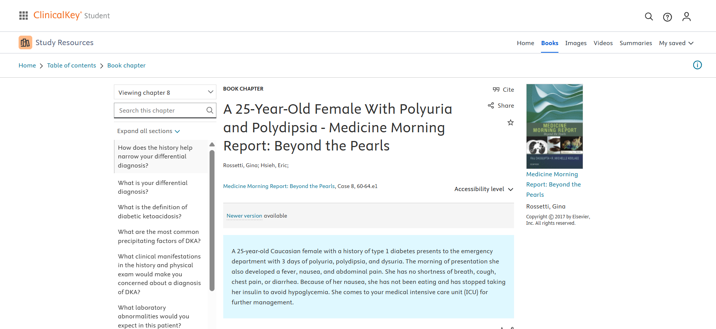  Provide Direct URLs of Books for Reference https://www.clinicalkey.com/student/content/book/3-s2.0-B9781929007639000398#hl0000301  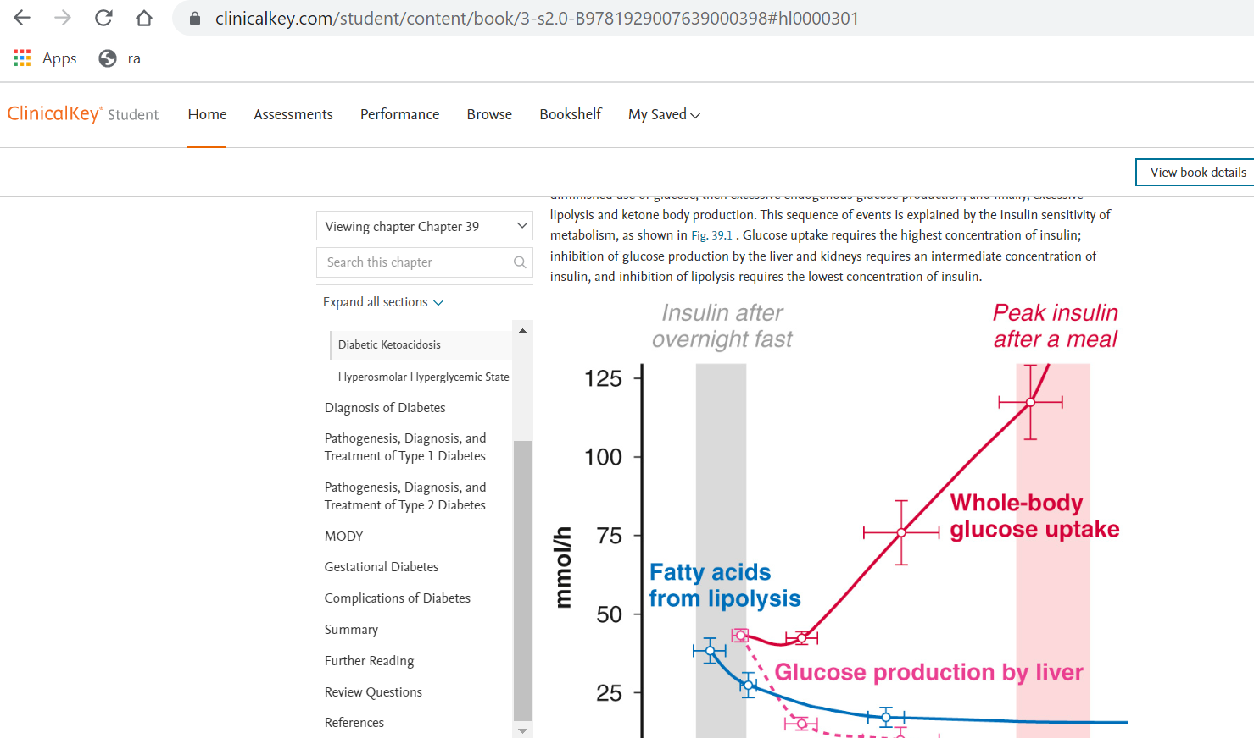  Provide Direct URLs of India Skills Videos diagnosis video (laboratory)  https://indiambbsskills.clinicalkey.com/local/courses/2611/s01_m27_Pancreatic_Function_Test%20part%202/data/LandingPg.html#  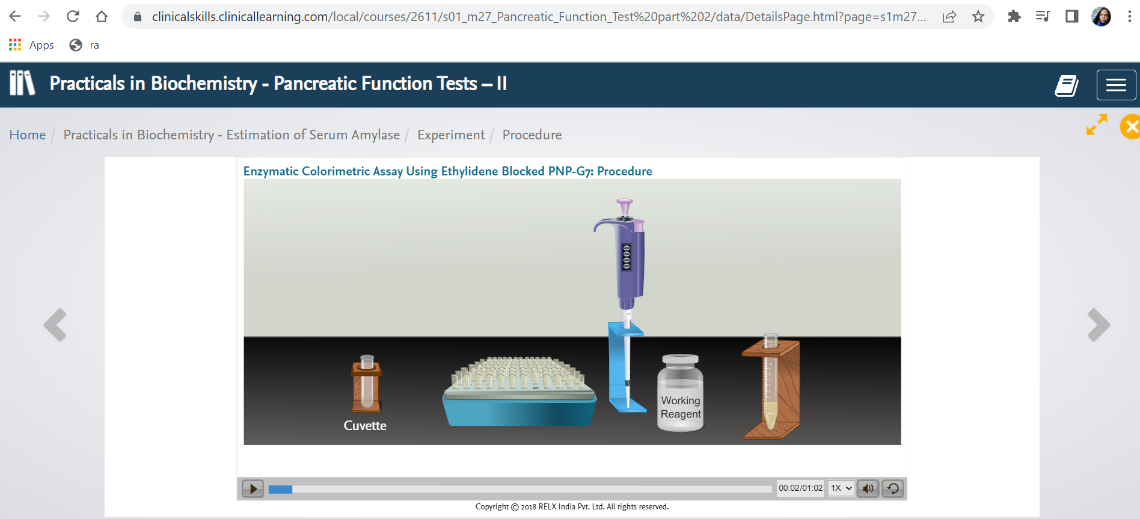  Provide Direct URLs of Videos/ Cases treatment with case  https://www.clinicalkey.com/student/content/video/23-s2.0-mm_9780323358095_0034  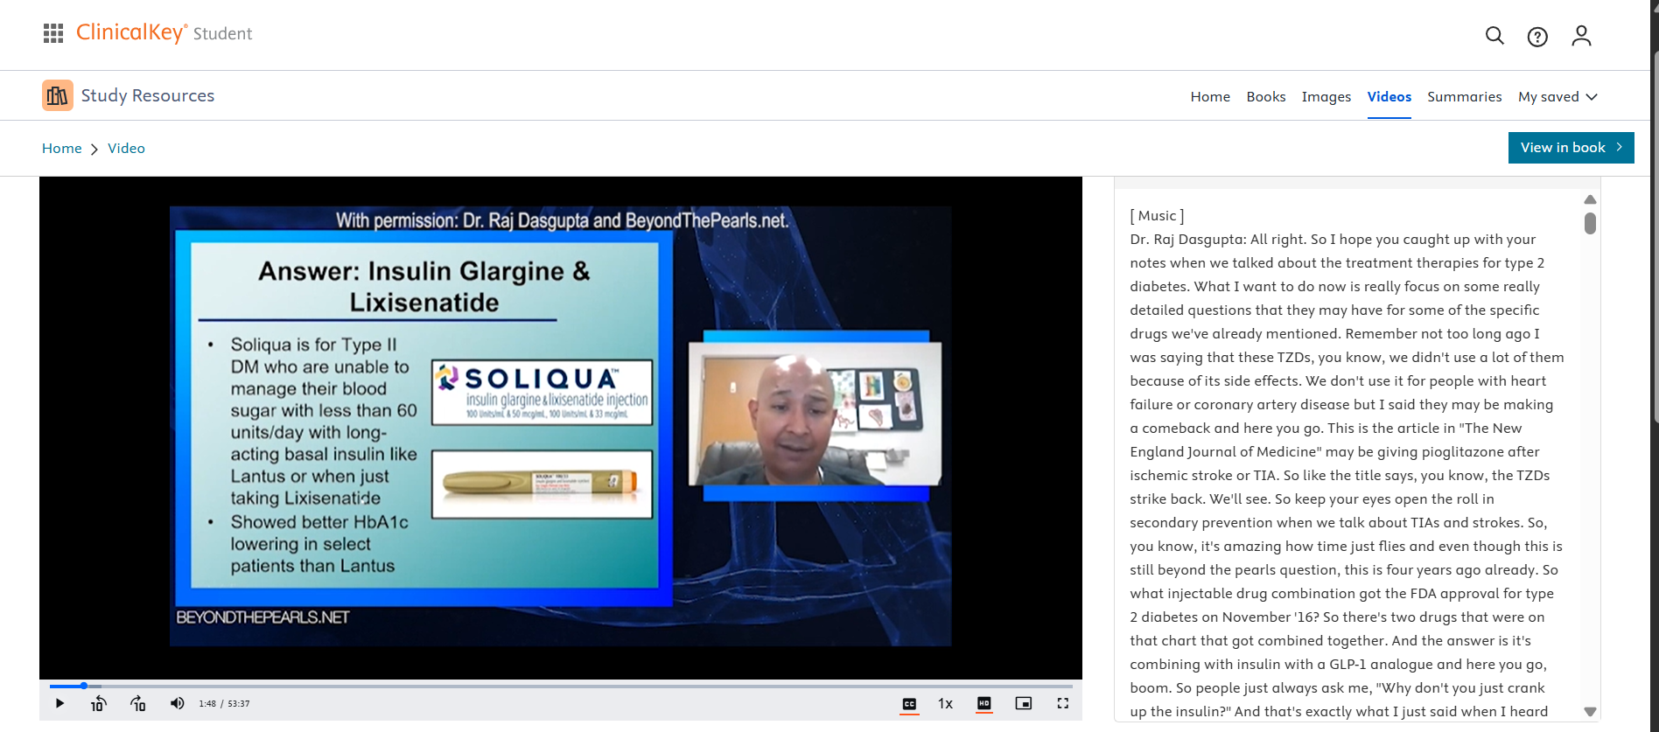  https://www.osmosis.org/learn/Diabetes_mellitus_(Type_1):_Clinical_sciences  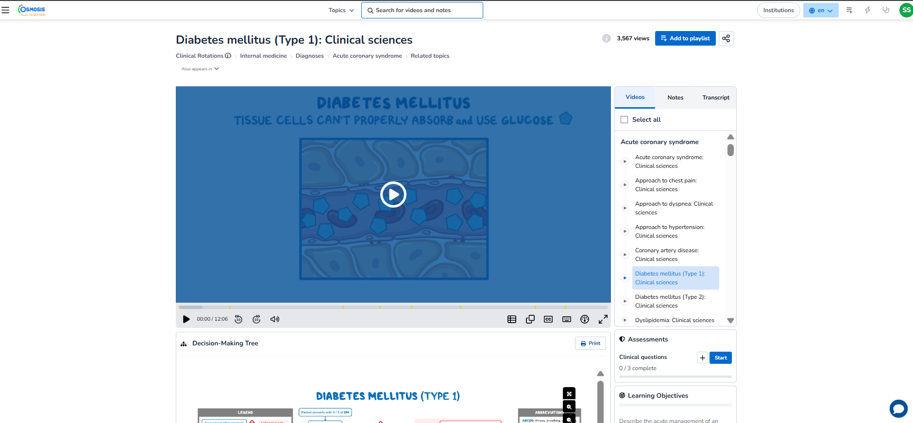  https://www.clinicalkey.com/student/content/book/3-s2.0-B978813126133000033X#section-hl0002741  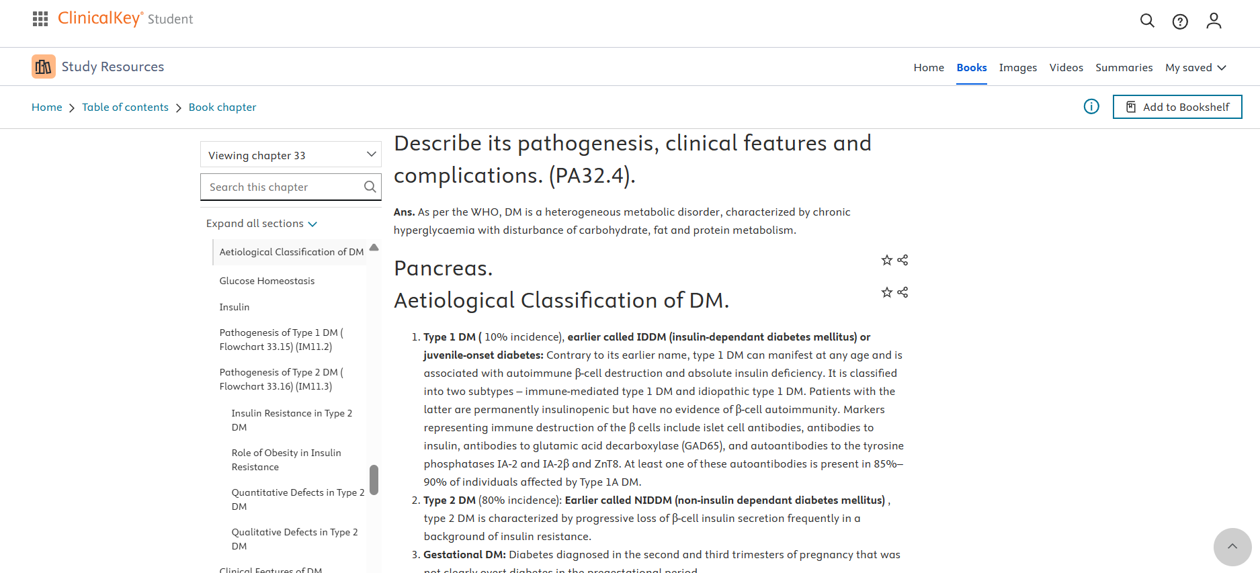 | Provide MCQs/ clinical oriented questions from pre-clinical years (Linker case)  https://www.osmosis.org/learn-quiz/Diabetes_mellitus_(Type_1)%3A_Clinical_sciences/step2/questions  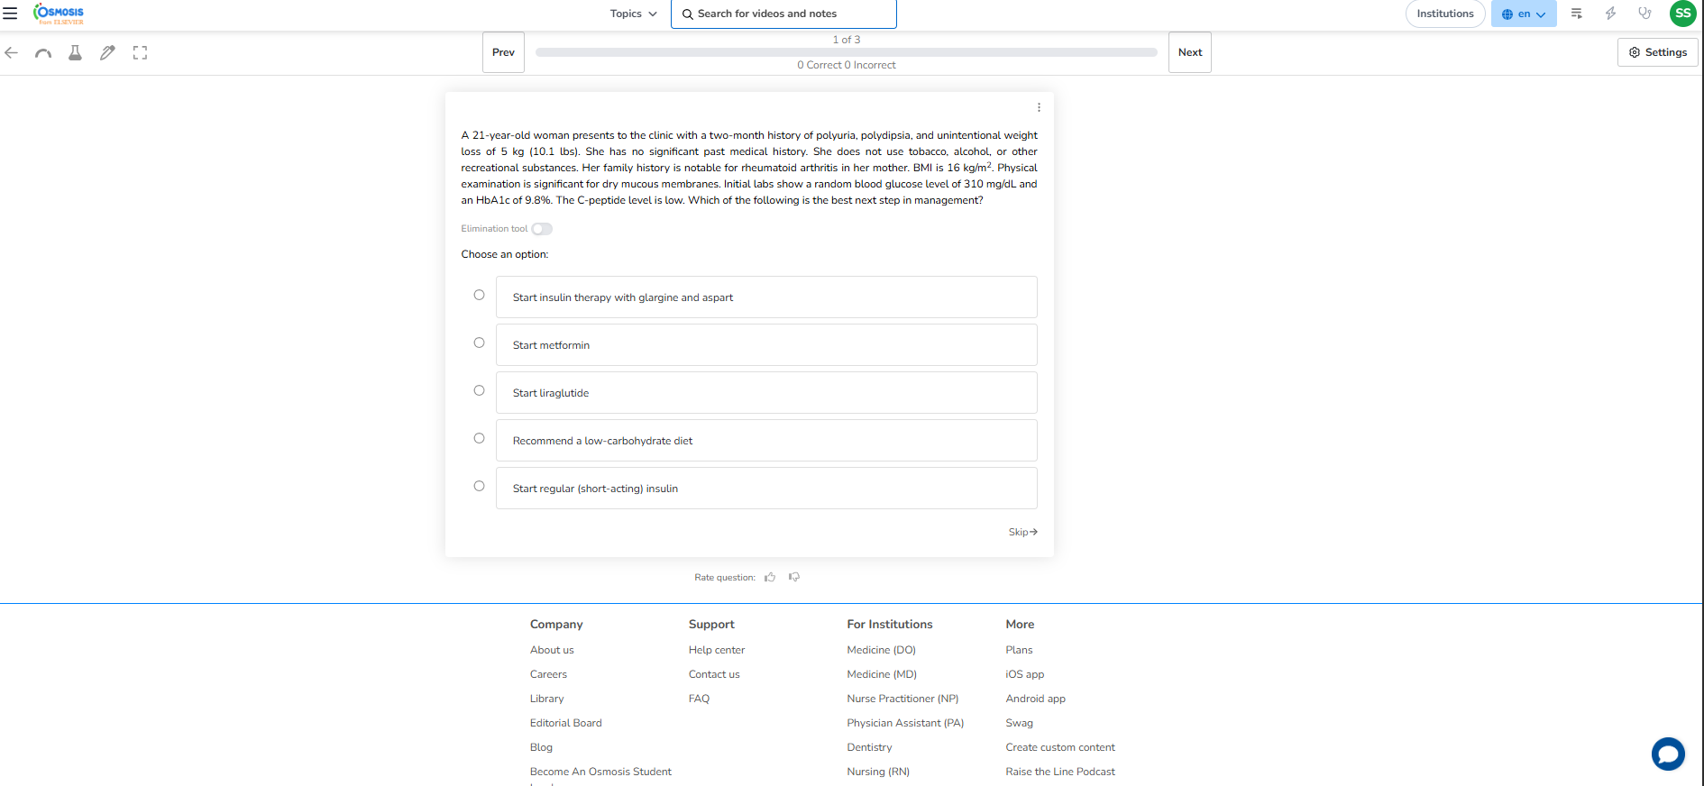  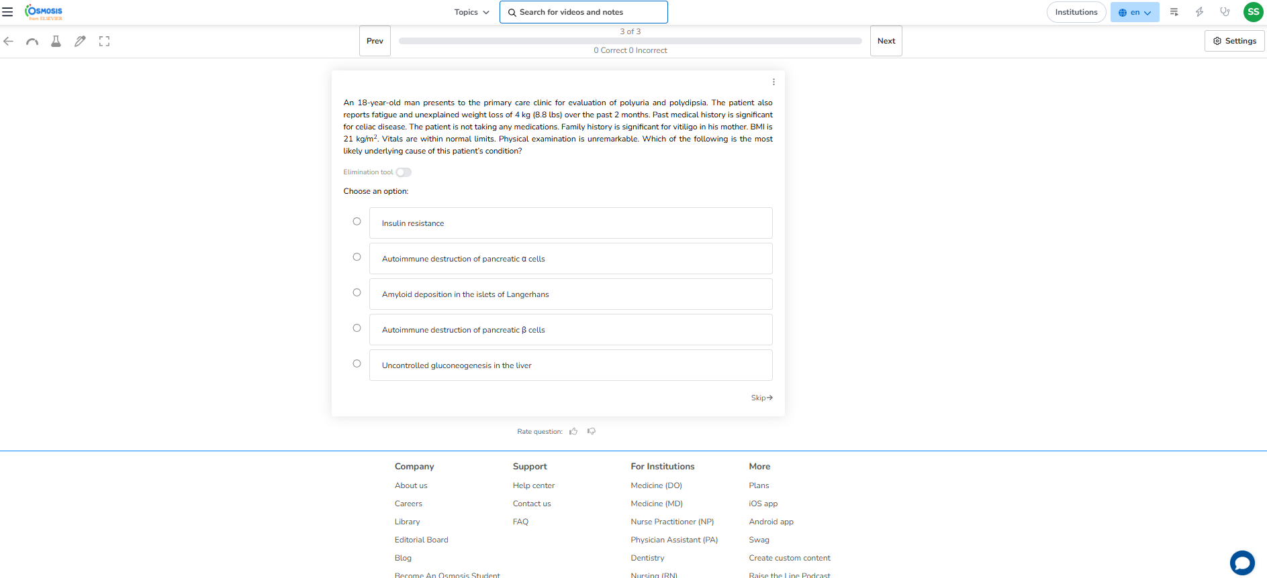

Question 3 - Also, please mention which other Medical Education teaching methodologies/ pedagogies you may like to pick to complete the topic/ module
- Practical demonstration in laboratory
- Small group discussion
- Laboratory reports interpretation
- Case based learning

Question 4 – If you were to include a component of AETCOM, please pick a resource and share the direct URL(s) + screen shots here.
https://www.clinicalkey.com/student/content/book/3-s2.0-B9780323052214000162
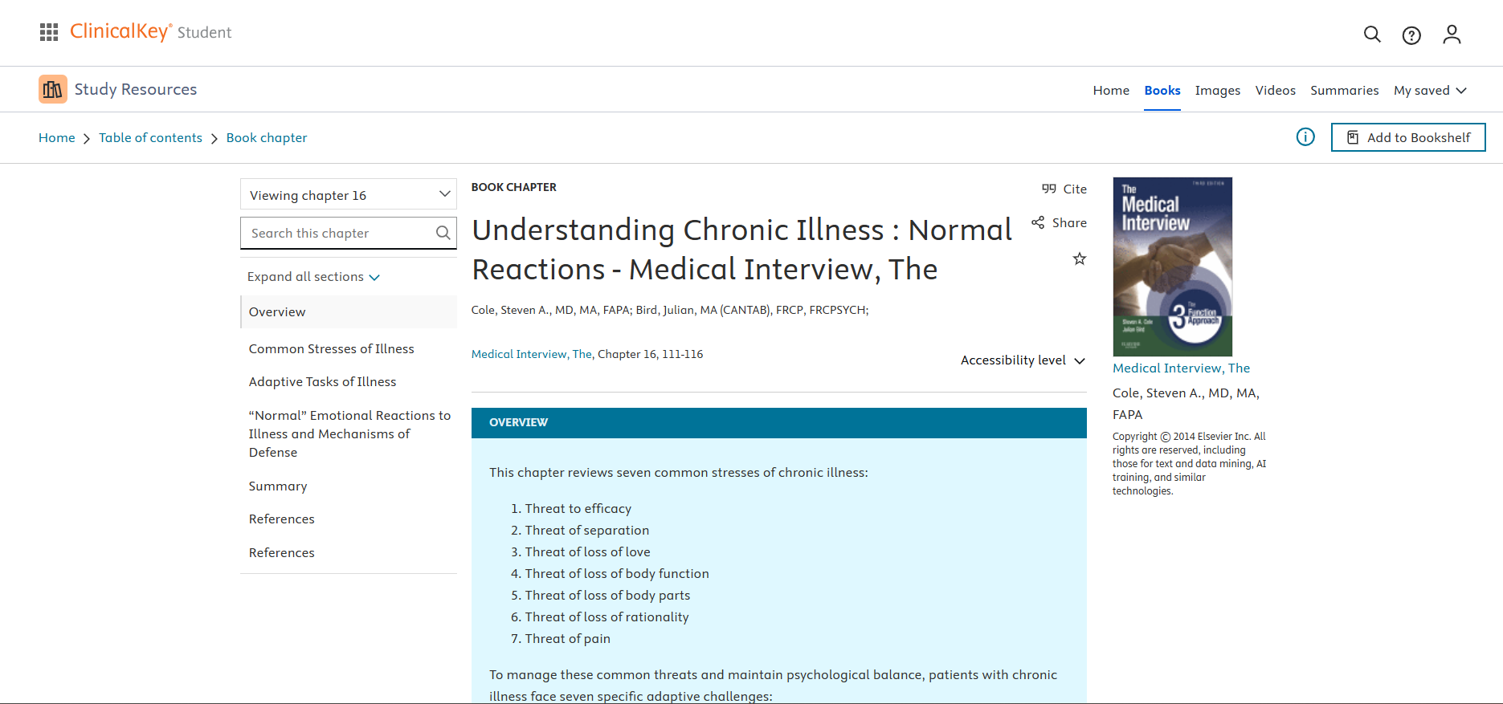
Question 5 - How would you define success for your students at the end of this topic/ module? How would you measure that?
All students must be able to understand and solve the assessments provided

