
Group Work for Faculty: Create a Digital Teaching Learning Module (TLM) to conduct the teaching methodology Integrated Learning using digital resources on the disease condition Ischemic Heart Disease(IHD)?

Name of all the faculty participants in the group:
Lead faculty who will make large group presentation:

* In the very beginning please nominate a group member who will present this group activity during the large group presentation
* Please create Digital TLM on the disease condition using the collection dashboard made available to you. Choose select competencies from new MBBS curriculum, so that you can complete the Digital TLM as per your lecture plan and time available
* You may like to take a screen shot for each resource link picked in Digital TLM

Please note that the Digital TLM provided here were originally created by educators like you during the face-face workshops and have been appropriately adapted. The versions shared are for sample purposes — you’re welcome to add, delete, or modify the resources as per your context and suitability.

Question 1 – Outline the teaching–learning- (formative) assessment methods you plan to use over the next class/ few weeks to complete the topic or module. Enumerate the steps you will follow during this period and the expected learning outcomes after each step. Plan a session with multiple subject specialties leads. Learning Outcomes will be linked to each selected competencies

Question 2 – From the NMC MBBS curriculum, identify the competencies your group would like to address for the given topic. Design a digital teaching–learning module that incorporates e-resources. Use the collection dashboard provided to locate direct URLs of relevant content (cases, videos, skills videos, images, assessments) along with screenshots of the content you plan to use across subject(s).
IHD (Ischemic Heart Disease) | TLM | Assessment
LEAD: ANATOMY  AN5.6 Describe the concept of anastomoses and collateral circulation with significance of end arteries.  AN5.8: Define thrombosis, infarction, and aneurysm.  PA26.1Distinguish arteriosclerosis from atherosclerosis. Describe the pathogenesis and pathology of various causes and types of arteriosclerosis  PA5.5, PA5.6: Define and describe Ischemia/infarction its types, etiology, morphologic changes and clinical effects; Identify and describe the gross and microscopic features of infarction in a pathologic specimen  LEAD:PHYSIOLOGY  PY5.6: Discuss physiological variations in ECG waveforms, abnormal waveforms and intervals, arrhythmias, heart blocks and myocardial Infarction  GM2.13: Discuss and enumerate the indications for and findings on echocardiogram, stress testing and coronary angiogram  LEAD:PATHOLOGY  PA27.5: Describe the epidemiology, risk factors, etiology, pathophysiology, pathology, presentations, gross and microscopic features, diagnostic tests and complications of ischemic heart disease  LEAD:MEDICINE  IM2.2: Discuss the etiology of risk factors both modifiable and non-modifiable of atherosclerosis and IHD | Provide Direct URLs of Clinical Corelation cases  https://www.clinicalkey.com/student/content/book/3-s2.0-B9788131264812000304#hl0001677  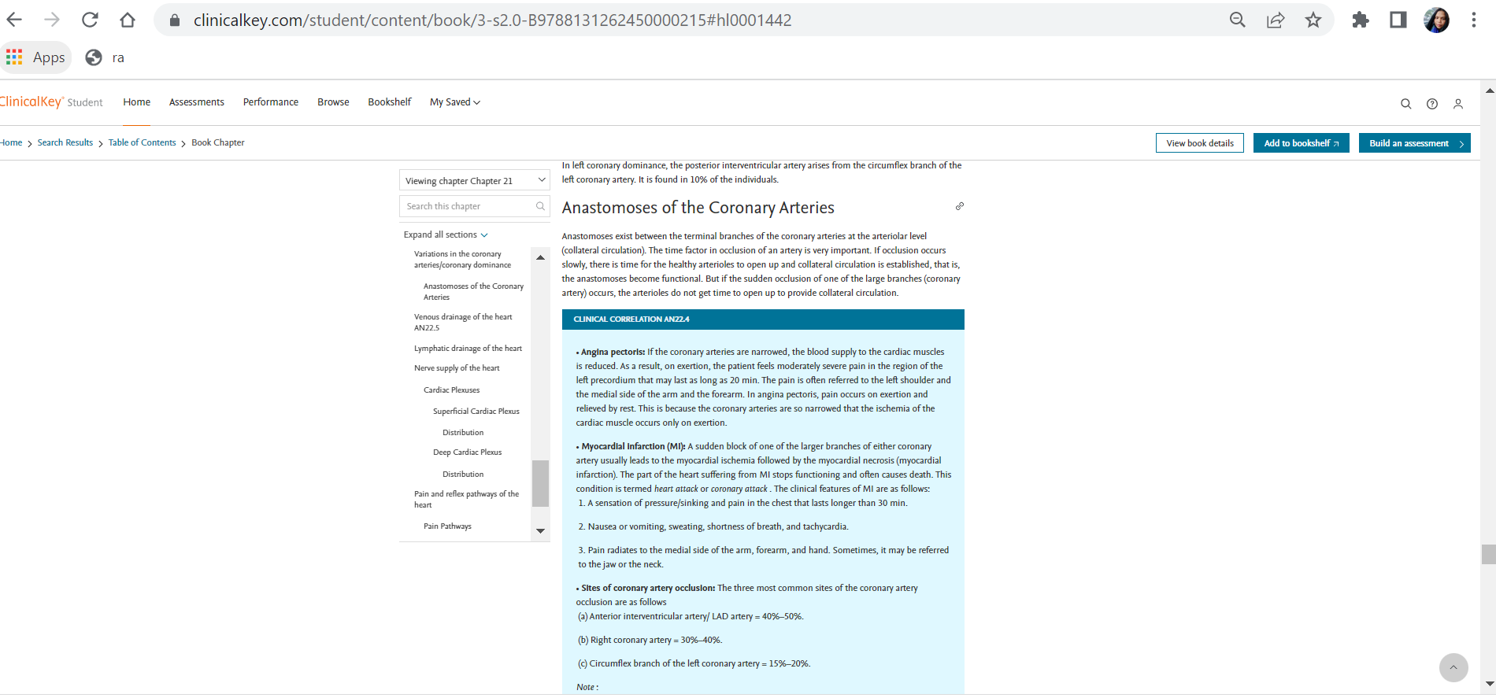  Provide Direct URLs of Videos  https://www.osmosis.org/learn/Ischemia  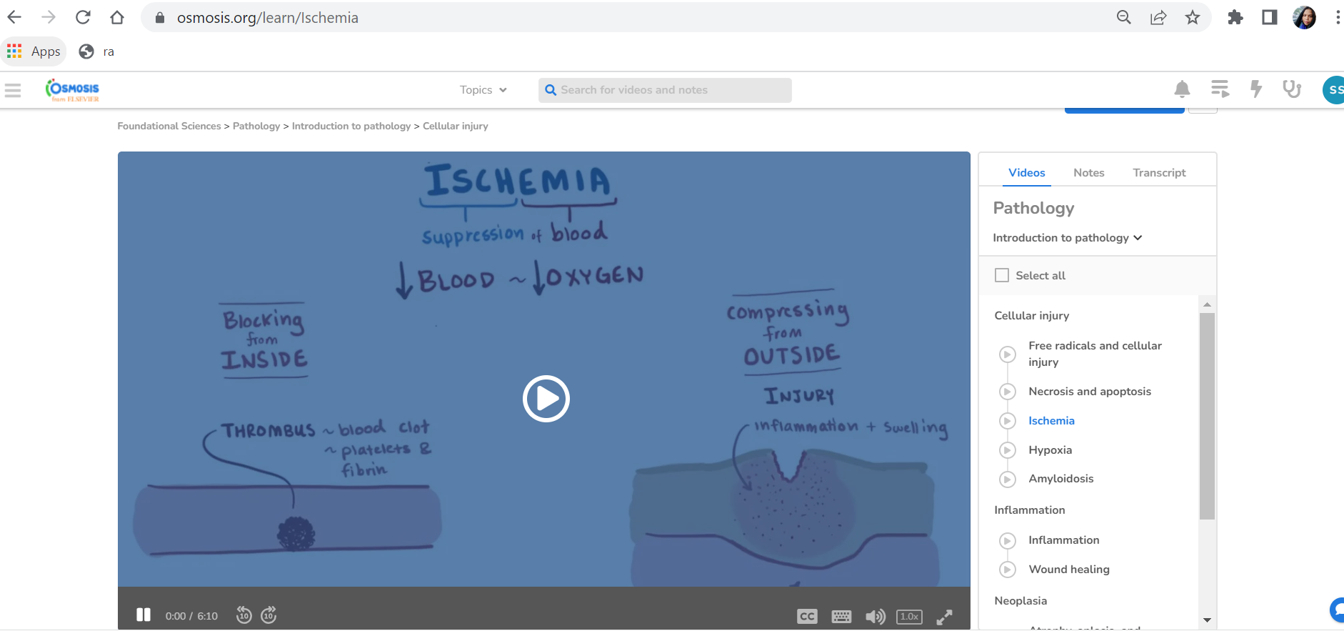  Provide Direct URLs of Images for PPTs  https://www.clinicalkey.com/student/search?query=ischemic%20heart%20disease&source=search-results&facets=!ct~IM&savedContent=false  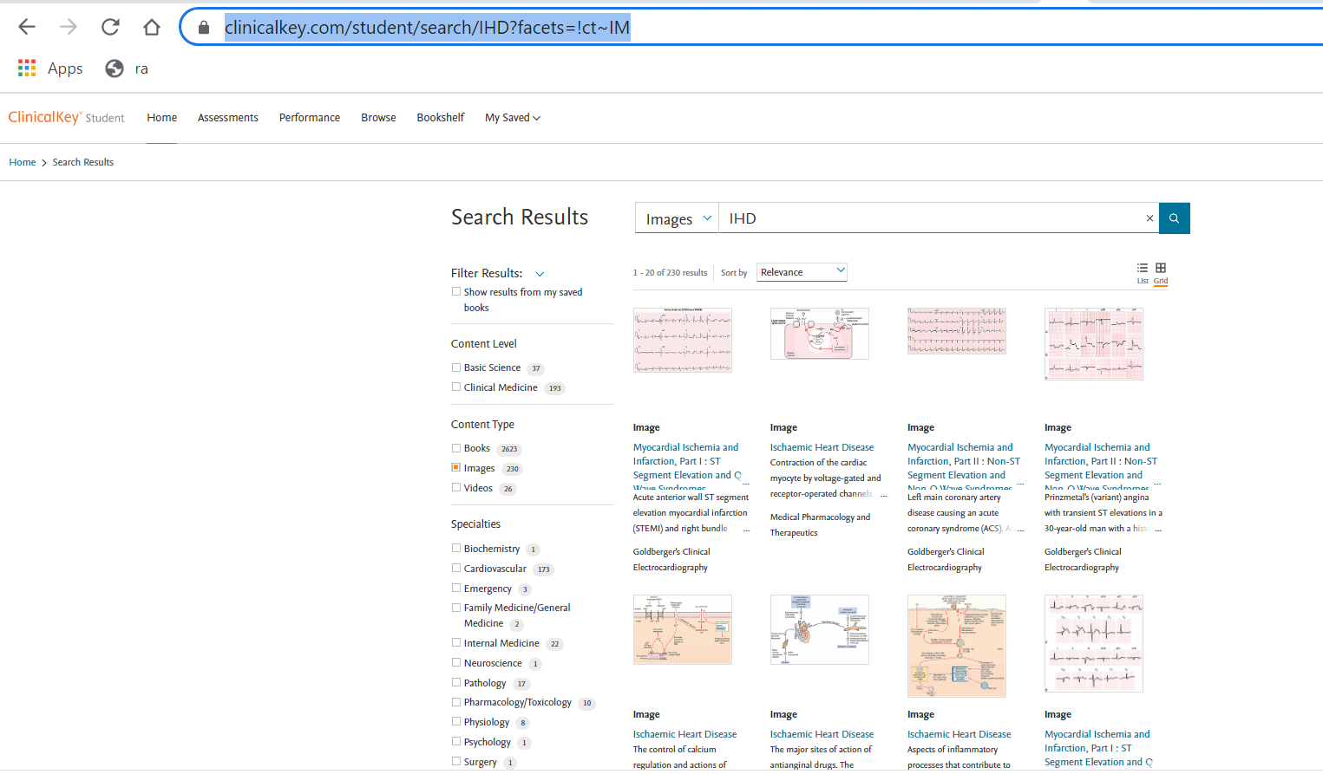  Provide Direct URLs of Angiogram/ ECG clinical Images  https://www.clinicalkey.com/student/content/book/3-s2.0-B9788131244654000185  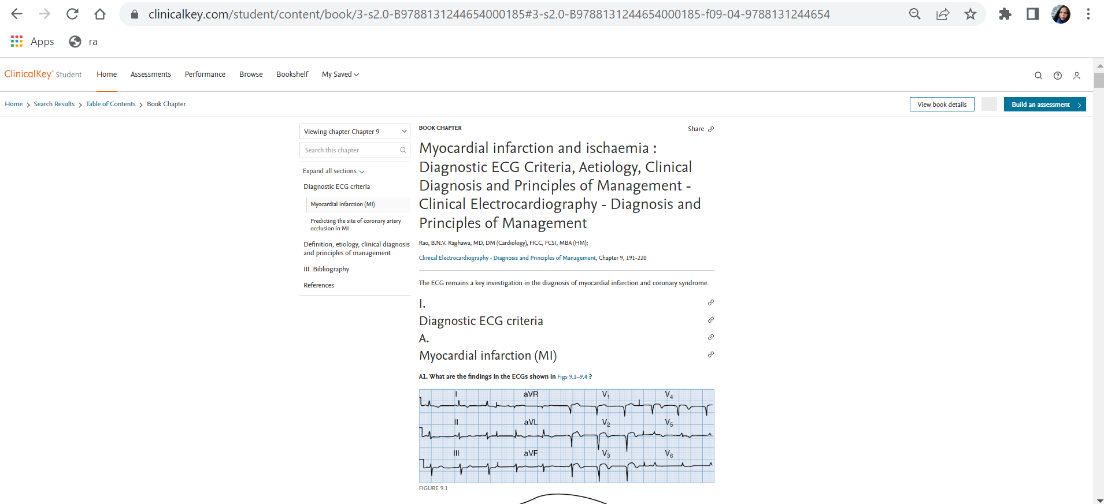  Provide Direct URLs of Skills Videos for CBL/ PBL - Recording & Interpretation of normal ECG. Else lecture SGD  https://indiambbsskills.clinicalkey.com/local/courses/2535/s02_m06_dv_electrocardiogram/data/LandingPg.html# 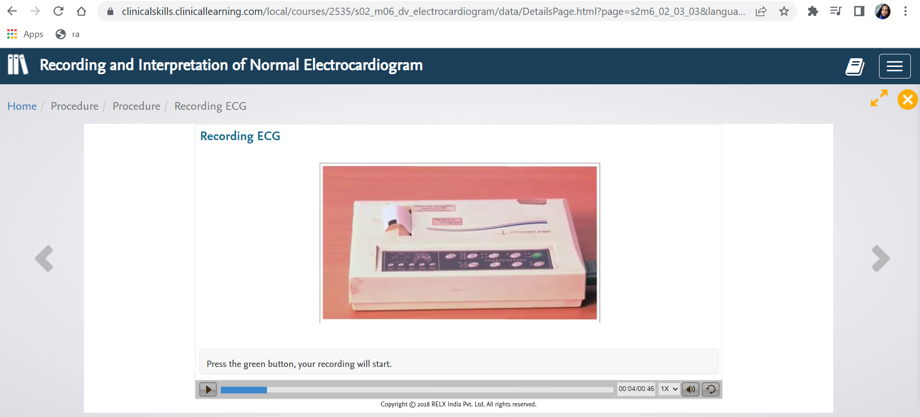  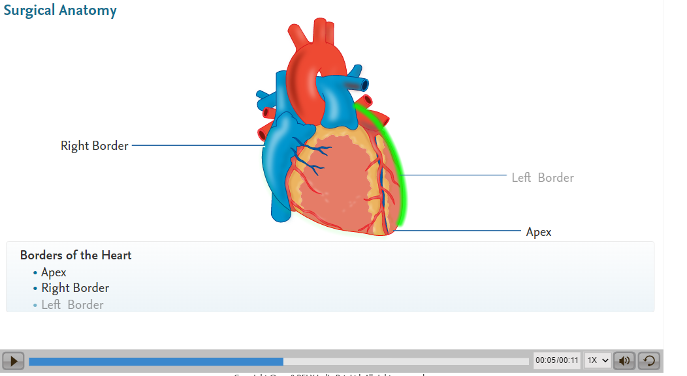  Provide Direct URLs of Lectures  https://www.clinicalkey.com/student/content/book/3-s2.0-B9780323846738000432#hl0000138 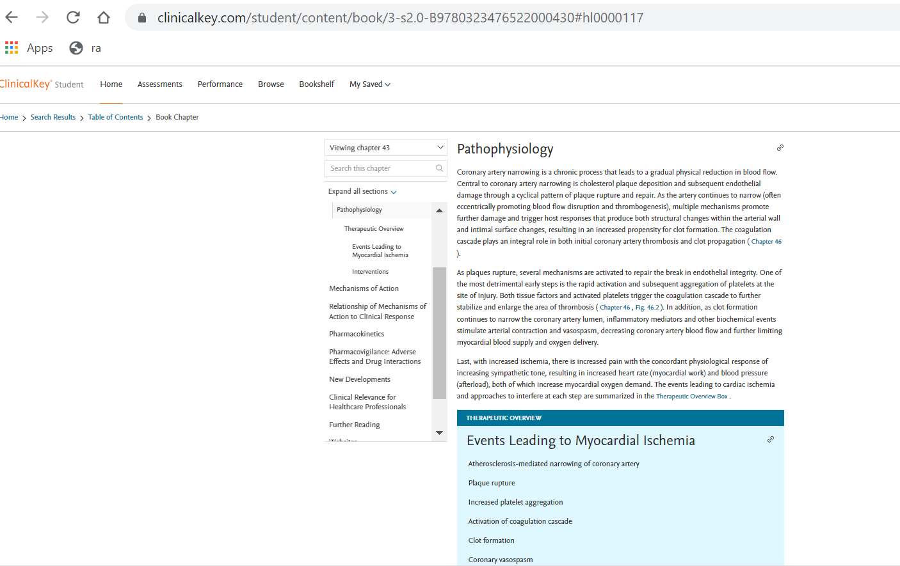  https://www.clinicalkey.com/student/content/book/3-s2.0-B9780723438601000079#hl0000141  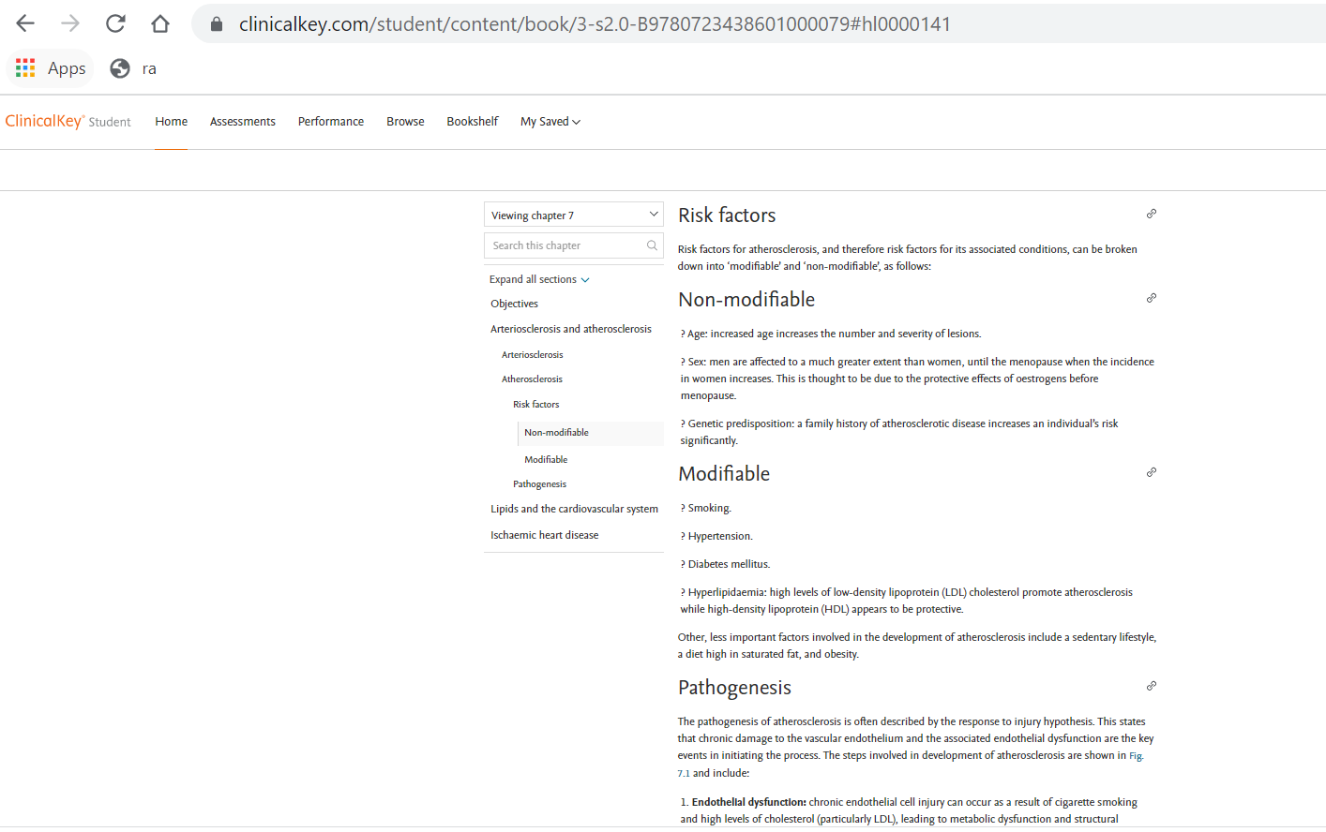  Provide Direct URLs for Lectures - IHD in India special features  https://www.clinicalkey.com/student/content/book/3-s2.0-B9780443115349000114#hl0000617  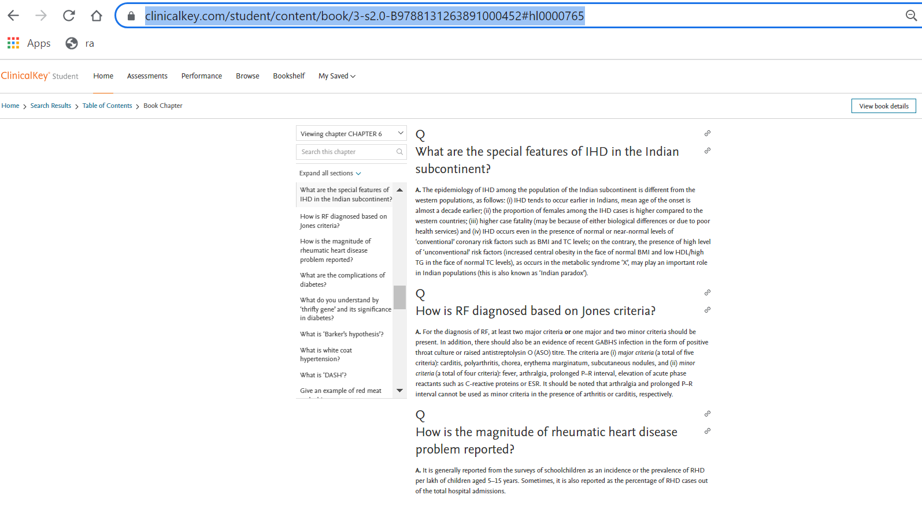 | Provide Direct URLs of Case Based Question  https://www.clinicalkey.com/student/practice/PJBMainIND0085  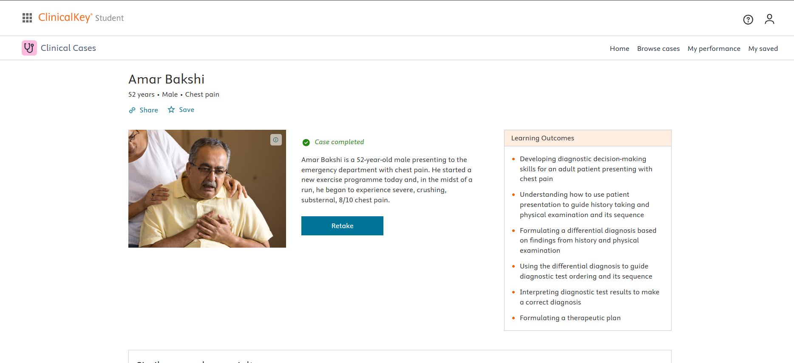  https://www.clinicalkey.com/student/content/book/3-s2.0-B9780702081590000050#hl0000938  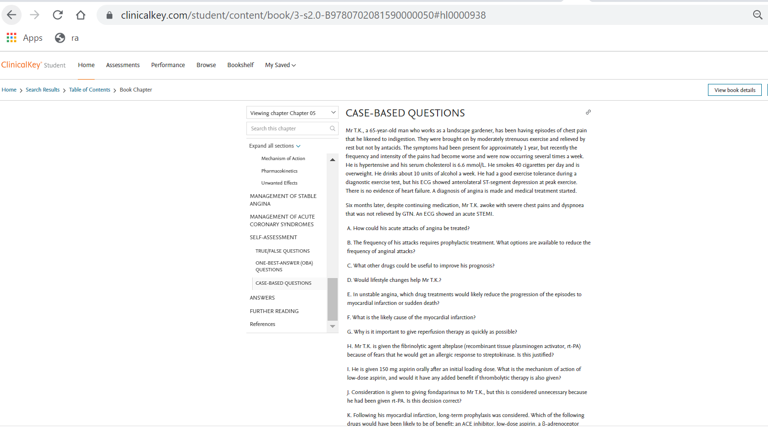  Provide MCQs/ clinical oriented questions from pre-clinical years (Linker case)  https://www.osmosis.org/learn-quiz/Ischemia/step1/questions  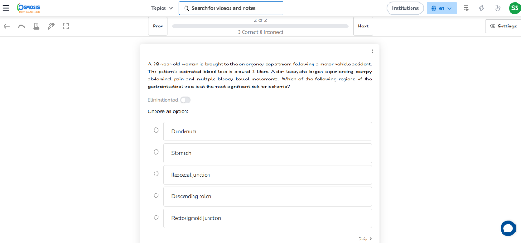  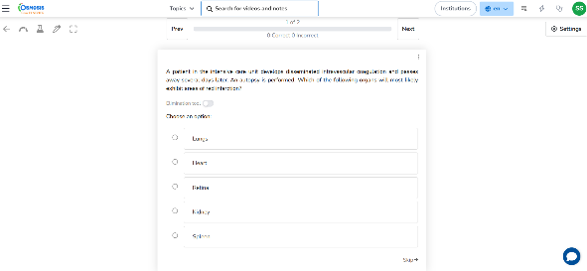

Question 3 - Also, please mention which other Medical Education teaching methodologies/ pedagogies you may like to pick to complete the topic/ module Small Group Discussion / Case based learning

Question 4 – If you were to include a component of AETCOM, please pick a resource and share the direct URL(s) + screen shots here.
https://www.clinicalkey.com/student/content/book/3-s2.0-B9780702078682000014#hl0000992
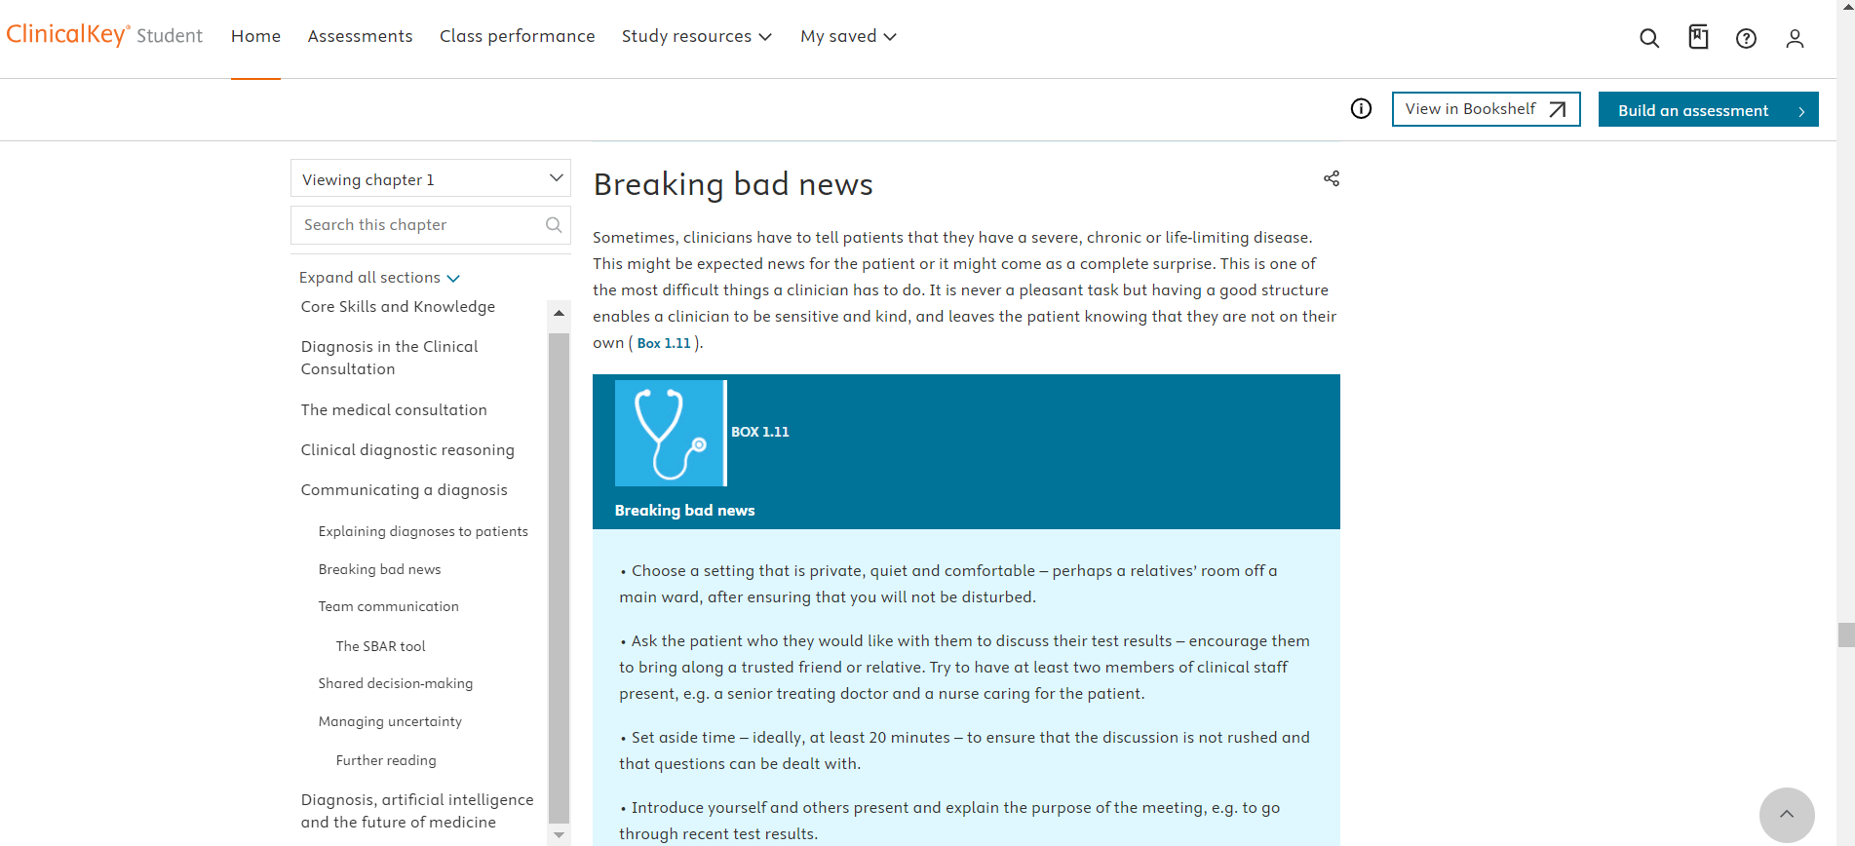
Question 5 - How would you define success for your students at the end of this topic/ module? How would you measure that?
All students must score more than 80% in the formative assessments assigned.

