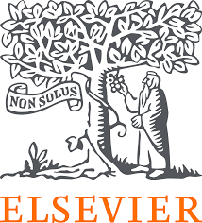
Group Work for Faculty: Create a Digital Teaching Learning Module (TLM) to conduct the teaching methodology Integrated Learning using digital resources on the disease condition Tuberculosis?

Name of all the faculty participants in the group:
Lead faculty who will make large group presentation:

* In the very beginning please nominate a group member who will present this group activity during the large group presentation
* Please create Digital TLM on the disease condition using the collection dashboard made available to you. Choose select competencies from new MBBS curriculum, so that you can complete the Digital TLM as per your lecture plan and time available
* You may like to take a screen shot for each resource link picked in Digital TLM

Please note that the Digital TLM provided here were originally created by educators like you during the face-face workshops and have been appropriately adapted. The versions shared are for sample purposes — you’re welcome to add, delete, or modify the resources as per your context and suitability.

Question 1 – Outline the teaching–learning- (formative) assessment methods you plan to use over the next class/ few weeks to complete the topic or module. Enumerate the steps you will follow during this period and the expected learning outcomes after each step. Plan a session with multiple subject specialties leads.

Question 2 – From the NMC MBBS curriculum, identify the competencies your group would like to address for the given topic. Design a digital teaching–learning module that incorporates e-resources. Use the collection dashboard provided to locate direct URLs of relevant content (cases, videos, skills videos, images, assessments) along with screenshots of the content you plan to use across subject(s).
Tuberculosis | TLM | Assessment
LEAD: Anatomy  AN24.3 :  Describe a bronchopulmonary segment with its clinical anatomy  LEAD:PHY  PY6.13:  Demonstrate the correct technique to perform measurement of peak expiratory flow rate in a normal volunteer or simulated environment  Lead Pathology  PA25.4:  Define and describe the etiology, types, pathogenesis, stages, morphology microscopic appearance and complications of tuberculosis  MI 17.5  Identify the common etiologic agents of lower respiratory tract infections in a provided Gram Stained & Acid fast stained smear of sputum/BAL/tracheal aspirate and correlate with the clinical findings provided  General Medicine  GM27.6  Demonstrate and perform a systematic examination that  establishes the diagnosis based on the clinical  presentation that includes a a) general examination, b)  examination of the chest and lung including loss of  volume, mediastinal shift, percussion and auscultation of  lung sounds and added sounds c) examination of the lymphatic system and d) relevant CNS examination  GM 27.14:  Prescribe an appropriate anti-tuberculosis Regimen based on the location of disease, smear positivity and negativity and comorbidities based on current national guidelines including directly observed tuberculosis therapy (DOTS)  LEAD: Community Medicine  CM8.3:  Enumerate and describe disease-specific National Health Programs including their prevention and treatment of a case | https://www.clinicalkey.com/student/content/book/3-s2.0-B9780702077050000549#hl0000515  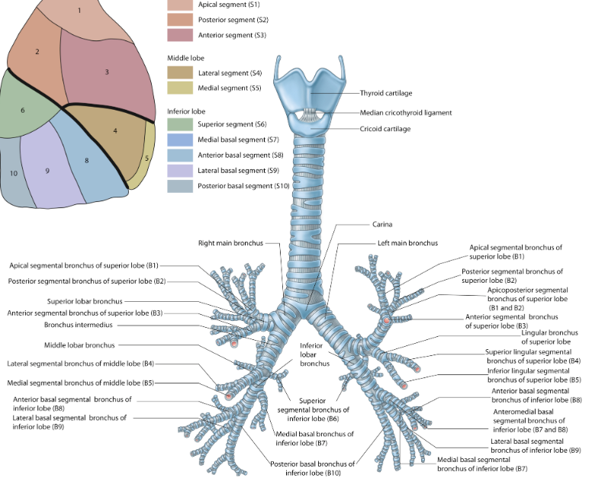  https://www.osmosis.org/learn/Anatomy_of_the_lungs_and_tracheobronchial_tree 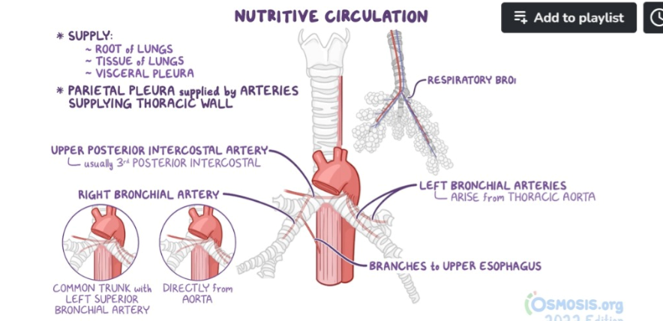  https://www.clinicalkey.com/student/content/book/3-s2.0-B9780702082849000118#hl0000338  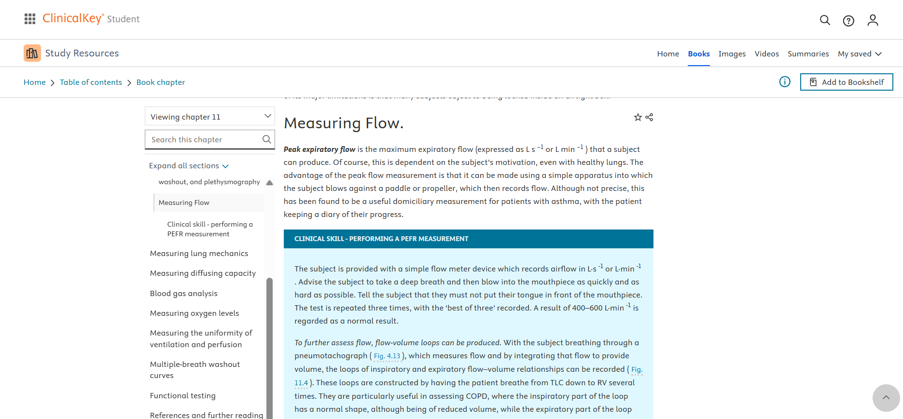  https://indiambbsskills.clinicalkey.com/local/courses/2495/m08_lymph_node_s04_Tuberculous_LN/data/DetailsPage.html?page=m8s4_04_02&language=_en&end=_s_001_en_main&level=LandingPg  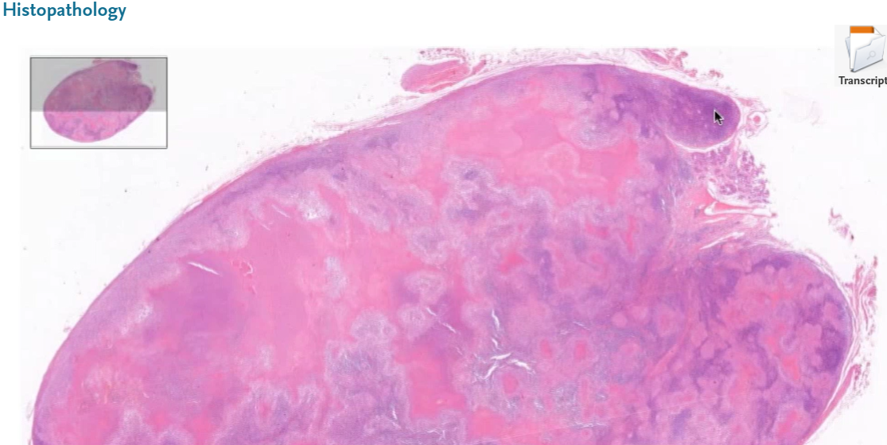  https://www.osmosis.org/learn/Mycobacterium_tuberculosis_(Tuberculosis)  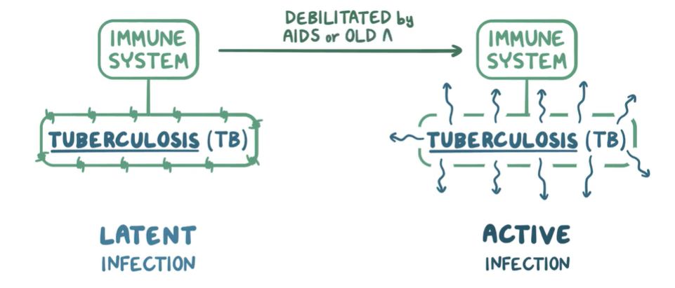  https://www.sciencedirect.com/journal/tuberculosis?_gl=1*dgee4u*_ga*MjAzMDgzNzE0My4xNjkwNTMzOTc2*_ga_4R527DM8F7*MTY5MDUzMzk3NS4xLjEuMTY5MDUzNzQxMS4wLjAuMA  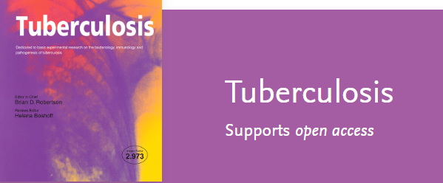  https://indiambbsskills.clinicalkey.com/local/courses/2439/Tuberculosis/data/LandingPg.html  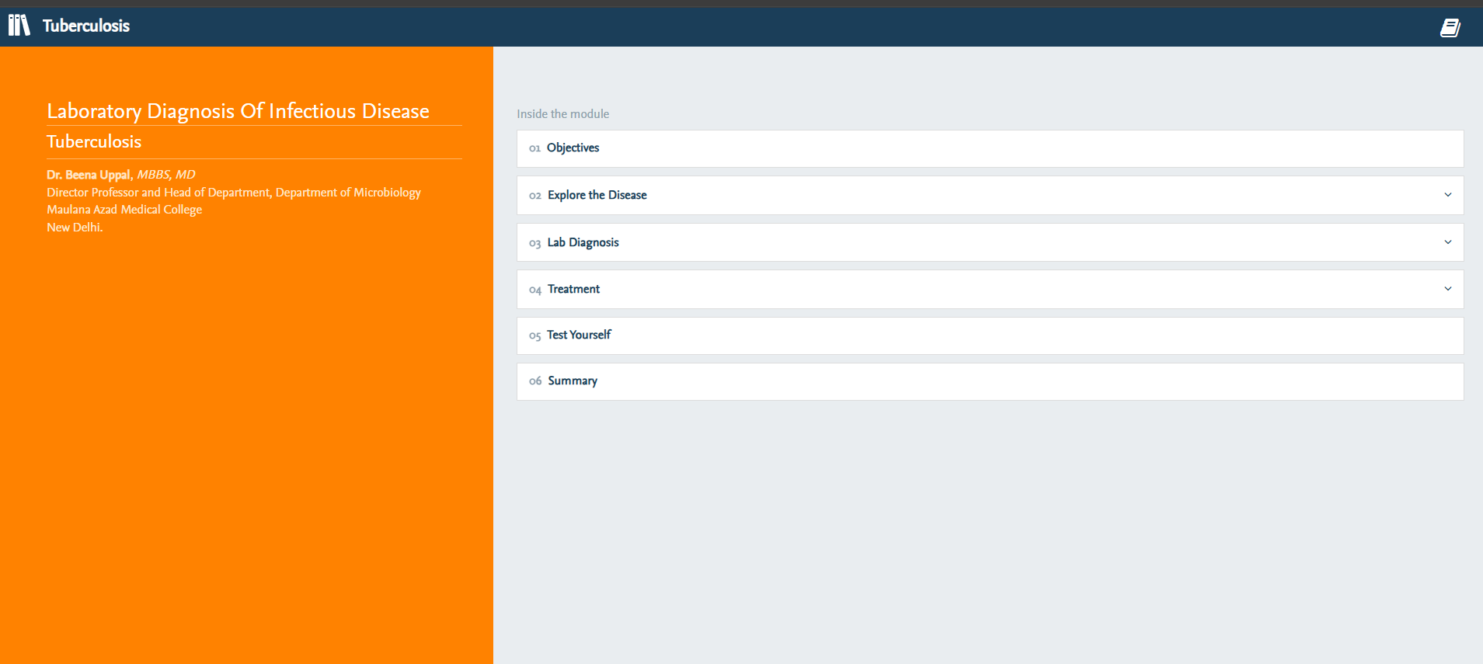  https://www.clinicalkey.com/student/content/book/3-s2.0-B9780443125942000200#hl0005598  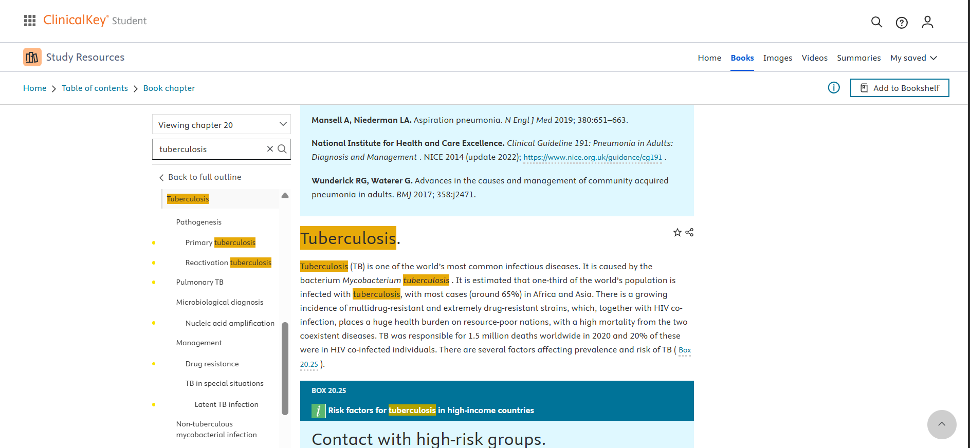  https://www.osmosis.org/learn/Antituberculosis_medications  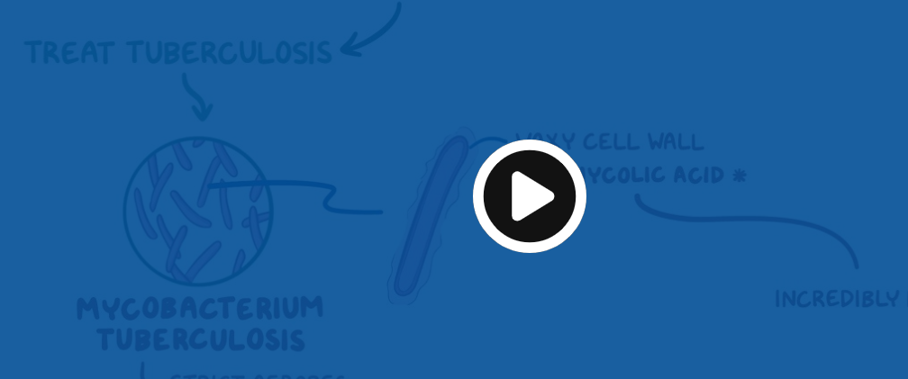  https://www.clinicalkey.com/student/content/book/3-s2.0-B9788131269053000170#hl0007893  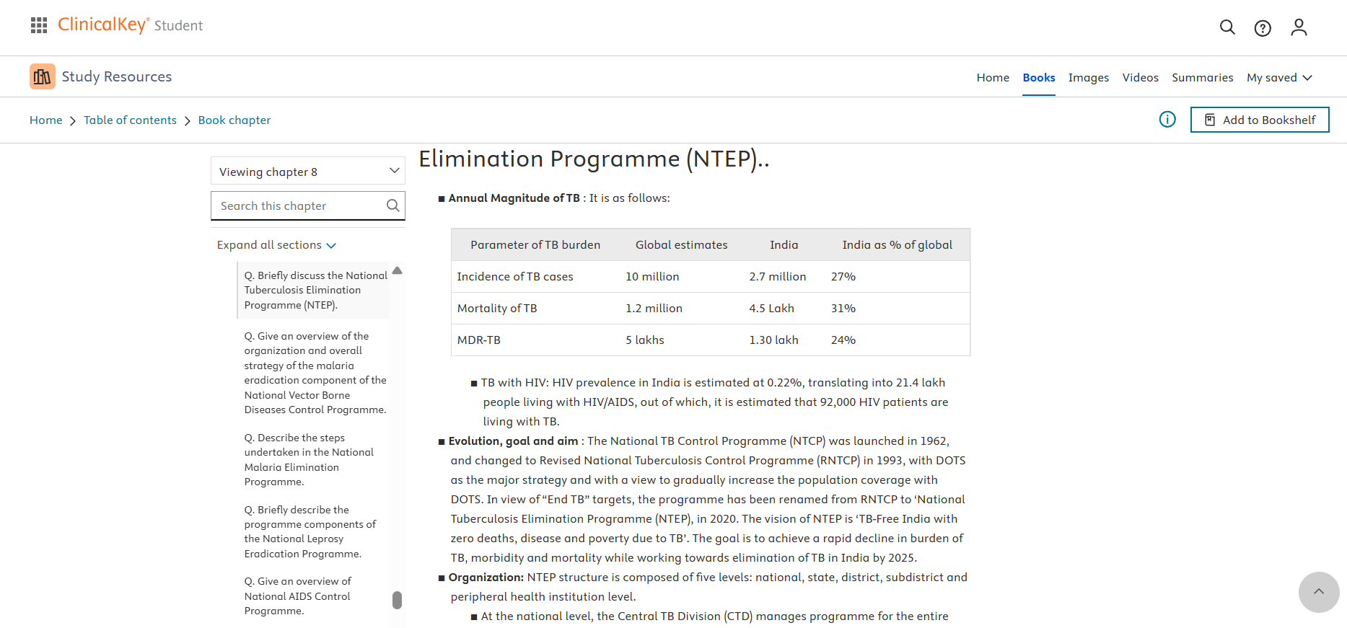 | Provide Direct URLs of Case Based Question  https://www.osmosis.org/learn/Drug_administration_and_dosing_regimens  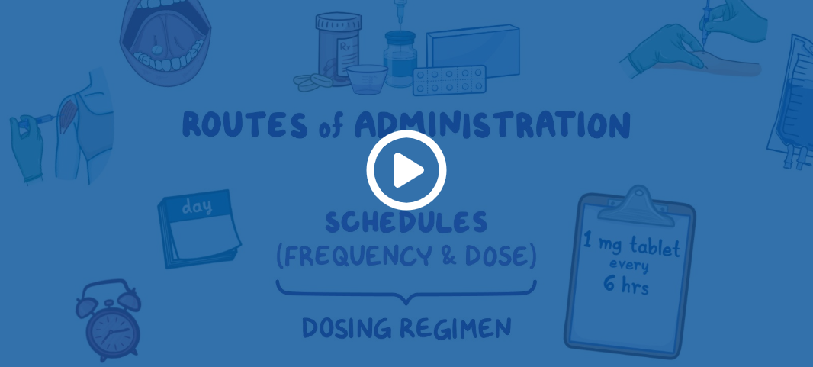  https://indiambbsskills.clinicalkey.com/local/courses/2439/Tuberculosis/data/DetailsPage.html?page=s03m07_04_01_01&language=_en&end=_s_001_en_main&level=LandingPg  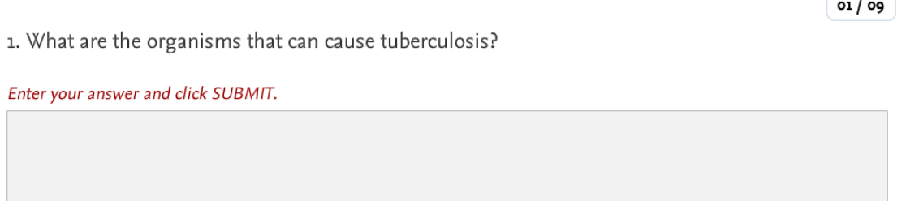

Question 3 - Also, please mention which other Medical Education teaching methodologies/ pedagogies you may like to pick to complete the topic/ module Small Group Discussion

Question 4 – If you were to include a component of AETCOM, please pick a resource and share the direct URL(s) + screen shots here.
https://www.clinicalkey.com/student/content/book/3-s2.0-B9780702075964000099#hl0000404
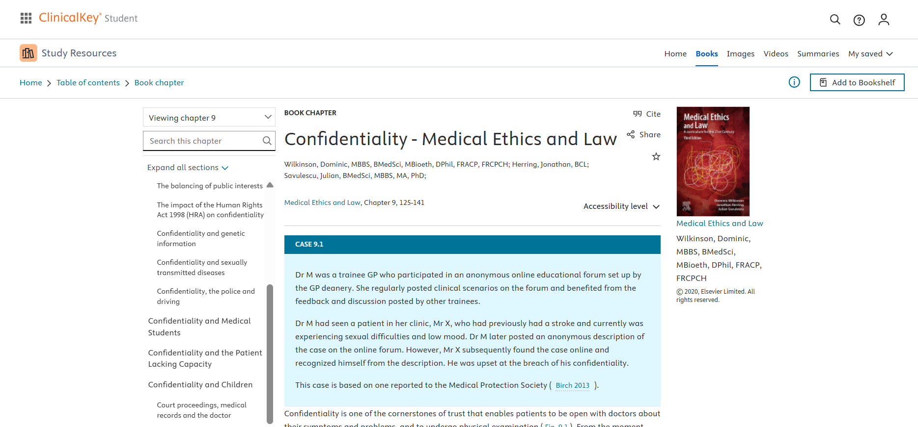
Question 5 - How would you define success for your students at the end of this topic/ module? How would you measure that?
Student feedback

