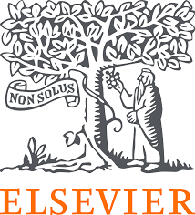 READY-TO-USE STANDARD DIGITAL TLMs TEMPLATE (ADAPTABLE AS NEEDED)
Group Work for Faculty: Create a Digital Teaching Learning Module (TLM) to conduct the teaching methodology _____SDL/ IL/ CBL/ ECE/Others________________________________using digital resources on the topic/ disease condition ___________ ___________?

Name of all the faculty participants in the group:
Lead faculty who will make large group presentation:

* In the very beginning please nominate a group member who will present this group activity during the large group presentation
* Please create the Digital TLM on the disease condition (Collection dashboard) assigned to you. Choose select competencies so that you are
able to complete the Digital TLM as per your lecture plan and time available
* You may like to a screen shot for each resource link picked in the Digital TLM

Question 1 – Outline the teaching–learning- (formative) assessment methods you plan to use over the next class/ few weeks to complete the topic or module. Enumerate the steps you will follow during this period and the expected learning outcomes after each step.
Question 2 – From the NMC MBBS curriculum, identify the competencies your group would like to address for the given topic. Design a digital teaching–learning module that incorporates e-resources. Use the collection dashboard provided to locate direct URLs of relevant content (cases, videos, skills videos, images, assessments) along with screenshots of the content you plan to use across subject(s).
Disease Condition/ Topic | TLM | Assessments (Formative/ Self)
LEAD: SUBJECT  Competency Number and Description | - Provide Direct URLs of Clinical Correlation cases  - Provide Direct URLs of Videos  - Provide Direct URLs of Images for PPTs  - Provide Direct URLs of Skills Videos/ Clinical Examination/ Dissection videos  - Provide Direct URLs of Lectures  - Provide Direct URLs for India Context | Provide Direct URLs of Case Based Question  Provide MCQs  Provide subjective questions

Question 3 - Also, please mention which other Medical Education teaching methodologies/ pedagogies you may like to pick to complete the topic/ module

Question 4 – If you were to include a component of AETCOM, please pick a resource and share the direct URL(s) + screen shots here.

Question 5 - How would you define success for your students at the end of this topic/ module? How would you measure that?

SAMPLE DIGITAL TLM TO GUIDE YOU IN CREATING YOUR OWN TLM

Group Work for Faculty: Create a Digital Teaching Learning Module (TLM) to conduct the teaching methodology _____SDL/ IL/ CBL/ ECE/Others________________________________using digital resources on the topic/ disease condition ___________ ___________?

Name of all the faculty participants in the group:
Lead faculty who will make large group presentation:

* In the very beginning please nominate a group member who will present this group activity during the large group presentation
* Please create the Digital TLM on the disease condition (Collection dashboard) assigned to you. Choose select competencies so that you are
able to complete the Digital TLM as per your lecture plan and time available
* You may like to a screen shot for each resource link picked in the Digital TLM

Question 1 – Outline the teaching–learning- (formative) assessment methods you plan to use over the next class/ few weeks to complete the topic or module. Enumerate the steps you will follow during this period and the expected learning outcomes after each step. Plan a session with multiple subject specialties leads. Learning Outcomes will be linked to each selected competencies

Question 2 – From the NMC MBBS curriculum, identify the competencies your group would like to address for the given topic. Design a digital teaching–learning module that incorporates e-resources. Use the collection dashboard provided to locate direct URLs of relevant content (cases, videos, skills videos, images, assessments) along with screenshots of the content you plan to use across subject(s).
IHD (Ischemic Heart Disease) | TLM | Assessment
LEAD: ANATOMY  AN5.6 Describe the concept of anastomoses and collateral circulation with significance of end arteries.  AN5.8: Define thrombosis, infarction, and aneurysm.  PA26.1Distinguish arteriosclerosis from atherosclerosis. Describe the pathogenesis and pathology of various causes and types of arteriosclerosis  PA5.5, PA5.6: Define and describe Ischemia/infarction its types, etiology, morphologic changes and clinical effects; Identify and describe the gross and microscopic features of infarction in a pathologic specimen  LEAD:PHYSIOLOGY  PY5.6: Discuss physiological variations in ECG waveforms, abnormal waveforms and intervals, arrhythmias, heart blocks and myocardial Infarction  GM2.13: Discuss and enumerate the indications for and findings on echocardiogram, stress testing and coronary angiogram  LEAD:PATHOLOGY  PA27.5: Describe the epidemiology, risk factors, etiology, pathophysiology, pathology, presentations, gross and microscopic features, diagnostic tests and complications of ischemic heart disease  LEAD:MEDICINE  IM2.2: Discuss the etiology of risk factors both modifiable and non-modifiable of atherosclerosis and IHD | Provide Direct URLs of Clinical Corelation cases  https://www.clinicalkey.com/student/content/book/3-s2.0-B9788131264812000304#hl0001677  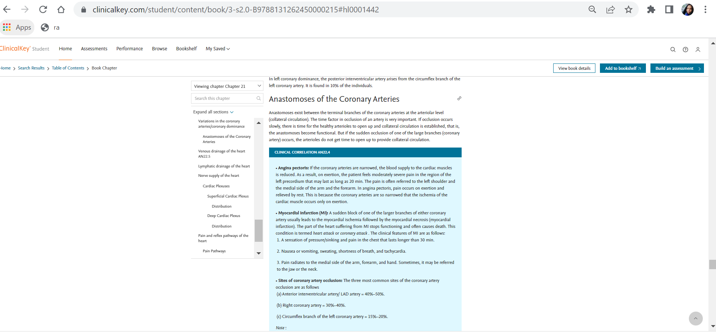  Provide Direct URLs of Videos  https://www.osmosis.org/learn/Ischemia  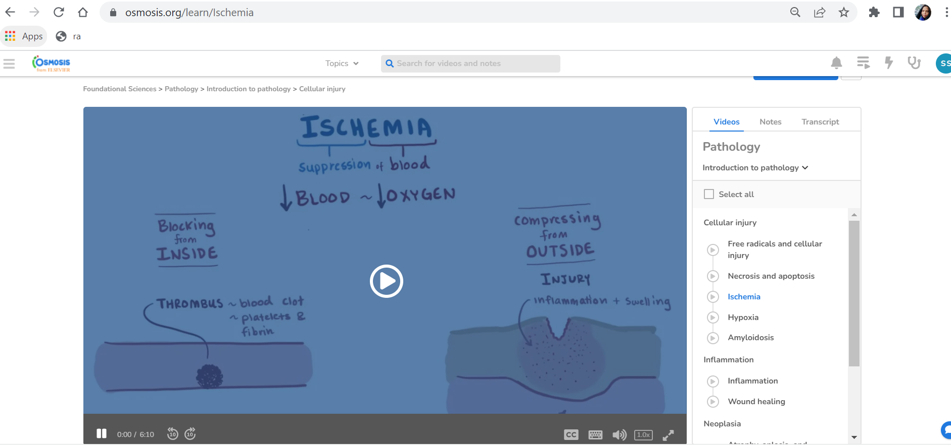  Provide Direct URLs of Images for PPTs  https://www.clinicalkey.com/student/search?query=ischemic%20heart%20disease&source=search-results&facets=!ct~IM&savedContent=false  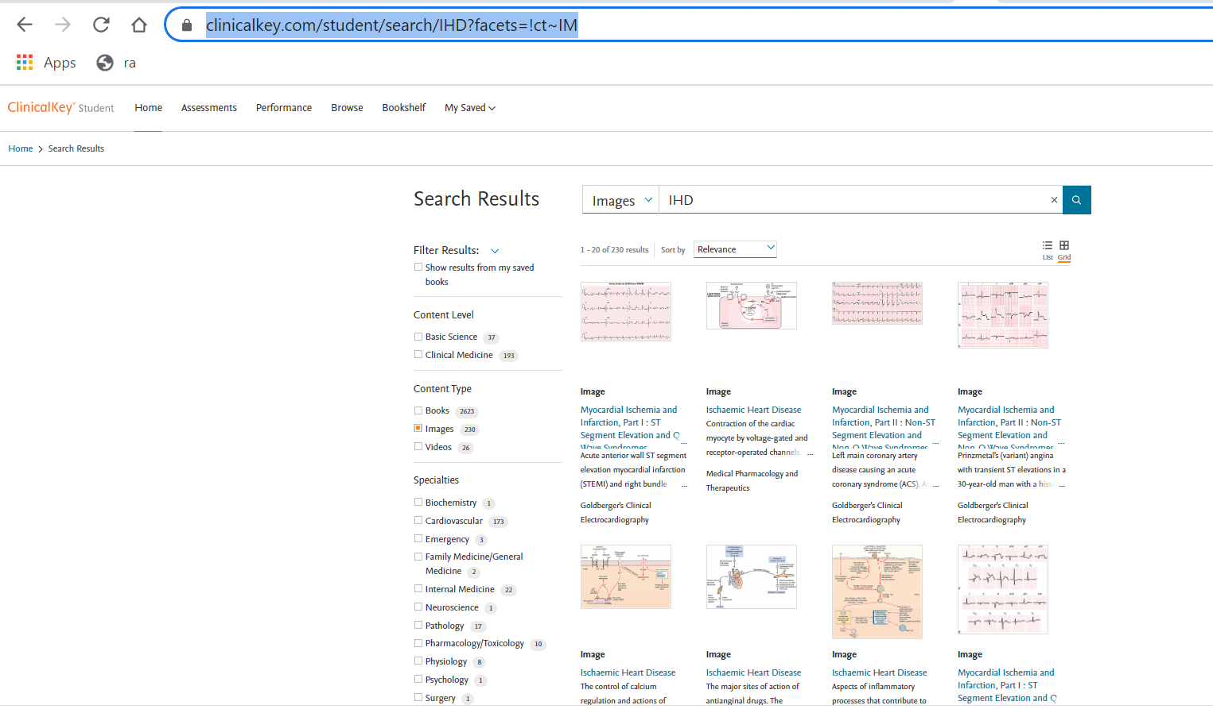  Provide Direct URLs of Angiogram/ ECG clinical Images  https://www.clinicalkey.com/student/content/book/3-s2.0-B9788131244654000185  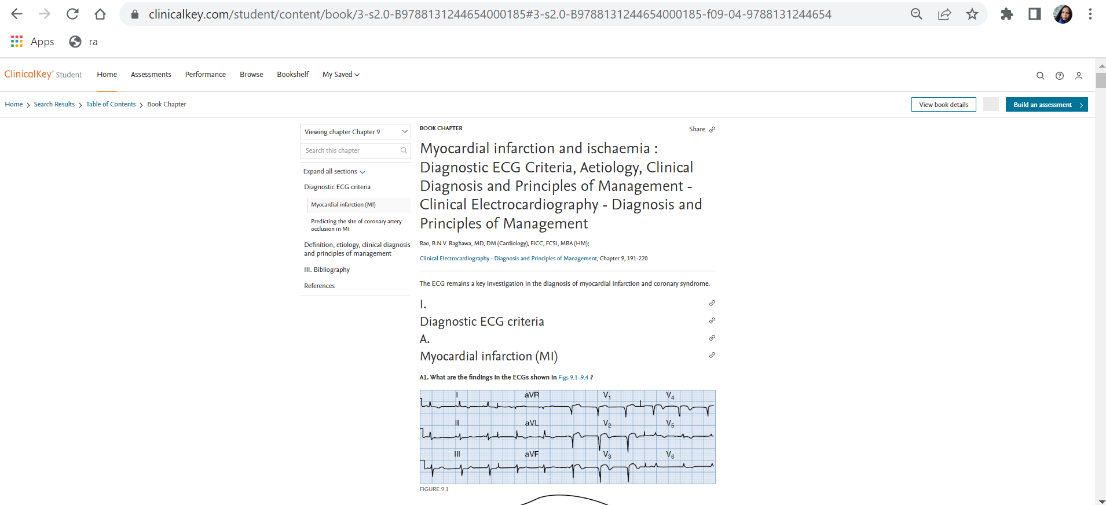  Provide Direct URLs of Skills Videos for CBL/ PBL - Recording & Interpretation of normal ECG. Else lecture SGD  https://indiambbsskills.clinicalkey.com/local/courses/2535/s02_m06_dv_electrocardiogram/data/LandingPg.html 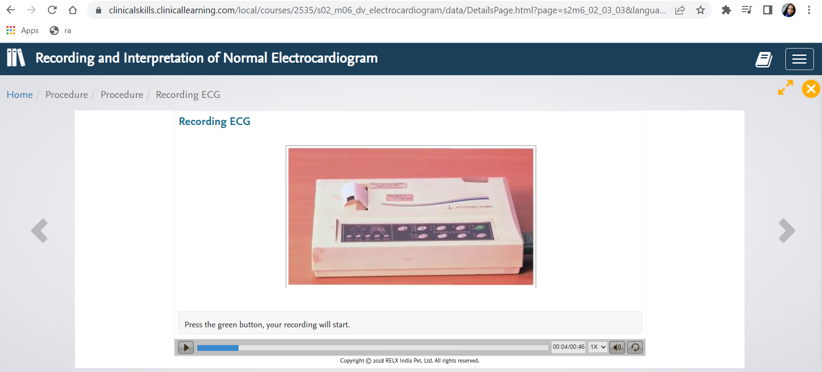  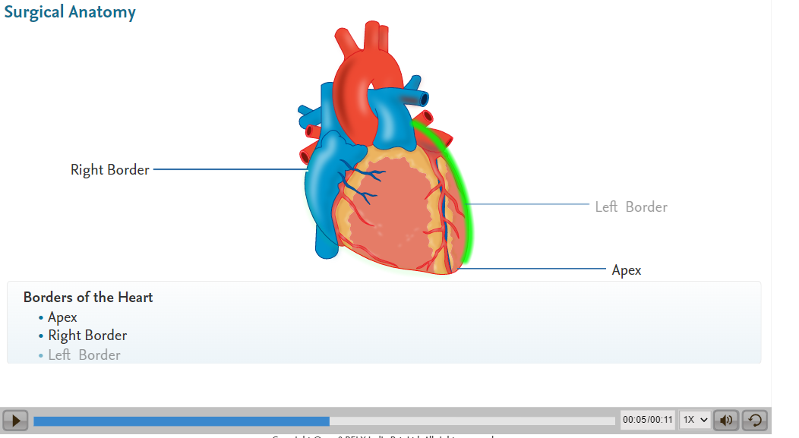  Provide Direct URLs of Lectures  https://www.clinicalkey.com/student/content/book/3-s2.0-B9780323846738000432#hl0000138 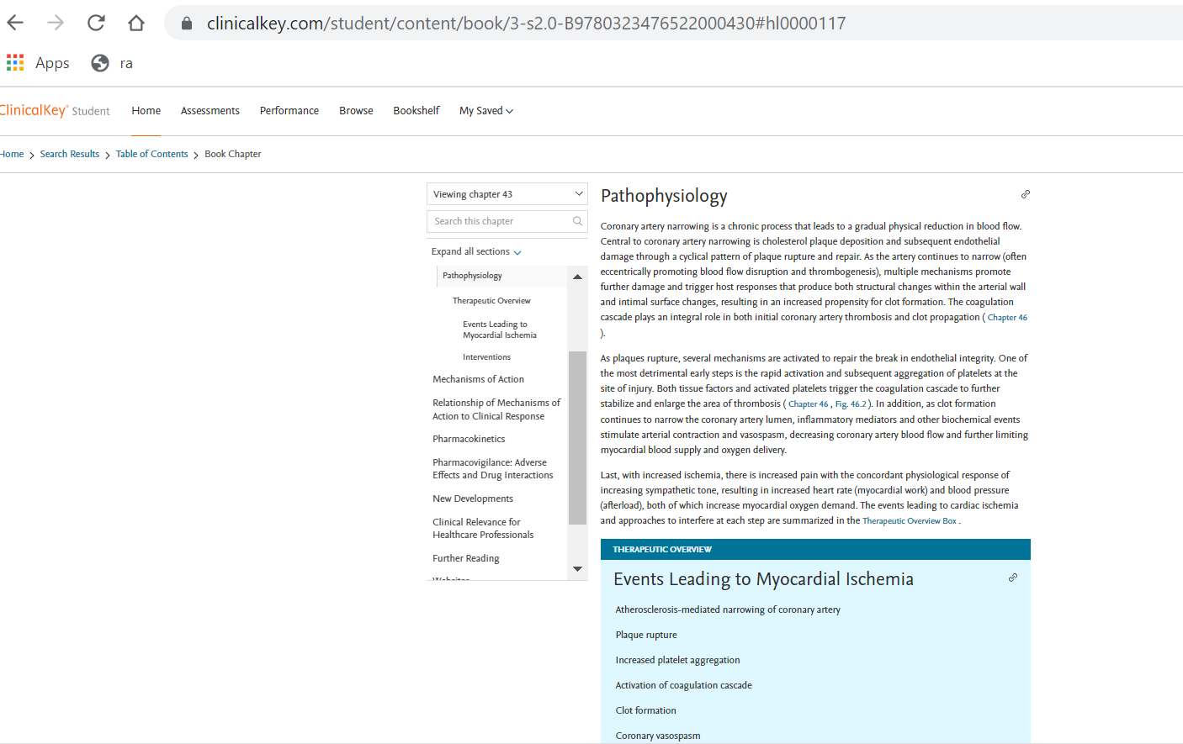  https://www.clinicalkey.com/student/content/book/3-s2.0-B9780723438601000079#hl0000141  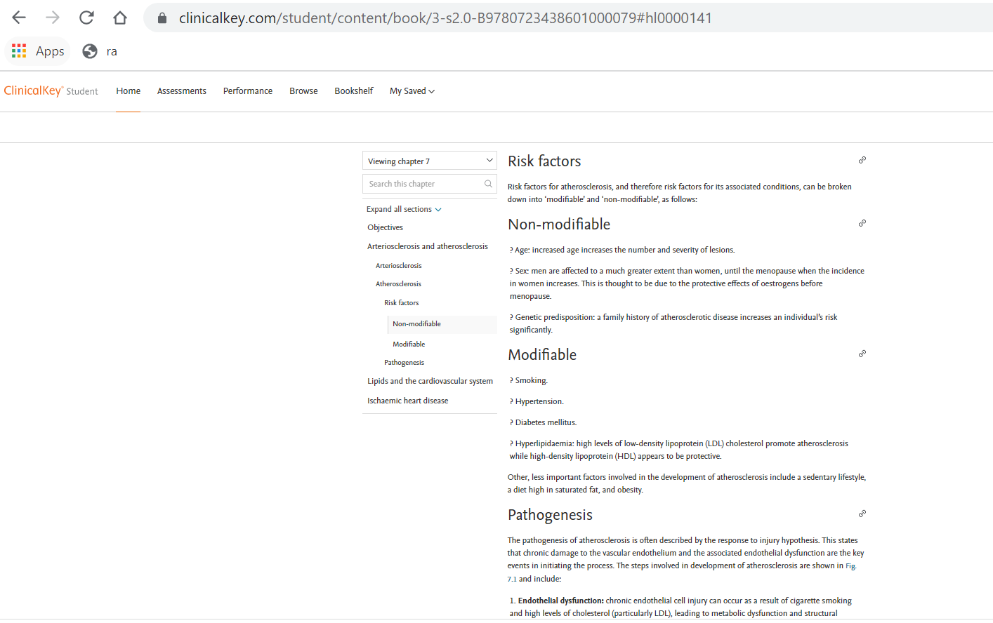  Provide Direct URLs for Lectures - IHD in India special features  https://www.clinicalkey.com/student/content/book/3-s2.0-B9780443115349000114#hl0000617  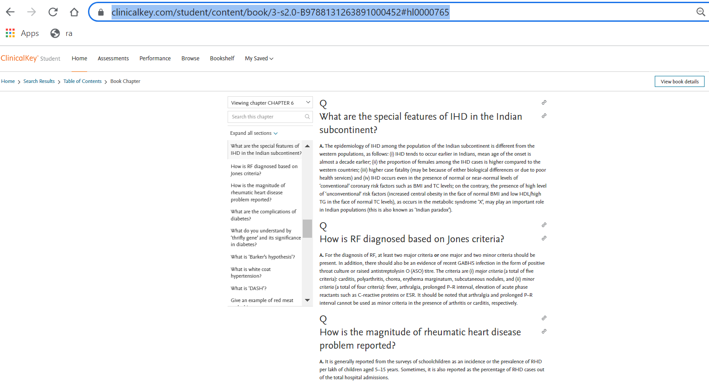 | Provide Direct URLs of Case Based Question  https://www.clinicalkey.com/student/practice/PJBMainIND0085  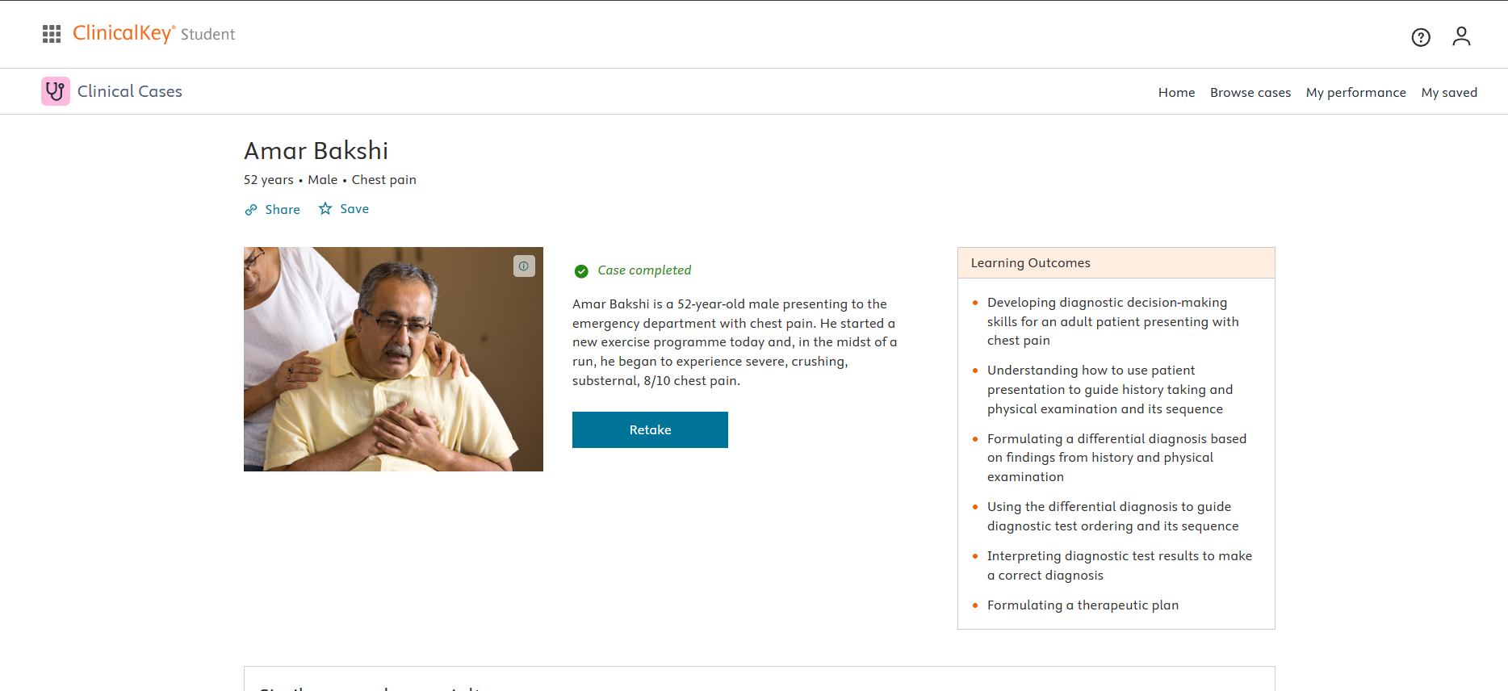  https://www.clinicalkey.com/student/content/book/3-s2.0-B9780702081590000050#hl0000938  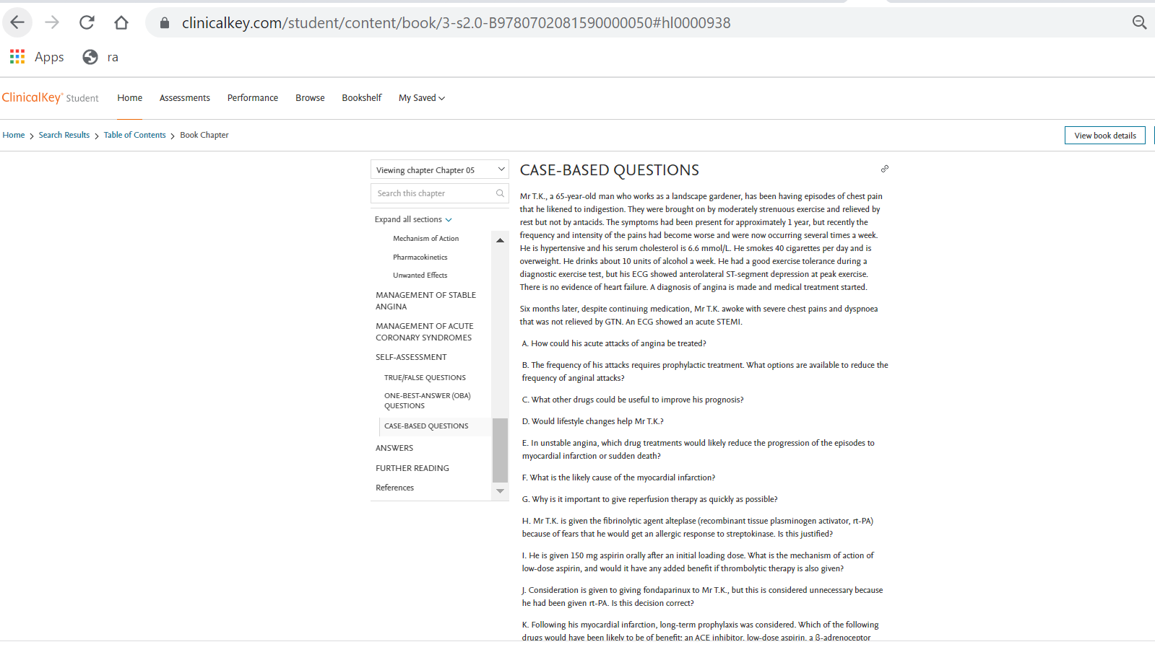  Provide MCQs/ clinical oriented questions from pre-clinical years (Linker case)  YAI_1606899440891  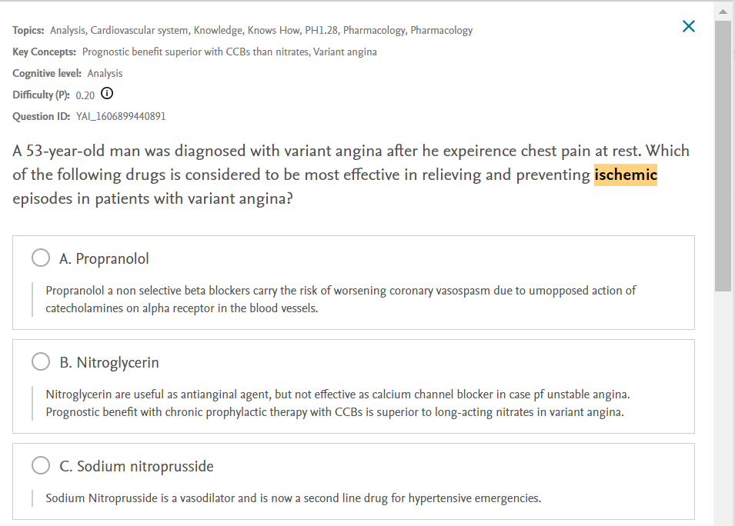  YAI_1635950935335  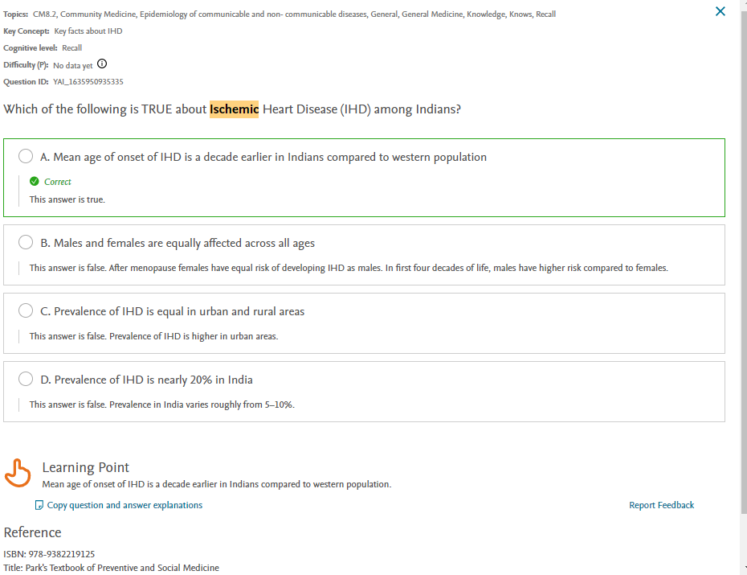

Question 3 - Also, please mention which other Medical Education teaching methodologies/ pedagogies you may like to pick to complete the topic/ module Small Group Discussion / Case based learning

Question 4 – If you were to include a component of AETCOM, please pick a resource and share the direct URL(s) + screen shots here.
https://www.clinicalkey.com/student/content/book/3-s2.0-B9780702078682000014#hl0000992
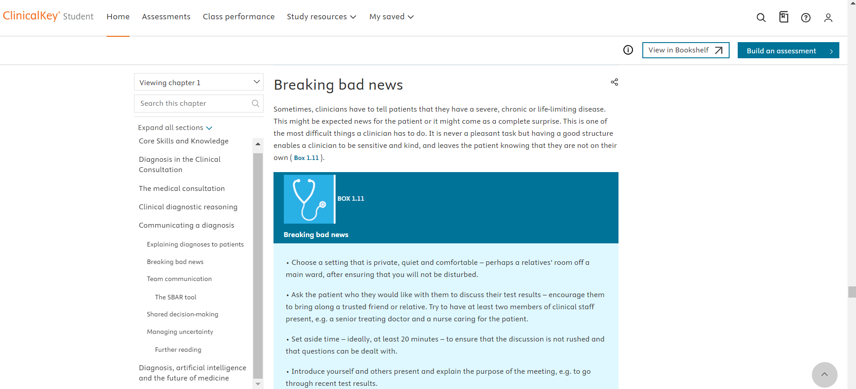
Question 5 - How would you define success for your students at the end of this topic/ module? How would you measure that?
All students must score more than 80% in the formative assessments assigned.

